Biodesigned bioinks for 3D printing via divalent crosslinking of self-assembled peptide-polysaccharide hybrids

Kate Firipis^{1,2}, Elizabeth Footner^{1,2}, Mitchell Boyd-Moss³, Chaitali Dekiwadia⁴, David Nisbet^{5,6,7}, Robert MI Kapsa^{1,2,8}, Elena Pirogova^{1,2}, Richard J. Williams^{3*}, Anita Quigley^{1,2,8*}
*Equal last author and corresponding authors.

- Biofab3D, Aikenhead Centre for Medical Discovery, St Vincent’s Hospital Melbourne, Fitzroy, VIC, 3065, Australia
- Biomedical and Electrical Engineering, School of Engineering, RMIT University, Melbourne, VIC, 3000, Australia
- Institute of Mental and Physical Health and Clinical Translation, School of Medicine, Deakin University, Waurn Ponds, VIC, 3216, Australia
- RMIT Microscopy and MicroAnalysis Facility (RMMF), STEM College, RMIT University, Melbourne, VIC, 3000, Australia
- Laboratory of Advanced Biomaterials, The Australian National University, Acton, Canberra, ACT, 2601, Australia
- The Graeme Clark Institute, The University of Melbourne, Melbourne, VIC, 3000, Australia
- Department of Biomedical Engineering, Faculty of Engineering and Information Technology, The University of Melbourne, Melbourne, VIC, 3000, Australia
- Department of Medicine, Melbourne University, St Vincent’s Hospital Melbourne, Fitzroy, VIC, 3065, Australia.

Keywords: self-assembling peptides, bioinks, biofabrication, polysaccharide, hybrid materials

Abstract
The demands of tissue engineering and regenerative medicine require biomaterials to be accurately deposited into biomimetic shapes, support cellular behaviour, and lead functional tissue formation. Bioinspired yet synthetic biomaterials offer significant advantages over processed, animal-derived products; including high reproducibility and clinical compliance, and specific engineered biomimicry of architecture and biological function. Self-assembling peptides are synthetic highly hydrated scaffolds that are rationally designed to mimic the extracellular matrix of a target tissue. Due to the potential benefits of chemically synthesised self-assembling peptides for clinical translation, their development into tools for biofabrication is warranted. However, these systems can be poorly suited to the demands of biofabrication, particularly when functionalised toward tissue-specific conditions. Here, we demonstrate how to improve biofabrication of self-assembling peptides. The fibrillar network arising from the self-assembling peptide Fmoc-FRGDF (containing cell attachment motif RGD) is combined with the robust polysaccharides agarose and alginate demonstrating enhanced printability and cellular compatibility. This study provides a robust methodology for the on-demand printing of personalised implants with a clinically relevant material.
- Introduction
3D bioprinting holds significant promise for the fabrication of complex tissues and organ scaffolds to relieve transplantation demand ^{1, 2}. Successful 3D bioprinting of functioning tissue is reliant on the development of biomaterials that can be accurately deposited while supporting beneficial cell behaviours ³. The properties of these materials, termed bioinks, are key for creating a conducive environment for 3D cell growth. The relationship of biomaterial properties such as stiffness ^{4, 5}, bioactivity ⁶ and scaffold architecture ⁷⁻¹² are known to have significant influence over essential cell behaviours such as proliferation, differentiation and migration ¹³. Therefore, the development of multifaceted bioinks that can both be accurately deposited with minimal effect on cell viability, and present tuneable engineered properties to support beneficial cellular behaviour, are desirable positive developments in the bioprinting field.

Bioinks, to date, rely significantly on methods of crosslinking to ensure gelation for maintenance of shape fidelity, not only during and immediately following fabrication, but also over the extended timescales required to support maturation of the construct. Processes involving permanent crosslinking can result in a highly complex dense scaffold, which may reduce cellular mobility and fluid diffusion ¹⁴. Further, covalent crosslinking processes can involve UV-irradiation and chemical agents that create free radicals, resulting in damage to cells ¹⁵. An alternative is supramolecular based bioinks, relying on non-covalent, hydrophobic forces, hydrogen bonding, π-π stacking, van der Waals forces and electrostatic interactions to provide a self-supporting hydrogel bioink ¹⁶. Bioinks that gel via supramolecular processes offer two significant benefits over permanent crosslinking; 1. Non-covalent gelation processes allow for cell-driven network rearrangement, and 2. Lack of cytotoxic gelation processes may result in improved cellular viability. Bioinks that use supramolecular gelation mechanisms include agarose and alginate, naturally occurring polysaccharide hydrogels ¹⁷⁻¹⁹. However, agarose and alginate are inert and lack cell attachment motifs, and without chemical modification often repel cell attachment ²⁰⁻²².

Further, supramolecular bioinks based on self-assembling peptides (SAPs) offer the additional benefits of being chemically well defined and easy to engineer ²³, biocompatible, bioresorbable, high batch-to-batch reproducibility and have engineered bioactivity ²⁴⁻²⁹. SAPs are made up of short amino acid sequences designed to self-assemble into nanostructures such as nanofibres ^{30, 31}. These structures further entangle to form highly hydrated bioactive and nanofibrous porous scaffolds ²⁹⁻³² with high biomimicry of the native body’s extracellular matrix (ECM) at physiological pH ^{30, 31, 33, 34}.

Our previous studies have described the fabrication of the SAP Fmoc-FRGDF, a fluorenyl-methyl-oxycarbonyl (Fmoc) capped pentapeptide that on application of a pH switch, undergoes self-assembly into a nanofibrous network, driven via π-π stacking of the aromatic groups and β-sheet interactions ^{30, 31}. This peptide contains the amino acid motif RGD, which can interact with cell transmembrane integrins α_{v}β₃, α_{v}β₅, α_{v}β₆, α_{v}β₈, α₅β₁ and α_{IIb}β₃ ³⁵. Previously, we have demonstrated the efficacy of bioactive Fmoc-FRGDF scaffolds for 3D cell culture of myoblasts ³⁶, primary human mammary fibroblasts ^{31, 37} and biocompatibility in vivo ³⁸. Further, we have demonstrated the ability to mechanically tune SAP material properties by varying the assembly rate ³⁹, gelation conditions ³⁹ or presence of other materials ^{36, 40, 41}. With the bioactivity of RGD, nanofibrous topography and ability for mechanical variation, Fmoc-FRGDF alone or in combination with other materials poses great potential as a bioink for 3D bioprinting. Whilst there is a growing body of work highlighting the use of SAPs as bioinks ⁴², to the best of our knowledge, no reports exist of such epitope-laden Fmoc-SAPs optimised for 3D extrusion printing or 3D patterning.

Hybrid Fmoc-FRGDF/polysaccharide hydrogels offer an intercalated network of tuneable properties that demonstrate improved control over bulk mechanical properties whilst presenting a bioactive nanofibrous scaffold ^{36, 40, 41}. Our previous work demonstrated that Fmoc-FRGDF in combination with agarose presents a tuneable hybrid material with enhanced control over mechanical stiffness at high concentrations. Building on our previous work with Fmoc-FRGDF (as both a stand-alone hydrogel and as a component of hybrid hydrogels) ^{36, 40, 41}, here we investigate the concept of 3D extrusion printing adapted for the mild conditions of ionic crosslinking to stabilise the printed scaffolds. Two approaches to enhance Fmoc-FRGDF for extrusion printing are demonstrated. Firstly, by exploiting the increased mechanical properties that have been reported in other non-bioactive peptide systems on exposure to ionic solution ⁴³, we demonstrate the fabrication of a macroscale, self-supporting and robust filament underpinned by the bioactive nanofibrous peptide gel (peptide noodles). Secondly, building on our work in hybrid peptide hydrogels ⁴⁰, we demonstrate that hybrid Fmoc-FRGDF agarose can support the 3D cell culture of human dermal fibroblasts and be patterned via 3D extrusion printing. Additionally, we consider a second polysaccharide component, alginate. Alginate is a highly researched, seaweed-derived biomaterial with known biocompatibility ⁴⁴⁻⁴⁷. The ability of alginate to undergo ionic crosslinking in the presence of calcium chloride allows great versatility in controlling scaffold mechanical properties post-printing without altering the polysaccharide’s initial concentration and subsequent printability (Figure 1, Table 1).

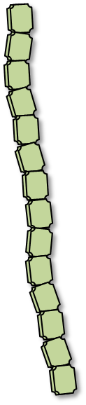
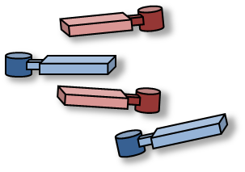
Figure 1: Schematic of hybrid materials fabrication process. Self-assembling peptide Fmoc-FRGDF undertook a pH switch to form bioactive peptide fibres. Combination with agarose or agarose and alginate resulted in a hybrid peptide bioink. The hybrid peptide bioink could be further crosslinked using CaCl₂ to improve the stability of the hydrogel.
Composite Self Assembling Peptide/Agarose/Alginate
Self-Assembling Peptide
Adjust pH
Briefly vortex
Melted Agarose
Alginate
Calcium ions
Crosslinked Self Assembling Peptide/Agarose/Alginate
Bioactive Fibres
Crosslinking
In this study, the combination of SAP Fmoc-FRGDF, agarose and alginate overcomes the limitations of alginate and agarose alone, which lack bioactive motifs and nanofibrous structures ²⁰⁻²². An improved biomimetic network is formed in the hybrid material, with tissue-specific bioactivity conferred from the SAP. To the best of our knowledge, it has not been reported how the combination of both agarose and alginate polysaccharides with Fmoc-FRGDF impacts material properties, and further, how exposure to ionic solutions, such as calcium chloride (which is known to affect both peptide and alginate material properties ⁴³), will impact the resultant material structure and viability of cultured human dermal fibroblast cells.

Significant research has focussed on evaluating the ability of novel bioinks to be successfully 3D extrusion printed. Material properties such as viscosity ⁴⁸⁻⁵⁰, thixotropic behaviour ⁵⁰⁻⁵⁵ and loss tangent ⁵⁶ are currently regarded as suitable predictors of successful biofabrication. However, these studies primarily study bioinks such as gelatin and alginate ^{48-52, 55, 56}, which do not contain the unique nanostructures that result in gelation of SAPs. Therefore, the relevance of these properties to SAP bioinks is unknown. Bioinks containing SAPs are a growing field in the literature, with significant questions remaining around which bioink properties are essential for SAP biofabrication and how to design SAPs for successful bioprinting ⁴². The development of SAP bioinks has significant implications for clinically translatable materials, as SAPs are chemically well defined, can be tailored to contain individual or combined motifs, and are synthetic, demonstrating excellent consistency between batches. Studies of SAP bioinks have reported measures of assessing printability such as viscosity ⁵⁷⁻⁶⁰, loss tangent ^{57, 58, 61}, shear-thinning ^{58, 59, 62}, achievable height ^{58, 59, 62, 63} and filament assessments ^{58, 59, 62}.
In this study we describe hybrid macromolecular (agarose-alginate) SAP hydrogels with shear thinning properties that provide a suitable environment for cell attachment and growth. Addition of SAP peptide to the macromolecular hydrogels, to create hybrid hydrogels, is shown to significantly improve the cell compatibility and printability of the hydrogels. The nanofibrous structure of the SAP network is maintained in the hybrid hydrogel systems and calcium based cross linking significantly increases stiffness (storage modulus) in both the peptide only hydrogels and the hybrid gel systems, whilst maintaining cellular compatibility.

The work presented here aims to contribute to the growing field of SAP bioinks and investigates novel SAP and SAP-hybrid bioink properties, including, viscosity, shear-recovery, shear-thinning, and loss tangent.

2. Materials and Methods
  - 2.1 Materials
Fmoc-Peptides were purchased from BioMatik, with HCl salt and with a purity of > 98 %. All other reagents are from Merck-Sigma unless otherwise mentioned.
  - 2.2 Fmoc-SAP gel preparation
Fmoc-peptides were prepared at 5 mg mL⁻¹. 5 mg of the peptide was suspended in 400 µL MilliQ water (Milli-Q advantage A10 System, Merck Milipore, Melbourne, Australia). The suspension was then dissolved with a minimal volume (~35 µL) of 0.5 M sodium hydroxide (NaOH), which has been shown to be effective and does not deprotect the Fmoc- from the peptide, as previously described ^{30, 41, 64, 65} (Sigma-Aldrich Pty. Ltd., Sydney, Australia). The pH of the peptide solution was then slowly acidified by dropwise addition of 0.1 M hydrochloric acid (HCl) until a pH of 7.4 was reached (typically 30–60 µL). The solution was continually vortexed throughout this process. Once a gel was formed at appropriate pH, phosphate-buffered saline (PBS) (Gibco) was added to achieve a final peptide concentration of 5 mg mL⁻¹ and 1 x PBS concentration. The pH of the Fmoc-SAPs was measured using a microprobe pH meter.
  - 2.3 Agarose & Alginate gel preparation
Low melting point (LMP) agarose (3,6-Anhydro-α-L-galacto-β-D-galactan, sulfate (SO₄²⁻): ≤0.15 %, ≥1200 g/cm² (1 % gel) was obtained from Sigma Aldrich. A polysaccharide solution of 6.00 % w/v was prepared by dissolving the polysaccharide in 5 mL of MilliQ at 80 °C. Thorough mixing occurred until a clear solution was obtained, followed by maintenance at 80 °C for further blending with Fmoc-SAP, alternatively agarose gels were made with a final concentration of 2 % w/v and 1 x PBS and allowed to reach gelation at room temperature (RT). Alginate was obtained from Sigma Aldrich (A0682, 4-12 cP.s at 1 % in H₂0 at 25 °C) and dissolved in MilliQ to a concentration of 3 % w/v. Thorough mixing occurred until a clear solution was obtained, followed by filter sterilisation. Agarose-alginate gels were made with a final concentration of 2 % w/v and 1 x PBS and allowed to reach gelation at room temperature (RT).
  - 2.4 Mixed Fmoc-SAP Agarose & Alginate gel preparation
Fmoc-SAP gels were prepared as above; however, 333.3 µL of LMP Agarose or LMP Agarose and Alginate (prepared as above) was added (Table 1). The resulting solution was briefly vortexed and left at 70 °C for 1 hour before cooling to RT. After gelation, hydrogels were maintained at RT for 16 hours. At this point, the composite hydrogels were considered equilibrated, and ready for further analysis.
  - 2.5 Ionic Crosslinking with Calcium Chloride
0.2 % w/v calcium chloride solution was used in all experiments. Materials were exposed to CaCl₂ solution for 10 minutes by pipetting of CaCl₂ solution on top of the hydrogel at a volume ratio of ~4:1. In the TEM, FTIR, Cryo-SEM and Rheological Analysis a ‘blob’ of hydrogel was surrounded with the solution. In the cell culture study the hydrogel was spread across the well plate and the CaCl₂ covered the gel surface.
  - 2.6 TEM
TEM was undertaken on a JEOL 1010 TEM (JEOL USA, Inc.). Samples were loaded onto holey carbon grids and negatively stained with 1 % uranyl acetate in water ⁶⁶. An accelerating voltage of 80 kV was used. Images were subjected to manual measurement of fibril width using ImageJ line and polygon tools. Measurements were calibrated against the scale bars on the images. At least 100 measurements were taken per sample, data were then subject to analysis with GraphPad Prism (v9.2.1) as follows: outliers were removed (ROUT, Q = 1%) and subject to a frequency distribution (relative frequency as percentages and automatic bin sizing), data were plotted as histogram, average fibre width was reported as median ± STD from descriptive statistics of the frequency distribution.
  - 2.7 Cryo-SEM
Hydrogels were made as described above with MilliQ substituted for PBS to avoid salt bridge formation. Cryo-scanning electron microscopy (Cryo-SEM) was performed ⁶⁷ using an FEI Quanta 200 ESEM (ThermoFisher) with the Gatan Cryo-stage. Samples were plunged into liquid nitrogen slurry, fractured, sublimated at -90 °C for 5 minutes before gold sputter coating for 240 seconds. Imaging was undertaken at 15 kV, spot size 5. Cryo-SEM can be destructive to delicate features ⁶⁸. Therefore, care was taken, not allowing the beam to sit on the sample for extended periods.
  - 2.8 Rheological Analysis
Rheology was undertaken on a calibrated rheometer (Anton Paar MCR 301, Anton Paar Pty. Ltd. Austria) fitted with a 15 mm cone plate fixture with a cone angle of 1 ° (CP15-1, Anton Paar Pty. Ltd. Austria) ⁶⁹. Shear-thinning measurements, firstly structure was allowed to recover for 1.5 minutes followed by exposure to a shear sweep from 0.01 to 300 s⁻¹. Shear-recovery measurements were collected at constant shear, firstly structure was allowed to recovery for 1 minute, followed by alternating measurement at 0.01 s⁻¹ and 300 s⁻¹ shear rates. Frequency sweeps were collected between 0.01 and 100 rad s⁻¹ in the linear viscoelastic range at a constant strain of 0.1 %. Loss tangent was derived from the frequency sweep data. All measurements were carried out in triplicate with the mean shown, calculated, and plotted in GraphPad Prism (v9.1.2).
  - 2.9 Printability Analysis
Bioinks were prepared as above and immediately placed into 3 mL Optimum® syringe barrels (Nordson EFD) and sealed before holding at 70 °C. At the time of printing, cartridges were fitted with conical 22 G (TT) Blue Precision Tips (Nordson EFD) and placed into an Inkredible® Bioprinter (Cellink) where they were prepared for bioprinting as per manufacturer’s recommendations. Briefly, axes were homed, and z-position calibrated. Pneumatic pressure was facilitated through MC mini compressor (MC90, BILTEMA) and further regulated using an AD300C automatic dispenser pressure regulator (Iwashita Instruments). Bioinks were extruded in a grid-like pattern as commanded by in-house developed G-code.
  - 2.10 Three-dimensional Cell Culture
Human dermal fibroblasts (Lonza) were grown under standard cell culture conditions in standard fibroblast media (Dulbecco’s Modified Eagle’s Medium (DMEM) F-12 with 10% fetal bovine serum (FBS), pen-strep and L-Glutamine (StemCell Technologies, Canada). Gels were prepared as above, however before gels could set at room temperature, 100 µL was pipetted into 48 well plates and spread across the surface via gentle shaking and spreading with a pipette tip. The gel-laden plates were exposed to a solution of CaCl₂ for 10 minutes and rinsed with 1 x PBS then exposed to UV for 1 hour and kept at 4 °C for 1-3 days before cell seeding. Fibroblasts were seeded at 10,000 per well and media was changed daily. At 24 hours and 72 hours in culture, live/dead staining was carried out using Ethium Homodimer (Thermo) and Calcein AM (Thermo) as recommended by the manufacturer. Each gel type was assayed in three replicates and three independent experiments were carried out to ensure consistency. Stained cells were observed under a fluorescent microscope (EVOS, Thermo).
Metabolic analysis of cellular proliferation on the hydrogels was carried out using a “Cell Titre Blue” kit (Promega), essentially as follows. Hydrogels were prepared in 48 well plates, as described above, before being seeded with 20,000 fibroblasts per well in 200ml of fibroblast culture media. The cells were incubated under standard tissue culture conditions, for 24 and 72 hours, before analysis for cellular content, according to manufacturer instruction. Absorbance readings were taken using a CLARIOstar plate reader (BMG Labtech).
  - 2.11 Statistical Analysis
Statistical analysis in Figure 5a represents unpaired t-tests Figure 5b and supplementary figure 4 represents a one-way ANOVA (GraphPad Prism version 9.1.2) where **** corresponds to p < 0.0001, *** corresponds to p ≤ 0.001, ** corresponds to p ≤ 0.01 and * corresponds to p ≤ 0.05.

3. Results and Discussion
  - 3.1 Peptide assemblies are maintained in the presence of polysaccharides and on exposure to calcium chloride
Our previous work has established that in the presence of agarose, the nano-assembly of the fibronectin-derived peptide Fmoc-FRGDF is maintained ⁴⁰. Here, two new conditions were investigated; 1. The addition of agarose and alginate (Table 1), and 2. The exposure of all materials to calcium chloride (CaCl₂) as a crosslinking agent. To demonstrate the effects on the peptide assembly, transmission electron microscopy (TEM) was undertaken. Hydrogels were imaged at the control state (pre-CaCl₂) as well as after exposure to 0.2 % w/v CaCl₂.

Table 1: Composition of hydrogels assessed in this study
Name | Fmoc-FRGDF (Peptide) | Agarose (Ag) | Alginate
Fmoc-FRGDF | 5 mg mL⁻¹ | - | -
Peptide-Agarose | 5 mg mL⁻¹ | 2.00 % w/v
Peptide-Ag-Alginate | 5 mg mL⁻¹ | 1.67 % w/v | 0.33 % w/v
Agarose | - | 2.00 % w/v | -
Ag-Alginate | - | 1.67 % w/v | 0.33 % w/v

TEM indicated that all peptide-containing materials retained a nanofibrous morphology (Figure 2). This was expected, as previous reports of peptide combination systems have demonstrated similar behaviour ^{36, 40, 41}. As evident from the representative images, a broad range of fibre widths were found to occur in the scaffolds. To quantify the range and frequency of the fibres, measurements of the fibre widths of over 100 fibres were taken per sample and plotted in Figure 2.

The fibre widths and their frequency varied between samples and conditions. The Fmoc-FRGDF control demonstrated fibres with an average width of 12.1 ± 5 nm, and after exposure to CaCl₂, this did not significantly change (12.3 ± 8 nm). However, the relative frequency of fibres in the 10-12 nm range decreased with the rise of larger fibre bundles between 20-38 nm, indicating exposure to CaCl₂ drives peptide fibre bundling.

Both the hybrid systems at the control state (pre-CaCl₂) presented average increases in fibre width compared to Fmoc-FRGDF. Peptide-agarose and peptide-agarose-alginate hydrogels demonstrated average fibre widths of 16.1 ± 5 nm and 20.3 ± 7 nm, respectively. The hybrid systems demonstrated the presence of globular components on and around the fibres, likely a build-up of polysaccharides, as similar globular structures were seen in the polysaccharide TEM images (Supplementary Figure 1). After exposure to CaCl₂, the hybrid materials demonstrated a decrease in measured fibre width, Peptide-Agarose reduced to an average of 11.6 ± 4 nm, and the Peptide-Ag-Alginate decreased to 15.4 ± 13 nm. This reduction is likely due to charge screening increasing the formation of stable peptide fibres due to increased allowance for attractive forces ⁴³. In comparison, in the presence of alginate (in the Peptide-Ag-Alginate material), this effect on the peptide fibres was reduced and instead, a more extensive distribution of structures was demonstrated, likely due to alginate’s interaction with divalent ions.
Self-assembling peptides rely on supramolecular interactions to form hydrogels, which may be affected by the shear processes experienced during extrusion printing. After shearing through the printing apparatus and subsequent exposure to CaCl₂ the nanofibre assemblies remained, supporting that nanofibres are maintained under all conditions. This confirmed that the beneficial bioactive nanofibres of Fmoc-FRGDF were retained when in the presence of the polysaccharides and after exposure to CaCl₂.

Figure 2: Nanofibres seen in Fmoc-FRGDF, Peptide-Agarose and Peptide-Ag-Alginate demonstrated the maintenance of overall 1D peptide self-assembly in the hybrid and crosslinked materials. However, distribution of fibre width and bundling varied in the presence of polysaccharides or on exposure to CaCl₂. (A-C) Transmission electron microscope images and (D-F) fibre distribution of Fmoc-FRGDF, Peptide-Agarose and Peptide-Ag-Alginate. (G-I) Transmission electron microscope images and (J-L) fibre distribution after exposure to CaCl₂ of Fmoc-FRGDF, Peptide-Agarose and Peptide-Ag-Alginate. Scale bars represent 400 nm, arrows indicate examples of individual nanofibres.
G
H
I
J
L
K
Fmoc-FRGDF, CaCl₂ Exposed

Peptide-Agarose CaCl₂ Exposed

Peptide-Ag-Alginate CaCl₂ Exposed
B
A
C
E
D
F
Fmoc-FRGDF
Peptide-Agarose
Peptide-Ag-Alginate
3.2 Varied microstructure of peptide, hybrid, and polysaccharide hydrogels
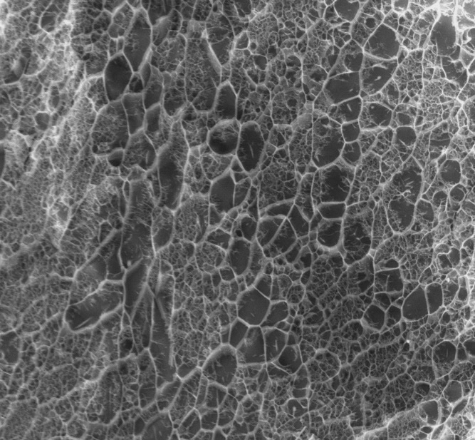
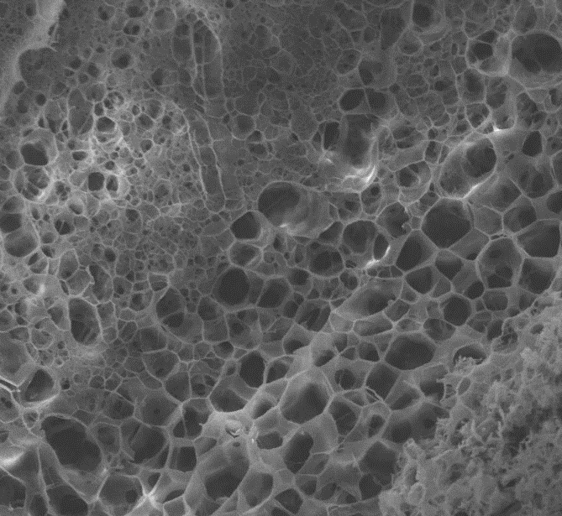
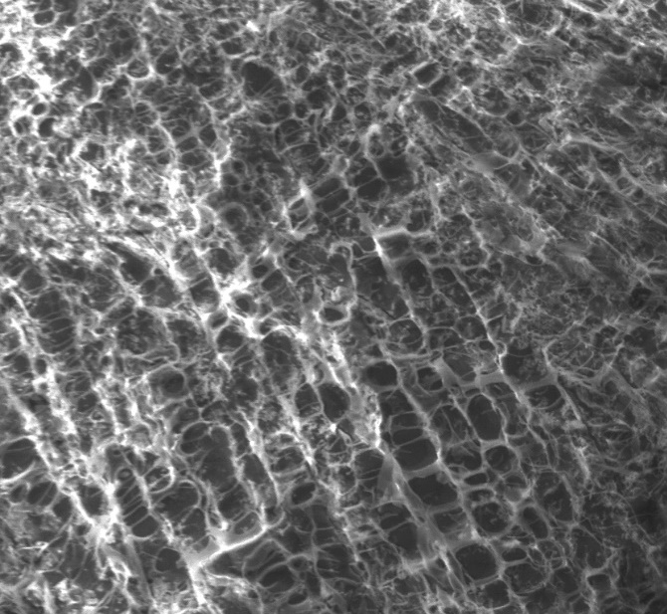
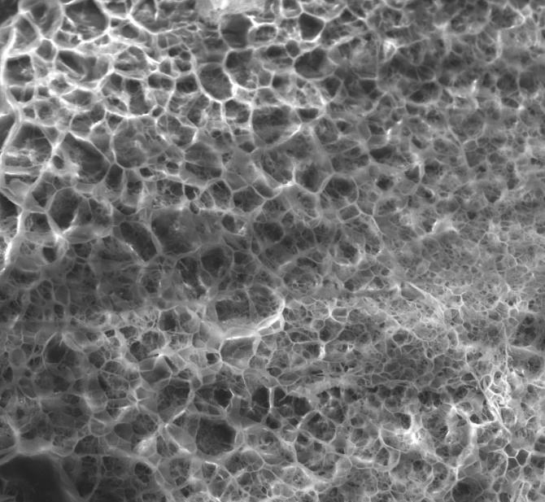
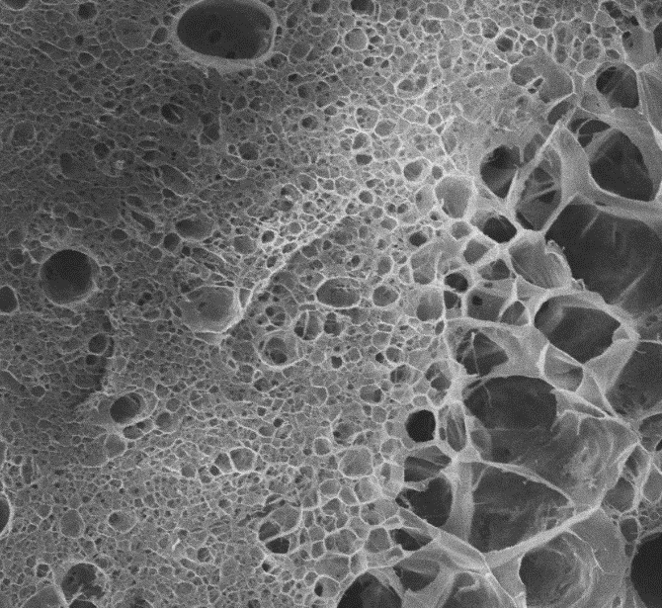
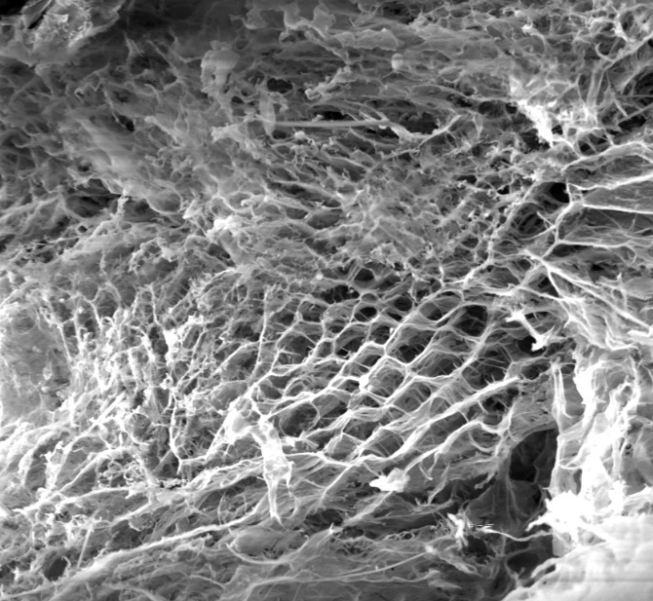
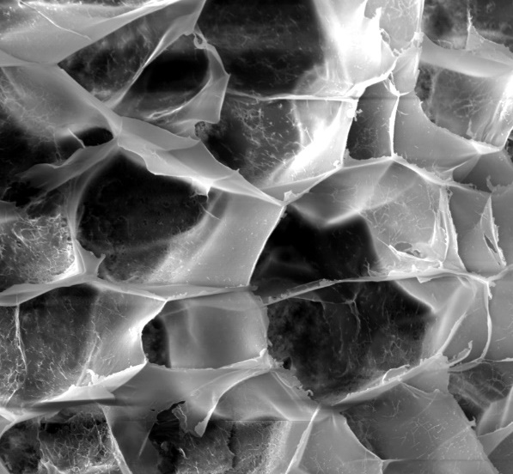
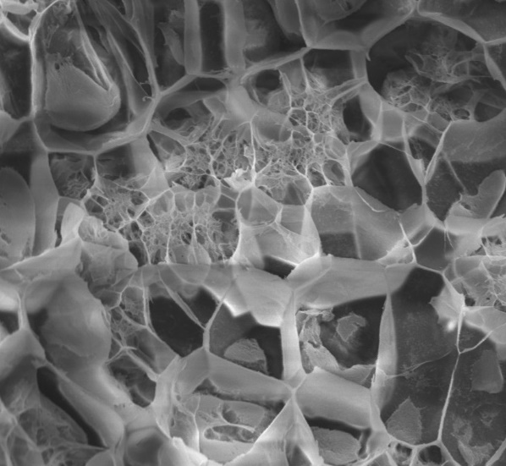
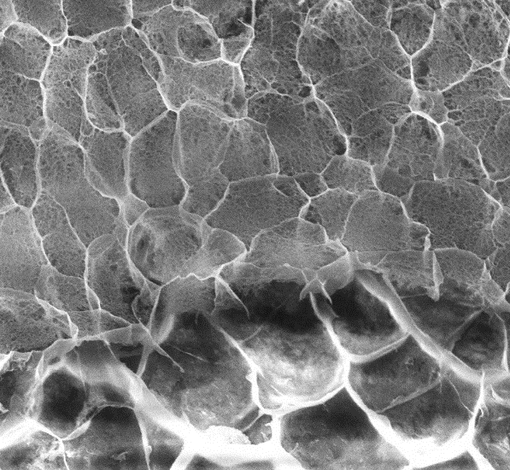
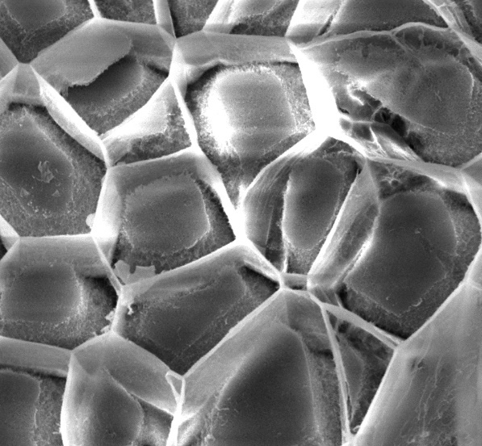
Micro-structures are essential characteristics of the extracellular matrix that promote nutrient and waste transfer from embedded cells ⁷⁰. To investigate the micro-structure of the developed materials, cryo-SEM was used to image the scaffold (Figure 3). Briefly, materials were snap-frozen by plunging into liquid nitrogen and fractured to expose the fundamental morphology without substantial variation to the underlying network, as previously described ⁴⁰. Fmoc-FRGDF presented a semi-ordered porous morphology that post-exposure to CaCl₂ did not significantly vary (Figure 3e). Similarly, the hybrid materials demonstrated a porous morphology with regions of high network density (Figure 3bi & 3di). Post-exposure to CaCl₂, the morphology did not significantly alter in either hybrid material (Figure 3bii & 3dii). Polysaccharide materials agarose and agarose + alginate demonstrated open porous networks and did not demonstrate a significant change in morphology post-exposure to CaCl₂, indicating CaCl₂ did not have a significant effect on the micro-morphologies of these materials (Figure 3a & 3c).
Ai
Bi
Ci
Di
Aii
Bii
Cii
Dii
Ei
Eii
Figure 3: The micromorphology of the materials was not significantly impacted by calcium chloride. However, the blending of Fmoc-FRGDF with Polysaccharides demonstrated altered morphology compared to either the peptide or polysaccharides alone. (A) i) Agarose ii) Agarose CaCl₂ exposed (B) i) Peptide-Ag ii) Peptide-Ag CaCl₂ exposed (C) i) Agarose + Alginate ii) Agarose + Alginate CaCl₂ (D) i) Peptide-Ag-Alginate ii) Peptide-Ag-Alginate CaCl₂ exposed (E) i) Fmoc-FRGDF ii) Fmoc-FRGDF CaCl₂ exposed. Scale bars represent 50 microns
.
  - 3.3 Modular hydrogel stiffness modification
Cells experience the mechanical properties of their surrounding microenvironment through mechanotransduction, and it is well known that the mechanical properties of the cellular environment can have a significant effect on cell behaviour ⁷¹. Therefore, to assess the material properties of the scaffold pre- and post- CaCl₂, oscillatory rheology was performed to determine the relative magnitude of the storage modulus, (which we refer to as stiffness for clarity), as a comparative measure. Hydrogels were subject to a frequency sweep within the linear viscoelastic range and analysed for storage modulus at 1 Hz (6.87 rad s⁻¹) to compare mechanical properties. Two conditions were assessed. The first was post-printing. To simulate the printing process, materials were manually extruded onto the rheometer plate through the printing apparatus at the minimum pressure required to reach extrusion, and this condition was termed “control”. The second condition was post-printing and post-CaCl₂ exposure. Materials were extruded as previously; however, deposited materials were collected into a well plate. Extruded samples were then exposed for 10 minutes to CaCl₂ and briefly rinsed with buffer before being transferred to the rheometer plate. This condition was termed “post-CaCl₂”.

In the pre-crosslinked “control”, the peptide stiffness was 0.13 kPa, which agreed with previously reported data for this peptide which has demonstrated values of 0.01 kPa to 11 kPa ^{27, 36, 38-41, 72} in 5 to 20 mg mL⁻¹ gels. Post-CaCl₂, the peptide stiffness substantially increased by over 2000% to a value of 243 kPa (*, p <0.05) (Figure 4). Although not reported for this peptide before, this effect was expected, as previous reports of other self-assembling peptides have demonstrated increased mechanical stiffness upon exposure to ionic solution ⁴³. It has been proposed that this effect is due to charge screening effects on the amino acid residues resulting in nanofibre assembly ⁴³. Here, it is likely that a similar charge screening effect occurred, possibly causing bundling of the nanofibres. As seen in TEM images earlier (Figure 2), CaCl₂ exposed peptide demonstrated increases in distribution of fibre width suggesting bundle formation.

B
A

Figure 4: SAP hydrogel stiffness is significantly modified by the addition of polysaccharides and exposure to CaCl₂. (A) Each material experienced a significant increase in storage modulus on exposure to CaCl₂. (B) The final storage modulus (post-CaCl2) of the materials varied between peptide, polysaccharide, and hybrids however only the peptide demonstrated a statistically significant increase. Error bars represent the SD.
In the polysaccharide samples, a significant increase in stiffness, post-CaCl₂ exposure was observed (Figure 4). Agarose stiffness increased from 2.9 kPa to 5.4 kPa (**, p<0.01) and agarose-alginate stiffness increased from 2.6 kPa to 3.4 kPa (**, p<0.01). In the hybrid samples, the peptide-agarose, and peptide-agarose-alginate hydrogels both significantly increased in stiffness post-CaCl₂ from 11.7 kPa to 31.5 kPa (***, p<0.001) and 8.1 kPa to 34.7 kPa (**, p<0.01), respectively (Figure 4). These significant increases were likely due to the peptide within the hybrid undergoing changes in conformation, demonstrating the dynamic nature of these materials. This was supported by the TEM images demonstrating nano-scale conformational changes in fibre bundling toward increased fibre bundle widths (Figure 2).
In both cases, there was no statistically significant difference in final CaCl₂ crosslinked modulus between agarose and agarose-alginate polysaccharide conditions, or, between the hybrid’s stiffness’ post-CaCl₂ treatment.
The rheological properties (as measured by oscillatory rheology) of decellularized extracellular matrices have been reported for brain⁷³, lung⁷⁴, bladder⁷⁵, heart⁷⁶, dermis⁷⁷, skeletal muscle⁷⁸ and cartilage⁷⁹ and range from approximately 1 Pa to 3 kPa (cartilage). The hydrogels described in the current study range in stiffness from 0.13 kPa to 243 kPa (peptide gels) and 8.1kPa to 34.7 kPa (hybrid hydrogels) demonstrating a wide range of stiffnesses that would be suitable for a number of softer and stiffer tissues.

These findings correlate with previous reports of peptide stiffness increase when combined with polysaccharides ⁴⁰. However, the data reported for peptide-agarose in the pre-crosslinked control varied from previously reported data which estimated the stiffness of Fmoc-FRGDF with 2 % w/v agarose at 1.2 kPa ⁴⁰. In this study, the discrepancy was likely due to the increased PBS concentration used. Peptide systems have been shown to increase in stiffness with increased PBS concentration ³⁹. However, as the method of loading used here included pre-shearing of the hydrogel (through the printing apparatus), it was possible that the printing process influences stiffness. This has been previously reported for Fmoc-peptides, where compression or extrusion of the peptide results in non-reversible increase in stiffness ^{62, 80}. However, this has not been previously demonstrated in hybrid SAPs. As printing may introduce variance into the mechanical properties of peptide materials prepared for printing, it is recommended that future studies report mechanical stiffness pre- and post-printing.

  - 3.4 Peptide-hybrids demonstrate successful printing outcomes
The printing conditions were optimised by varying extrusion speed, height and considering the lag time (Supplementary Table 1). To assess printability, a previously reported method was used ⁵⁵. Briefly, a two-layer grid was printed, and a measure of printability, P(r), was assessed by measuring the circularity of resultant prints in the following equation.
$$\frac{2π}{C}=Pr$$
Equation 1: Assessment of printability (Pr), Where Pr is a measure of printability, and C is circularity.
A Pr of 1 is ideal, Pr values over 1 indicate overgelation and under 1 indicate undergelation. In comparison to the poor shape fidelity of the peptide-alone samples, hybrid bioinks demonstrated excellent printability with Pr values of 1.2 (peptide-agarose) and 0.98 (peptide-agarose-alginate), indicating that peptide-agarose was slightly overgelated (Figure 5). These values were similar to the polysaccharide-alone bioinks that demonstrated Pr values of 0.99 (agarose) and 0.94 agarose-alginate. This data indicated that the printability outcome of the hybrid bioinks was substantially reliant on the polysaccharide network. As the peptide material demonstrates significant shear-thinning behaviour, this result was expected as the shape fidelity post-printing was reliant on the less-affected polysaccharide network.
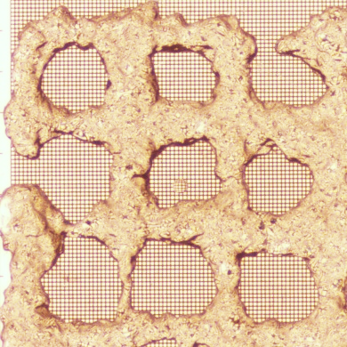
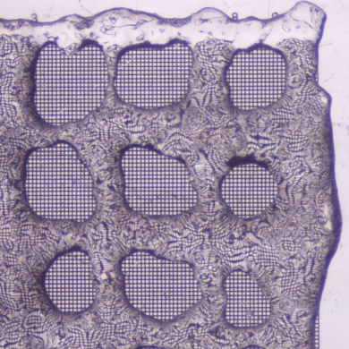
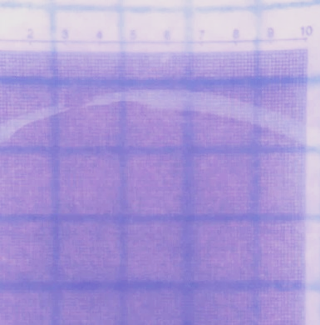
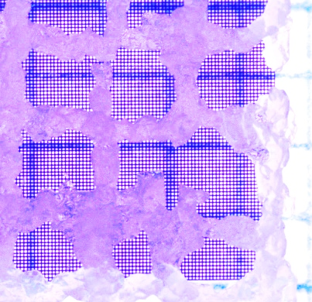
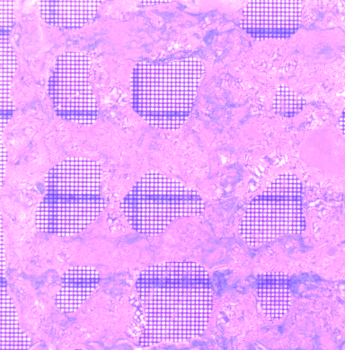
Figure 5: Extrusion Printing of Biomaterials (A) Peptide-alone (B) Agarose-Peptide (C) Agarose-Alginate Peptide (D) Agarose-alone (E) Agarose-Alginate (F) Printability measure

A
B
D
E
C
F

  - 3.5 Investigating predictors of successful peptide hybrid bioprinting
Bioprinting relies on bioink material properties that can result in high shape fidelity and cellular viability. These properties have been significantly tied to rheological properties such as viscosity ⁵⁷⁻⁶⁰, shear-thinning ^{58, 59, 62} and loss tangent ^{57, 58, 61}. However, these properties have not been substantially reported in the SAP bioink literature, and it remains unclear if these traditional bioink predictors are applicable to peptide and peptide-hybrid bioinks.

3.5.1 Viscosity
Viscosity has been identified as an important determiner of shape fidelity (the maintenance of the deposited shape post-printing). Collection of rheological data of samples subject to a shear sweep demonstrated a change in viscosity with increasing shear force. Shear-thinning occurs as bioink viscosity reduces with increasing shear force. During the extrusion process, materials are subject to a range of shear forces determined by printing pressure and printing setup. Here, a shear rate of 300 s⁻¹ was used to simulate the shear experienced during printing. Shear-thinning behaviours of bioinks are important to reduce the shear-stresses experienced by encapsulated cells and improve cellular viability post-printing.
All materials demonstrated a shear-thinning response as indicated by a drop in viscosity with application of shear (Figure 6a). At 300 s⁻¹, Fmoc-FRGDF’s viscosity dropped to 0.01 Pa.s from an initial value of 12.5 Pa.s. This was the lowest viscosity range reported out of the materials tested.
Polysaccharide materials demonstrated an increased initial viscosity compared to the Fmoc-FRGDF material. Agarose started at a viscosity of 725 Pa.s and dropped to 0.5 Pa.s at 300 s⁻¹. Similarly, agarose-alginate started at 530 Pa.s and dropped to 0.7 Pa.s at 300 s⁻¹. The hybrid materials demonstrated an increased overall viscosity compared to the polysaccharides and peptide material, demonstrating a combination effect on viscosity. Peptide-agarose started at a viscosity of 2630 Pa.s and dropped to 1.1 Pa.s upon applied shear force at 300 s⁻¹. Similarly, peptide-agarose-alginate started at a viscosity of 1160 Pa.s and dropped to 1 Pa.s at 300 s⁻¹.
This data indicated a substantial increase in initial viscosity in the hybrid systems, compared to either the peptide or polysaccharides alone. The hybrids demonstrated similar viscosities to the polysaccharides alone after shear, indicating that although the initial viscosity of the hybrids is higher than the polysaccharides, the shear-thinning response of the incorporated peptide results in comparable final viscosities.
All materials exhibited shear-thinning behaviours indicating these materials were suitable for cellular encapsulation and bioprinting. Although shear thinning is an important characteristic for protecting encapsulated cells, of equal importance is the ability for shear-thinned materials to regain their gelated form after the cessation of shear. This behaviour, shear-recovery, is important so that the deposited material retains its shape post-printing. Shear-recovery behaviours of the materials were investigated by exposing the material to high-shear, followed by a period of low-shear (Figure 6b).

3.5.2 Shear-Recovery
Fmoc-FRGDF exhibited good shear-recovery and the ability to recover some viscosity within a minute (58 % of original viscosity). Over the course of a three-step shear-recovery, the percentage recovery reduced further from 58 % to 55 %. However, at the third cessation of shear, the material was able to regain 79 % of the original viscosity, with little to no variation across tests indicating that the peptide material may undergo a reproducible change in mechanical properties after the shear step method used here. This finding has implications for the use of peptide materials as cell laden bioinks. Future studies may consider pre-shearing peptide bioinks to improve any fluctuations in printing as it is evident that several rounds of high shear impact the peptide’s viscosity. Although the peptide demonstrated adequate shear-recovery within these conditions (Figure 6b), the lack of successful printing outcomes (Figure 5a) indicated that shear-recovery was not a good predictor of printability via extrusion printing.

In comparison to the peptide materials, polysaccharide materials exhibited incomplete shear-recovery. After exposure to high shear, agarose was unable to regain substantial viscosity within a minute (25 % of original). Over the course of the three-step shear-recovery, the recovery reduced further to 19 % and finally 18 % of the original. The agarose-alginate blend demonstrated improved shear-recovery, with only an initial drop to 53 %, further 43 %, and finally 44 %.

Hybrid polysaccharide-peptide materials followed a similar shear-recovery pattern to agarose. Over the three-step shear recovery, peptide-agarose material dropped to 23 % original viscosity, followed by 14 % and finally 13 %. Peptide-agarose-alginate blends demonstrated improved performance in the first two steps (first recovery 38 %, second recovery 24 %); however, by the third shear step, the recovery was only able to reach 19 % (Figure 6b). These results indicated that the alginate containing materials demonstrated improved performance in the shear-step recovery test.

Shear-recovery is an important property for printability. Our results indicate that peptide-alone materials exhibit suitable shear-recovery properties. However, as the shape fidelity of the peptide material post-extrusion was not maintained, this indicates that the shear-recovery test is not suitable as a test for printability of peptide materials. The shear-recovery of the peptide-polysaccharide and polysaccharide alone materials was lower than expected (as materials exhibited printability), with an average final recovery of only 33 %. This may indicate that shear recovery is less critical than viscosity. As the printability outcomes of the hybrids and polysaccharides alone did not greatly differ, it was deemed that there was not sufficient data to tie shear-recovery to outcomes of printing. Future studies could investigate the printability and shear-recovery of a range of peptide and polysaccharide concentrations to fully elucidate whether a relationship exists.

Figure 6: Rheological assessments (A) Shear-thinning behaviours (B) Shear-step recovery behaviour (C) Tan δ (D) Frequency Sweep indicates gelation of materials as seen by G’ storage modulus (solid line) being larger than G” loss modulus (dashed line).

A
B
C
D

3.5.3 Loss Tangent
Another measure has been tied to printability, namely loss tangent, which defines the relationship between storage and loss moduli. This property is termed loss tangent or tan δ. Previous reports have indicated a tan δ value of 0.25-0.45 is a predictor of printability outcomes in hybrid gelatin-alginate bioinks ⁵⁶. To investigate the suitability of this measure to peptide and peptide hybrid materials, an investigation of tan δ was undertaken.

Peptide-alone material exhibited a tan δ of ~0.35, as the peptide material concentration was on the lower gelation threshold, this value was highly variable (Figure 6c). As the peptide alone was unable to retain shape fidelity post-printing, this result indicated that tan δ was not a suitable predictor of printability in this case. Comparatively, the hybrid and polysaccharide materials demonstrated stable tan δ values. Peptide-agarose and peptide-agarose-alginate materials demonstrated a tan δ of 0.18 and 0.2, respectively, placing these materials slightly below the tan δ range previously reported. Agarose and agarose-alginate materials exhibited a tan δ of 0.1, placing the polysaccharide materials substantially below the reported range. Regardless of this, both hybrid and polysaccharide materials exhibited printability, indicating a range of 0.2 to 0.1 tan δ may be a suitable predictor for hybrid peptide-macromolecule bioinks.

  - 3.6 Peptide and hybrids demonstrate sustained cell viability and attachment
Next, to demonstrate the cellular compatibility of the developed materials, particularly the effects of peptide addition to the materials, human dermal fibroblasts were seeded on top of cast hydrogels at a density of 10,000 per well (25,000 per mL). 100 µL of each material was cast into each well of a 48 well plate and both pre- and post-CaCl₂ conditions were assessed. After casting and CaCl₂ exposure, gel-laden cell culture plates were exposed to UV for 1 hour to ensure sterility before cells were seeded. Cast gels were stored for 1-3 days at 4 °C before seeding. Triplicate studies were undertaken with three technical repeats per condition (n=3).

After 24 hours of culture, cell viability was high at 99 % in both pre- and post-crosslinked peptide and peptide-hybrid materials (Figures 7 & 8). However, in agarose-alginate and agarose materials, cells did not remain evenly distributed and formed cell “clumps” suggesting a lack of interaction with the hydrogel surfaces. This was the case in both agarose-alginate and agarose hydrogels both before (Figure 7a & b) and after (Figure 8a & b) CaCl₂ crosslinking at both 24 hours and 72 hrs (Figures 7d & e and 8d & e, respectively). In contrast the Fmoc-FRDGF peptide gels supported a consistent distribution of cells through the hydrogel with little evidence of clumping at 24 and 72hrs culture in both pre-crosslinked (Figure 7c & f) and CaCl₂ crosslinked (Figure 8c & 8f) hydrogels. In these gels, fibroblasts demonstrated both rounded morphology and a “spread” morphology suggesting interaction with the Fmoc-FRGDF nanofibrils (Figures 7c, 7f & 8c, 8f). In addition, in the Fmoc-FRGDF hydrogels, cells demonstrated infiltration into the gels, either by migration or through gravitational force, at both 24 and 72 hours in both pre-crosslinked (Figures 7c & 7f) and crosslinked hydrogels (Figures 8c & 8f). In comparison, the peptide-hybrid materials, which exhibit a denser scaffold, supported fibroblast growth on top of the gel, with little cellular infiltration seen.
Analysis of cell viability suggested high viability in all gels tested, both pre and post CaCl₂ crosslinking, however cell clumping was observed in agarose and agarose-alginate hydrogels suggesting lack of cell adhesion molecules. This was improved by the addition of Fmoc-FRGDF to create a blended hydrogel system that improved cellular distribution (demonstrated at 24 and 72 hours) and facilitated cell spreading, suggesting interaction of the cells with the FRGDF motif present in the hybrid gels.

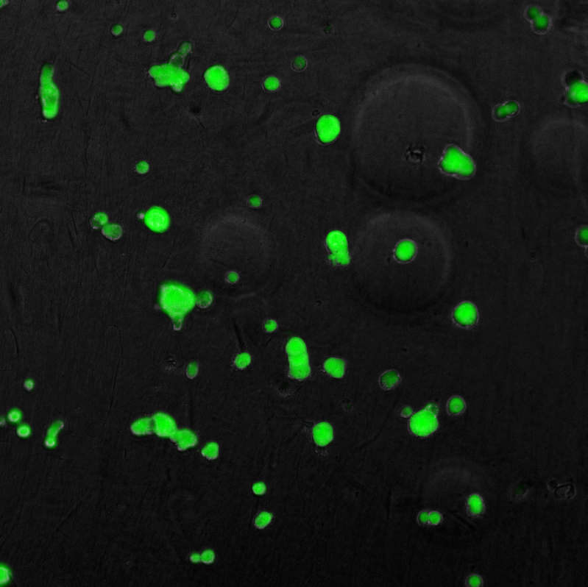
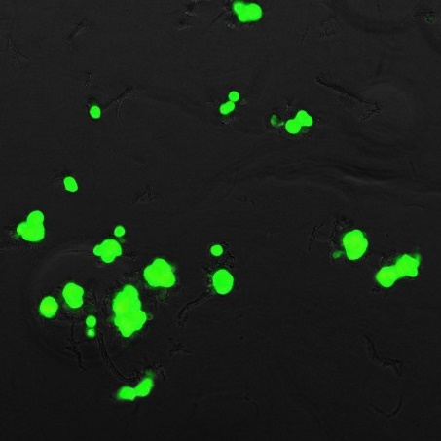
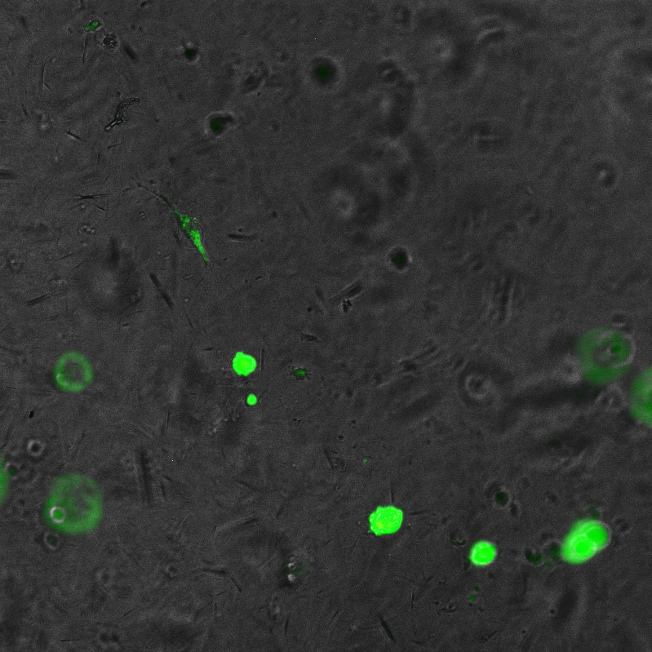
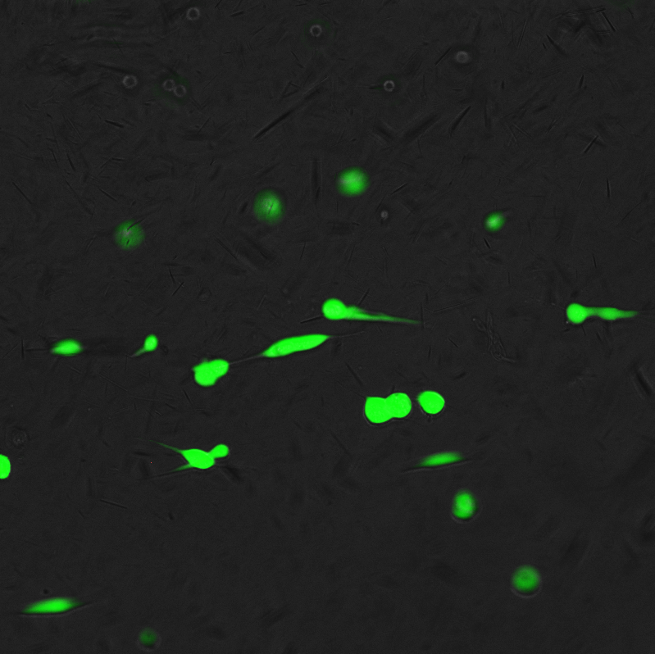
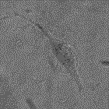
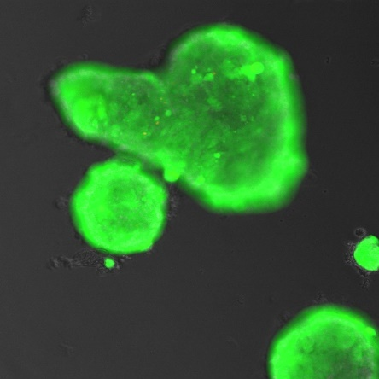
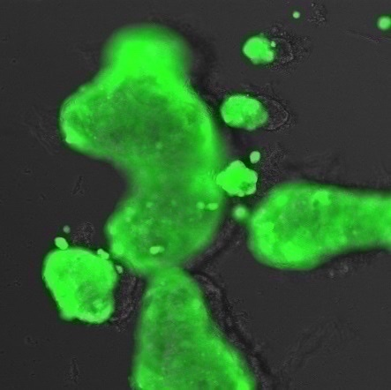
24 hours
72 hours
g
h
i
j
Fmoc-FRGDF-Agarose
Fmoc-FRGDF- Ag-Alginate
24 hours
72 hours
c
Fmoc-FRGDF
b
a
d
e
f
Agarose
Ag-Alginate

Figure 7: Live dead staining indicated human dermal fibroblasts demonstrate high viability in all materials at 24 hr. In agarose (a) and agarose-alginate (Ag-Agarose) blends (b) cell viability was high however cells were clumped and did not remain evenly distributed through the gel. In contrast Fmoc-FRGDF (c) supported high cell viability and an even distribution of cells throughout the hydrogel. This was observed at both 24 (a-c) and 72 hours (d-f). Cell distribution was enhanced in fmoc-FRGDF-Agarose and Fmoc-FRGDF-Ag-Alginate blended hydrogels at 24 hrs (g, h) and 72 hrs (i,j), compared to Agarose and Ag-Alginate only gels (a-f). Scale bars = 200 µm.
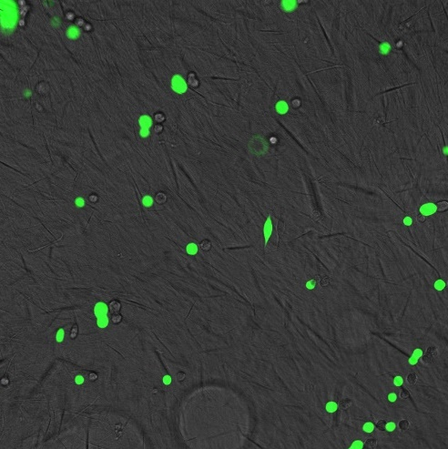
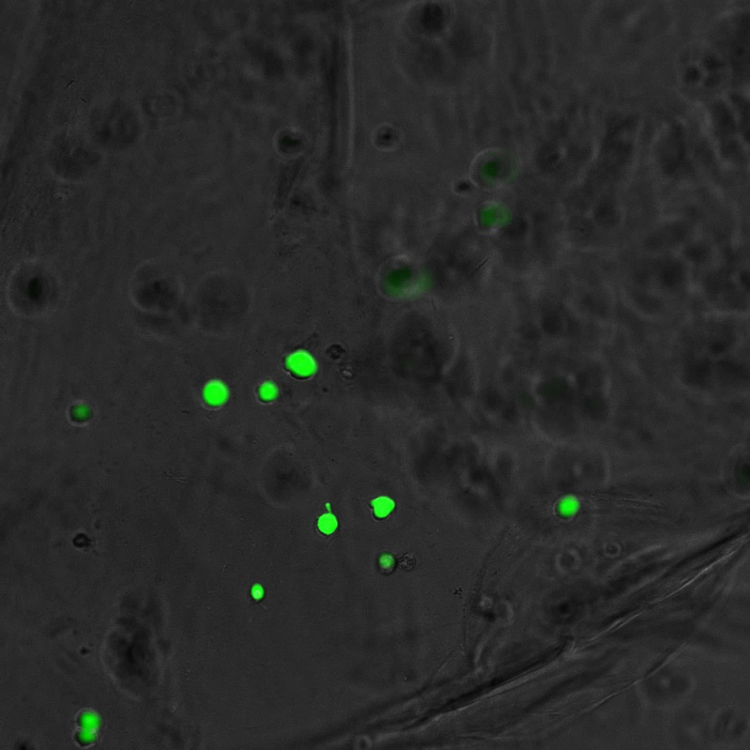
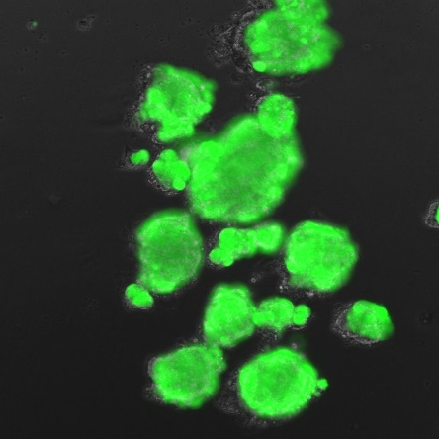
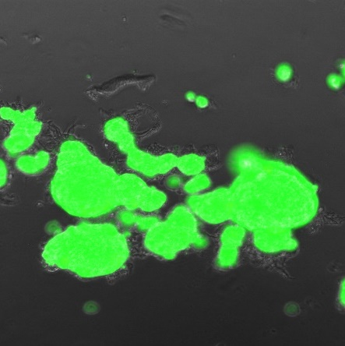
Figure 8: Live dead staining indicated human dermal fibroblasts demonstrate high viability in all CaCl₂ crosslinked hydrogel materials at 24 hrs. In agarose (a) and agarose-alginate (Ag-Agarose) blends (b) cell viability was high however cells were clumped and did not remain evenly distributed through the gel. In contrast Fmoc-FRGDF (c) supported high cell viability and an even distribution of cells throughout the hydrogel. This was observed at both 24 (a-c) and 72 hours (d-f). Cell distribution was enhanced in fmoc-FRGDF-Agarose and Fmoc-FRGDF-Ag-Alginate blended hydrogels at 24 hrs (g, h) and 72 hrs (i,j), compared to Agarose and Ag-Alginate only gels (a-f). Scale bars = 200 µm.
g
h
i
j
24 hours
72 hours
Fmoc-FRGDF-Agarose CaCl₂
Fmoc-FRGDF-Ag-Alginate CaCl₂
Fmoc-FRGDF CaCl₂
b
a
d
e
24 hours
72 hours
Agarose CaCl₂
Ag-Alginate CaCl₂
c
f
In the polysaccharide alone conditions, it was evident that there was no/very little cell-material interaction with all cells rounded in a spheroid-like morphology (Figure 7 & 8).
Cells exhibited an increased incidence of spreading in the peptide-alone materials. In the hybrid materials, the inclusion of bioactive peptide Fmoc-FRGDF was likely the cause of improved cell attachment due to the inclusion of RGD motifs. RGD motifs in self-assembling peptide materials have previously been shown to facilitate cell attachment, compared to an RGE motif presented on similar nanofibres ⁸¹. As seen in the TEM images, in the hybrid materials, the polysaccharides colocalise with the bundles of peptide fibres, and therefore, the reduced cell spreading may be due to the polysaccharide reducing cellular access to the attachment motifs on the bioactive fibres and preventing cellular migration through the reinforced material. Human dermal fibroblast growth on these peptide and peptide hybrid materials and the high cell viability indicates that the peptide and hybrid materials may demonstrate excellent bioprinting outcomes which, with future optimisation, can be developed into an application specific material.

4. Conclusions
In the bioprinting field, synthetic yet bioinspired materials offer significant benefits over natural material classes that either require significant modification to biofabricate, or conversely synthetic materials that require significant functionalisation to provide a tissue specific response. In this work, several self-assembling peptide hybrid materials were characterised and evaluated for use in bioprinting and as biomaterials. We demonstrated that the hybrid materials retain the desirable bioactive properties of nanofiber formation to yield a shear-thinning hydrogel that can provide a suitable microenvironment to support cells during the mechanically challenging conditions of biofabrication. We also investigated several bioprinting rheological assessments of viscosity, shear-thinning, shear-recovery and tan δ and demonstrated that viscosity was a suitable predictor for printability using the materials in this study.
Exposure to CaCl₂ post fabrication was confirmed as an effective strategy to enhance mechanical properties post-printing, resulting in substantial increases in stiffness in both the peptide-only and hybrid hydrogels. Assessment of the final material properties indicated that minimal change occurs in the micro-morphology of the materials when exposed to the CaCl₂, indicating the mechanical changes are likely due to the reinforcement of the underlying peptide fibrillar network.
Finally, the cellular assessment of the materials indicated that the peptide-containing materials were a good environment for cell survival, demonstrating high viability. Importantly, the addition of the peptide to the agarose/alginate composite hydrogels was observed to both improve cellular distribution throughout the material and prevented cellular “clumping”; a state where attachment-based cells resort to through lack of suitable cell-material interactions. Together, these results indicate that by careful engineering of complementary properties of materials, peptide materials can lend their tailored biological properties to polysaccharide hydrogels, conferring their biodesigned cell interactive properties to the hybrid gel systems. The use of synthetic supramolecularly defined peptide/polysaccharide bioinks may provide new avenues for clinical translation of bioinks obliviating concerns of natural animal-derived materials and enabling a tissue specific toolkit.

Declaration of competing interest
The authors declare that they have no known competing financial interests or personal relationships that could have appeared to influence the work reported in this article.
Acknowledgment
The authors acknowledge the facilities, and the scientific and technical assistance of the RMIT Microscopy & Microanalysis Facility (RMMF), a linked laboratory of Microscopy Australia.
Funding: D.R.N was supported by a NHMRC Research Leadership Fellowship GNT1135657. K.F. was supported by an Australian Government Research Training Program Scholarship via the Industry Doctoral Training Centre. E.F. was supported by an Australian Government Research Training Program Scholarship and an RMIT Engineering Scholarship.
Appendix A. Supplementary data
The following are the supplementary data to this article:
Supplementary Figure 1. TEM of polysaccharides
Supplementary Figure 2. Filament formation of Fmoc-FRGDF
Supplementary Figure 3. Fibroblast spreading on tissue culture plastic
Supplementary Video 1. Filament formation of Fmoc-FRGDF
Supplementary Table 1. Printing Parameters

References
1. O'Brien, F. J., Biomaterials & scaffolds for tissue engineering. Mater Today 2011, 14 (3), 88-95.
2. Melchels, F. P. W.; Domingos, M. A. N.; Klein, T. J.; Malda, J.; Bartolo, P. J.; Hutmacher, D. W., Additive manufacturing of tissues and organs. Prog Polym Sci 2012, 37 (8), 1079-1104.
3. Wang, T.; Forsythe, J.; Parish, C.; Nisbet, D., Biofunctionalisation of polymeric scaffolds for neural tissue engineering. Journal of Biomaterials Applications 2012, 27 (4), 369-390.
4. Wen, J. H.; Vincent, L. G.; Fuhrmann, A.; Choi, Y. S.; Hribar, K. C.; Taylor-Weiner, H.; Chen, S.; Engler, A. J., Interplay of matrix stiffness and protein tethering in stem cell differentiation. Nat Mater 2014, 13 (10), 979-87.
5. d’Angelo, M.; Benedetti, E.; Tupone, M. G.; Catanesi, M.; Castelli, V.; Antonosante, A.; Cimini, A., The Role of Stiffness in Cell Reprogramming: A Potential Role for Biomaterials in Inducing Tissue Regeneration. Cells 2019, 8 (9), 1036.
6. Long, K. R.; Huttner, W. B., How the extracellular matrix shapes neural development. Open Biology 2019, 9 (1), 180216.
7. Noriega, S. E.; Hasanova, G. I.; Schneider, M. J.; Larsen, G. F.; Subramanian, A., Effect of Fiber Diameter on the Spreading, Proliferation and Differentiation of Chondrocytes on Electrospun Chitosan Matrices. Cells Tissues Organs 2012, 195 (3), 207-221.
8. Wang, X.; Lou, T.; Zhao, W.; Song, G.; Li, C.; Cui, G., The effect of fiber size and pore size on cell proliferation and infiltration in PLLA scaffolds on bone tissue engineering. Journal of Biomaterials Applications 2016, 30 (10), 1545-1551.
9. Narayanan, N.; Jiang, C.; Wang, C.; Uzunalli, G.; Whittern, N.; Chen, D.; Jones, O. G.; Kuang, S.; Deng, M., Harnessing Fiber Diameter-Dependent Effects of Myoblasts Toward Biomimetic Scaffold-Based Skeletal Muscle Regeneration. Frontiers in Bioengineering and Biotechnology 2020, 8 (203), 203.
10. Cun, X.; Hosta-Rigau, L., Topography: A Biophysical Approach to Direct the Fate of Mesenchymal Stem Cells in Tissue Engineering Applications. Nanomaterials 2020, 10 (10), 2070.
11. Hollister, S. J., Porous scaffold design for tissue engineering. Nat Mater 2005, 4 (7), 518-24.
12. Khan, F.; Tanaka, M.; Ahmad, S. R., Fabrication of polymeric biomaterials: a strategy for tissue engineering and medical devices. J Mater Chem B 2015, 3 (42), 8224-8249.
13. Ruprecht, V.; Monzo, P.; Ravasio, A.; Yue, Z.; Makhija, E.; Strale, P. O.; Gauthier, N.; Shivashankar, G. V.; Studer, V.; Albiges-Rizo, C.; Viasnoff, V., How cells respond to environmental cues - insights from bio-functionalized substrates. J Cell Sci 2017, 130 (1), 51-61.
14. Malda, J.; Visser, J.; Melchels, F. P.; Jungst, T.; Hennink, W. E.; Dhert, W. J.; Groll, J.; Hutmacher, D. W., 25th anniversary article: Engineering hydrogels for biofabrication. Adv Mater 2013, 25 (36), 5011-28.
15. Nguyen, A. K.; Goering, P. L.; Reipa, V.; Narayan, R. J., Toxicity and photosensitizing assessment of gelatin methacryloyl-based hydrogels photoinitiated with lithium phenyl-2,4,6-trimethylbenzoylphosphinate in human primary renal proximal tubule epithelial cells. Biointerphases 2019, 14 (2), 021007.
16. Chimene, D.; Lennox, K. K.; Kaunas, R. R.; Gaharwar, A. K., Advanced Bioinks for 3D Printing: A Materials Science Perspective. Ann Biomed Eng 2016, 44 (6), 2090-102.
17. Unagolla, J. M.; Jayasuriya, A. C., Hydrogel-based 3D bioprinting: A comprehensive review on cell-laden hydrogels, bioink formulations, and future perspectives. Applied Materials Today 2020, 18, 100479.
18. Jia, J.; Richards, D. J.; Pollard, S.; Tan, Y.; Rodriguez, J.; Visconti, R. P.; Trusk, T. C.; Yost, M. J.; Yao, H.; Markwald, R. R.; Mei, Y., Engineering alginate as bioink for bioprinting. Acta Biomaterialia 2014, 10 (10), 4323-4331.
19. López-Marcial, G. R.; Zeng, A. Y.; Osuna, C.; Dennis, J.; García, J. M.; O’Connell, G. D., Agarose-Based Hydrogels as Suitable Bioprinting Materials for Tissue Engineering. ACS Biomaterials Science & Engineering 2018, 4 (10), 3610-3616.
20. Zarrintaj, P.; Manouchehri, S.; Ahmadi, Z.; Saeb, M. R.; Urbanska, A. M.; Kaplan, D. L.; Mozafari, M., Agarose-based biomaterials for tissue engineering. Carbohydr Polym 2018, 187, 66-84.
21. Cambria, E.; Brunner, S.; Heusser, S.; Fisch, P.; Hitzl, W.; Ferguson, S. J.; Wuertz-Kozak, K., Cell-Laden Agarose-Collagen Composite Hydrogels for Mechanotransduction Studies. Front Bioeng Biotechnol 2020, 8 (346), 346.
22. Andersen, T.; Auk-Emblem, P.; Dornish, M., 3D Cell Culture in Alginate Hydrogels. Microarrays (Basel) 2015, 4 (2), 133-61.
23. Tao, K.; Levin, A.; Adler-Abramovich, L.; Gazit, E., Fmoc-modified amino acids and short peptides: simple bio-inspired building blocks for the fabrication of functional materials. Chem Soc Rev 2016, 45 (14), 3935-53.
24. Mehrban, N.; Pineda Molina, C.; Quijano, L. M.; Bowen, J.; Johnson, S. A.; Bartolacci, J.; Chang, J. T.; Scott, D. A.; Woolfson, D. N.; Birchall, M. A.; Badylak, S. F., Host macrophage response to injectable hydrogels derived from ECM and alpha-helical peptides. Acta Biomater 2020, 111, 141-152.
25. Fleming, S.; Ulijn, R. V., Design of nanostructures based on aromatic peptide amphiphiles. Chem. Soc. Rev. 2014, 43 (23), 8150-8177.
26. Varanko, A. K.; Su, J. C.; Chilkoti, A., Elastin-Like Polypeptides for Biomedical Applications. In Annual Review of Biomedical Engineering, 2020; Vol. 22, pp 343-369.
27. Horgan, C. C.; Rodriguez, A. L.; Li, R.; Bruggeman, K. F.; Stupka, N.; Raynes, J. K.; Day, L.; White, J. W.; Williams, R. J.; Nisbet, D. R., Characterisation of minimalist co-assembled fluorenylmethyloxycarbonyl self-assembling peptide systems for presentation of multiple bioactive peptides. Acta biomaterialia 2016, 38, 11-22.
28. Somaa, F. A.; Wang, T. Y.; Niclis, J. C.; Bruggeman, K. F.; Kauhausen, J. A.; Guo, H.; McDougall, S.; Williams, R. J.; Nisbet, D. R.; Thompson, L. H.; Parish, C. L., Peptide-Based Scaffolds Support Human Cortical Progenitor Graft Integration to Reduce Atrophy and Promote Functional Repair in a Model of Stroke. Cell Rep 2017, 20 (8), 1964-1977.
29. Franks, S. J.; Firipis, K.; Ferreira, R.; Hannan, K. M.; Williams, R. J.; Hannan, R. D.; Nisbet, D. R., Harnessing the self-assembly of peptides for the targeted delivery of anti-cancer agents. Mater Horiz 2020, 7 (8), 1996-2010.
30. Rodriguez, A. L.; Parish, C. L.; Nisbet, D. R.; Williams, R. J., Tuning the amino acid sequence of minimalist peptides to present biological signals via charge neutralised self assembly. Soft Matter 2013, 9 (15), 3915-3919.
31. Modepalli, V. N.; Rodriguez, A. L.; Li, R.; Pavuluri, S.; Nicholas, K. R.; Barrow, C. J.; Nisbet, D. R.; Williams, R. J., In vitro response to functionalized self-assembled peptide scaffolds for three-dimensional cell culture. Biopolymers 2014, 102 (2), 197-205.
32. Maclean, F. L.; Ims, G. M.; Horne, M. K.; Williams, R. J.; Nisbet, D. R., A Programmed Anti-Inflammatory Nanoscaffold (PAIN) as a 3D Tool to Understand the Brain Injury Response. Adv Mater 2018, 30 (50), e1805209.
33. Hunt, C. P. J.; Penna, V.; Gantner, C. W.; Moriarty, N.; Wang, Y.; Franks, S.; Ermine, C. M.; Luzy, I. R.; Pavan, C.; Long, B. M.; Williams, R. J.; Thompson, L. H.; Nisbet, D. R.; Parish, C. L., Tissue Programmed Hydrogels Functionalized with GDNF Improve Human Neural Grafts in Parkinson's Disease. Advanced Functional Materials 2021, n/a (n/a), 2105301.
34. Wang, Y.; He, X.; Bruggeman, K. F.; Gayen, B.; Tricoli, A.; Lee, W. M.; Williams, R. J.; Nisbet, D. R., Peptide Programmed Hydrogels as Safe Sanctuary Microenvironments for Cell Transplantation. Advanced Functional Materials 2019, 30 (9), 1900390.
35. Kapp, T. G.; Rechenmacher, F.; Neubauer, S.; Maltsev, O. V.; Cavalcanti-Adam, E. A.; Zarka, R.; Reuning, U.; Notni, J.; Wester, H. J.; Mas-Moruno, C.; Spatz, J.; Geiger, B.; Kessler, H., A Comprehensive Evaluation of the Activity and Selectivity Profile of Ligands for RGD-binding Integrins. Sci Rep 2017, 7 (1), 39805.
36. Li, R.; McRae, N. L.; McCulloch, D. R.; Boyd-Moss, M.; Barrow, C. J.; Nisbet, D. R.; Stupka, N.; Williams, R. J., Large and Small Assembly: Combining Functional Macromolecules with Small Peptides to Control the Morphology of Skeletal Muscle Progenitor Cells. Biomacromolecules 2018, 19 (3), 825-837.
37. Aye, S. S.; Li, R.; Boyd-Moss, M.; Long, B.; Pavuluri, S.; Bruggeman, K.; Wang, Y.; Barrow, C. R.; Nisbet, D. R.; Williams, R. J., Scaffolds Formed via the Non-Equilibrium Supramolecular Assembly of the Synergistic ECM Peptides RGD and PHSRN Demonstrate Improved Cell Attachment in 3D. Polymers (Basel) 2018, 10 (7), 690.
38. Rodriguez, A. L.; Wang, T. Y.; Bruggeman, K. F.; Horgan, C. C.; Li, R.; Williams, R. J.; Parish, C. L.; Nisbet, D. R., In vivo assessment of grafted cortical neural progenitor cells and host response to functionalized self-assembling peptide hydrogels and the implications for tissue repair. J Mater Chem B 2014, 2 (44), 7771-7778.
39. Li, R.; Horgan, C. C.; Long, B.; Rodriguez, A. L.; Mather, L.; Barrow, C. J.; Nisbet, D. R.; Williams, R. J., Tuning the mechanical and morphological properties of self-assembled peptide hydrogels via control over the gelation mechanism through regulation of ionic strength and the rate of pH change. Rsc Adv 2015, 5 (1), 301-307.
40. Firipis, K.; Boyd-Moss, M.; Long, B.; Dekiwadia, C.; Hoskin, W.; Pirogova, E.; Nisbet, D. R.; Kapsa, R. M. I.; Quigley, A. F.; Williams, R. J., Tuneable Hybrid Hydrogels via Complementary Self-Assembly of a Bioactive Peptide with a Robust Polysaccharide. ACS Biomater Sci Eng 2021, 7 (7), 3340-3350.
41. Li, R.; Boyd-Moss, M.; Long, B.; Martel, A.; Parnell, A.; Dennison, A. J. C.; Barrow, C. J.; Nisbet, D. R.; Williams, R. J., Facile Control over the Supramolecular Ordering of Self-assembled Peptide Scaffolds by Simultaneous Assembly with a Polysacharride. Sci Rep 2017, 7 (1), 4797.
42. Firipis, K.; Nisbet, D. R.; Franks, S. J.; Kapsa, R. M. I.; Pirogova, E.; Williams, R. J.; Quigley, A., Enhancing Peptide Biomaterials for Biofabrication. Polymers 2021, 13 (16), 2590.
43. Zhang, S.; Greenfield, M. A.; Mata, A.; Palmer, L. C.; Bitton, R.; Mantei, J. R.; Aparicio, C.; De La Cruz, M. O.; Stupp, S. I., A self-assembly pathway to aligned monodomain gels. Nature Materials 2010, 9 (7), 594-601.
44. Naghieh, S.; Sarker, M. D.; Abelseth, E.; Chen, X., Indirect 3D bioprinting and characterization of alginate scaffolds for potential nerve tissue engineering applications. Journal of the Mechanical Behavior of Biomedical Materials 2019, 93, 183-193.
45. Quigley, A. F.; Cornock, R.; Mysore, T.; Foroughi, J.; Kita, M.; Razal, J. M.; Crook, J.; Moulton, S. E.; Wallace, G. G.; Kapsa, R. M. I., Wet-Spun Trojan Horse Cell Constructs for Engineering Muscle. Front Chem 2020, 8, 18.
46. Lee, K. Y.; Mooney, D. J., Alginate: properties and biomedical applications. Prog Polym Sci 2012, 37 (1), 106-126.
47. Jia, J.; Richards, D. J.; Pollard, S.; Tan, Y.; Rodriguez, J.; Visconti, R. P.; Trusk, T. C.; Yost, M. J.; Yao, H.; Markwald, R. R.; Mei, Y., Engineering alginate as bioink for bioprinting. Acta Biomater 2014, 10 (10), 4323-31.
48. Chung, J. H. Y.; Naficy, S.; Yue, Z.; Kapsa, R.; Quigley, A.; Moulton, S. E.; Wallace, G. G., Bio-ink properties and printability for extrusion printing living cells. Biomater Sci 2013, 1 (7), 763-773.
49. Aguado, B. A.; Mulyasasmita, W.; Su, J.; Lampe, K. J.; Heilshorn, S. C., Improving viability of stem cells during syringe needle flow through the design of hydrogel cell carriers. Tissue Engineering Part A 2011, 18 (7-8), 806-815.
50. Li, Z.; Huang, S.; Liu, Y.; Yao, B.; Hu, T.; Shi, H.; Xie, J.; Fu, X., Tuning Alginate-Gelatin Bioink Properties by Varying Solvent and Their Impact on Stem Cell Behavior. Scientific Reports 2018, 8 (1), 8020.
51. Chen, Y.; Xiong, X.; Liu, X.; Cui, R.; Wang, C.; Zhao, G.; Zhi, W.; Lu, M.; Duan, K.; Weng, J.; Qu, S.; Ge, J., 3D Bioprinting of shear-thinning hybrid bioinks with excellent bioactivity derived from gellan/alginate and thixotropic magnesium phosphate-based gels. J Mater Chem B 2020, 8 (25), 5500-5514.
52. Li, H.; Tan, Y. J.; Leong, K. F.; Li, L., 3D Bioprinting of Highly Thixotropic Alginate/Methylcellulose Hydrogel with Strong Interface Bonding. ACS Appl Mater Interfaces 2017, 9 (23), 20086-20097.
53. Wilson, S. A.; Cross, L. M.; Peak, C. W.; Gaharwar, A. K., Shear-Thinning and Thermo-Reversible Nanoengineered Inks for 3D Bioprinting. ACS Applied Materials & Interfaces 2017, 9 (50), 43449-43458.
54. Shin, M.; Galarraga, J. H.; Kwon, M. Y.; Lee, H.; Burdick, J. A., Gallol-derived ECM-mimetic adhesive bioinks exhibiting temporal shear-thinning and stabilization behavior. Acta Biomater 2019, 95, 165-175.
55. Ouyang, L.; Yao, R.; Zhao, Y.; Sun, W., Effect of bioink properties on printability and cell viability for 3D bioplotting of embryonic stem cells. Biofabrication 2016, 8 (3), 035020.
56. Gao, T.; Gillispie, G. J.; Copus, J. S.; Pr, A. K.; Seol, Y. J.; Atala, A.; Yoo, J. J.; Lee, S. J., Optimization of gelatin-alginate composite bioink printability using rheological parameters: a systematic approach. Biofabrication 2018, 10 (3), 034106.
57. Rauf, S.; Susapto, H. H.; Kahin, K.; Alshehri, S.; Abdelrahman, S.; Lam, J. H.; Asad, S.; Jadhav, S.; Sundaramurthi, D.; Gao, X.; Hauser, C. A. E., Self-assembling tetrameric peptides allow in situ 3D bioprinting under physiological conditions. Journal of Materials Chemistry B 2021, 9 (4), 1069-1081.
58. Susapto, H. H.; Alhattab, D.; Abdelrahman, S.; Khan, Z.; Alshehri, S.; Kahin, K.; Ge, R.; Moretti, M.; Emwas, A.-H.; Hauser, C. A. E., Ultrashort Peptide Bioinks Support Automated Printing of Large-Scale Constructs Assuring Long-Term Survival of Printed Tissue Constructs. Nano Letters 2021, 21 (7), 2719-2729.
59. Sather, N. A.; Sai, H.; Sasselli, I. R.; Sato, K.; Ji, W.; Synatschke, C. V.; Zambrotta, R. T.; Edelbrock, J. F.; Kohlmeyer, R. R.; Hardin, J. O.; Berrigan, J. D.; Durstock, M. F.; Mirau, P.; Stupp, S. I., 3D Printing of Supramolecular Polymer Hydrogels with Hierarchical Structure. Small 2021, 17 (5), 2005743.
60. Arab, W.; Kahin, K.; Khan, Z.; Hauser, C. A. E., Exploring nanofibrous self-assembling peptide hydrogels using mouse myoblast cells for three-dimensional bioprinting and tissue engineering applications. Int J Bioprint 2019, 5 (2), 198.
61. Raphael, B.; Khalil, T.; Workman, V. L.; Smith, A.; Brown, C. P.; Streuli, C.; Saiani, A.; Domingos, M., 3D cell bioprinting of self-assembling peptide-based hydrogels. Mater Lett 2017, 190, 103-106.
62. Nolan, M. C.; Fuentes Caparrós, A. M.; Dietrich, B.; Barrow, M.; Cross, E. R.; Bleuel, M.; King, S. M.; Adams, D. J., Optimising low molecular weight hydrogels for automated 3D printing. Soft Matter 2017, 13 (45), 8426-8432.
63. Jian, H.; Wang, M.; Dong, Q.; Li, J.; Wang, A.; Li, X.; Ren, P.; Bai, S., Dipeptide Self-Assembled Hydrogels with Tunable Mechanical Properties and Degradability for 3D Bioprinting. ACS Applied Materials & Interfaces 2019, 11 (50), 46419-46426.
64. Horgan, C. C.; Rodriguez, A. L.; Li, R.; Bruggeman, K. F.; Stupka, N.; Raynes, J. K.; Day, L.; White, J. W.; Williams, R. J.; Nisbet, D. R., Characterisation of minimalist co-assembled fluorenylmethyloxycarbonyl self-assembling peptide systems for presentation of multiple bioactive peptides. Acta Biomater 2016, 38, 11-22.
65. Li, R.; Pavuluri, S.; Bruggeman, K.; Long, B. M.; Parnell, A. J.; Martel, A.; Parnell, S. R.; Pfeffer, F. M.; Dennison, A. J.; Nicholas, K. R.; Barrow, C. J.; Nisbet, D. R.; Williams, R. J., Coassembled nanostructured bioscaffold reduces the expression of proinflammatory cytokines to induce apoptosis in epithelial cancer cells. Nanomedicine 2016, 12 (5), 1397-407.
66. Tsai, W.-W.; Li, L.-s.; Cui, H.; Jiang, H.; Stupp, S. I., Self-assembly of amphiphiles with terthiophene and tripeptide segments into helical nanostructures. Tetrahedron 2008, 64 (36), 8504-8514.
67. Jayawarna, V.; Ali, M.; Jowitt, T. A.; Miller, A. F.; Saiani, A.; Gough, J. E.; Ulijn, R. V., Nanostructured Hydrogels for Three-Dimensional Cell Culture Through Self-Assembly of Fluorenylmethoxycarbonyl–Dipeptides. Advanced Materials 2006, 18 (5), 611-614.
68. Glaeser, R. M., Specimen Behavior in the Electron Beam. In The Resolution Revolution: Recent Advances In cryoEM, Crowther, R. A., Ed. Academic Press: 2016; Vol. 579, pp 19-50.
69. O'Connell, C. D.; Zhang, B.; Onofrillo, C.; Duchi, S.; Blanchard, R.; Quigley, A.; Bourke, J.; Gambhir, S.; Kapsa, R.; Di Bella, C.; Choong, P.; Wallace, G. G., Tailoring the mechanical properties of gelatin methacryloyl hydrogels through manipulation of the photocrosslinking conditions. Soft Matter 2018, 14 (11), 2142-2151.
70. Wu, Y.; Hospodiuk, M.; Peng, W.; Gudapati, H.; Neuberger, T.; Koduru, S.; Ravnic, D. J.; Ozbolat, I. T., Porous tissue strands: avascular building blocks for scalable tissue fabrication. Biofabrication 2018, 11 (1), 015009.
71. Martino, F.; Perestrelo, A. R.; Vinarský, V.; Pagliari, S.; Forte, G., Cellular Mechanotransduction: From Tension to Function. Frontiers in Physiology 2018, 9 (824), 824.
72. Aye, S.-S.; Li, R.; Boyd-Moss, M.; Long, B.; Pavuluri, S.; Bruggeman, K.; Wang, Y.; Barrow, C.; Nisbet, D.; Williams, R., Scaffolds Formed via the Non-Equilibrium Supramolecular Assembly of the Synergistic ECM Peptides RGD and PHSRN Demonstrate Improved Cell Attachment in 3D. Polymers 2018, 10 (7), 690.
73. Medberry, C. J.; Crapo, P. M.; Siu, B. F.; Carruthers, C. A.; Wolf, M. T.; Nagarkar, S. P.; Agrawal, V.; Jones, K. E.; Kelly, J.; Johnson, S. A.; Velankar, S. S.; Watkins, S. C.; Modo, M.; Badylak, S. F., Hydrogels derived from central nervous system extracellular matrix. Biomaterials 2013, 34 (4), 1033-40.
74. Pouliot, R. A.; Link, P. A.; Mikhaiel, N. S.; Schneck, M. B.; Valentine, M. S.; Kamga Gninzeko, F. J.; Herbert, J. A.; Sakagami, M.; Heise, R. L., Development and characterization of a naturally derived lung extracellular matrix hydrogel. J Biomed Mater Res A 2016, 104 (8), 1922-35.
75. Freytes, D. O.; Martin, J.; Velankar, S. S.; Lee, A. S.; Badylak, S. F., Preparation and rheological characterization of a gel form of the porcine urinary bladder matrix. Biomaterials 2008, 29 (11), 1630-7.
76. Singelyn, J. M.; Christman, K. L., Modulation of material properties of a decellularized myocardial matrix scaffold. Macromol Biosci 2011, 11 (6), 731-8.
77. Wolf, M. T.; Daly, K. A.; Brennan-Pierce, E. P.; Johnson, S. A.; Carruthers, C. A.; D'Amore, A.; Nagarkar, S. P.; Velankar, S. S.; Badylak, S. F., A hydrogel derived from decellularized dermal extracellular matrix. Biomaterials 2012, 33 (29), 7028-38.
78. DeQuach, J. A.; Lin, J. E.; Cam, C.; Hu, D.; Salvatore, M. A.; Sheikh, F.; Christman, K. L., Injectable skeletal muscle matrix hydrogel promotes neovascularization and muscle cell infiltration in a hindlimb ischemia model. Eur Cell Mater 2012, 23, 400-12; discussion 412.
79. Pati, F.; Jang, J.; Ha, D. H.; Won Kim, S.; Rhie, J. W.; Shim, J. H.; Kim, D. H.; Cho, D. W., Printing three-dimensional tissue analogues with decellularized extracellular matrix bioink. Nat Commun 2014, 5, 3935.
80. Adams, D. J.; Mullen, L. M.; Berta, M.; Chen, L.; Frith, W. J., Relationship between molecular structure, gelation behaviour and gel properties of Fmoc-dipeptides. Soft Matter 2010, 6 (9), 1971.
81. Zhou, M.; Smith, A. M.; Das, A. K.; Hodson, N. W.; Collins, R. F.; Ulijn, R. V.; Gough, J. E., Self-assembled peptide-based hydrogels as scaffolds for anchorage-dependent cells. Biomaterials 2009, 30 (13), 2523-30.

Supplementary Data
Biodesigned bioinks for 3D printing via divalent crosslinking of self-assembled peptide-polysaccharide hybrids

Kate Firipis, Elizabeth Footner, Mitchell Boyd-Moss, Chaitali Dekiwadia, David Nisbet, Robert MI Kapsa, Elena Pirogova, Richard J. Williams, Anita Quigley.

Supplementary Figure 1: Polysaccharides demonstrate alternate morphology to peptide fibres. Transmission electron microscopy of i) Agarose ii) Agarose + Alginate and post exposure to calcium chloride iii) Agarose iv) Agarose + Alginate. Scale bars represent 400 nm.
i
ii
iii
iv

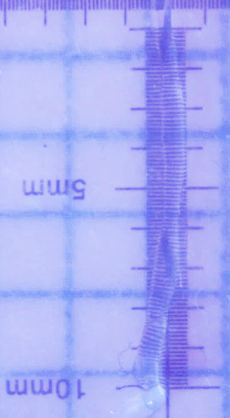
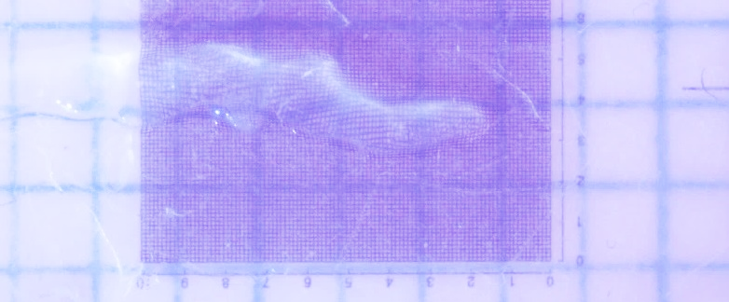
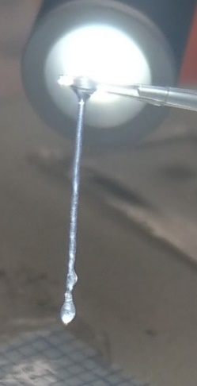
600um
500um
1200um
A
B
D
C

Supplementary Figure 2: Manual extrusion of Fmoc-FRGDF into calcium chloride bath demonstrates formation of peptide noodles. (A-C) 10µL pipette tip extruded noodles into a CaCl₂ bath, layered. Image taken after CaCl₂ removal (D) Printing apparatus extruded noodles into a CaCl₂ bath. Image taken after CaCl₂ removal.

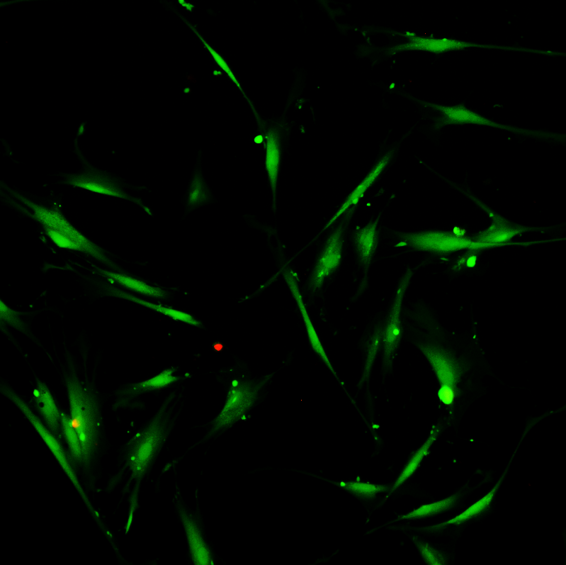
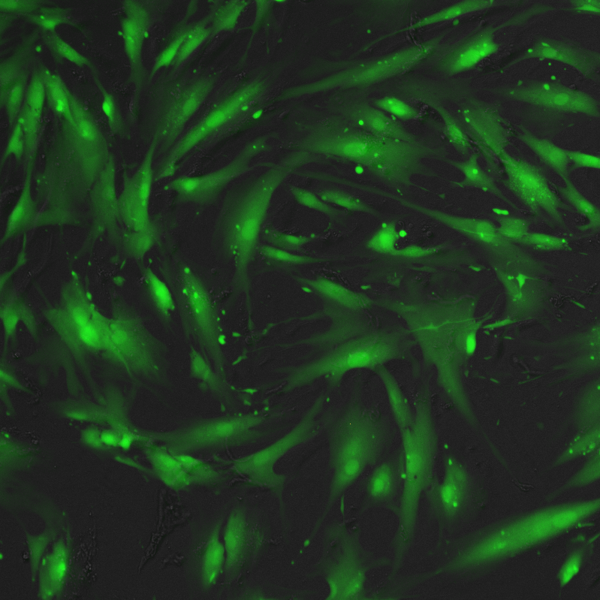
a
b
24 hours
72 hours

Supplementary Figure 3: Viability (Live/Dead) staining of human dermal fibroblasts used in this study demonstrated high viability at 24 and 72 hours.
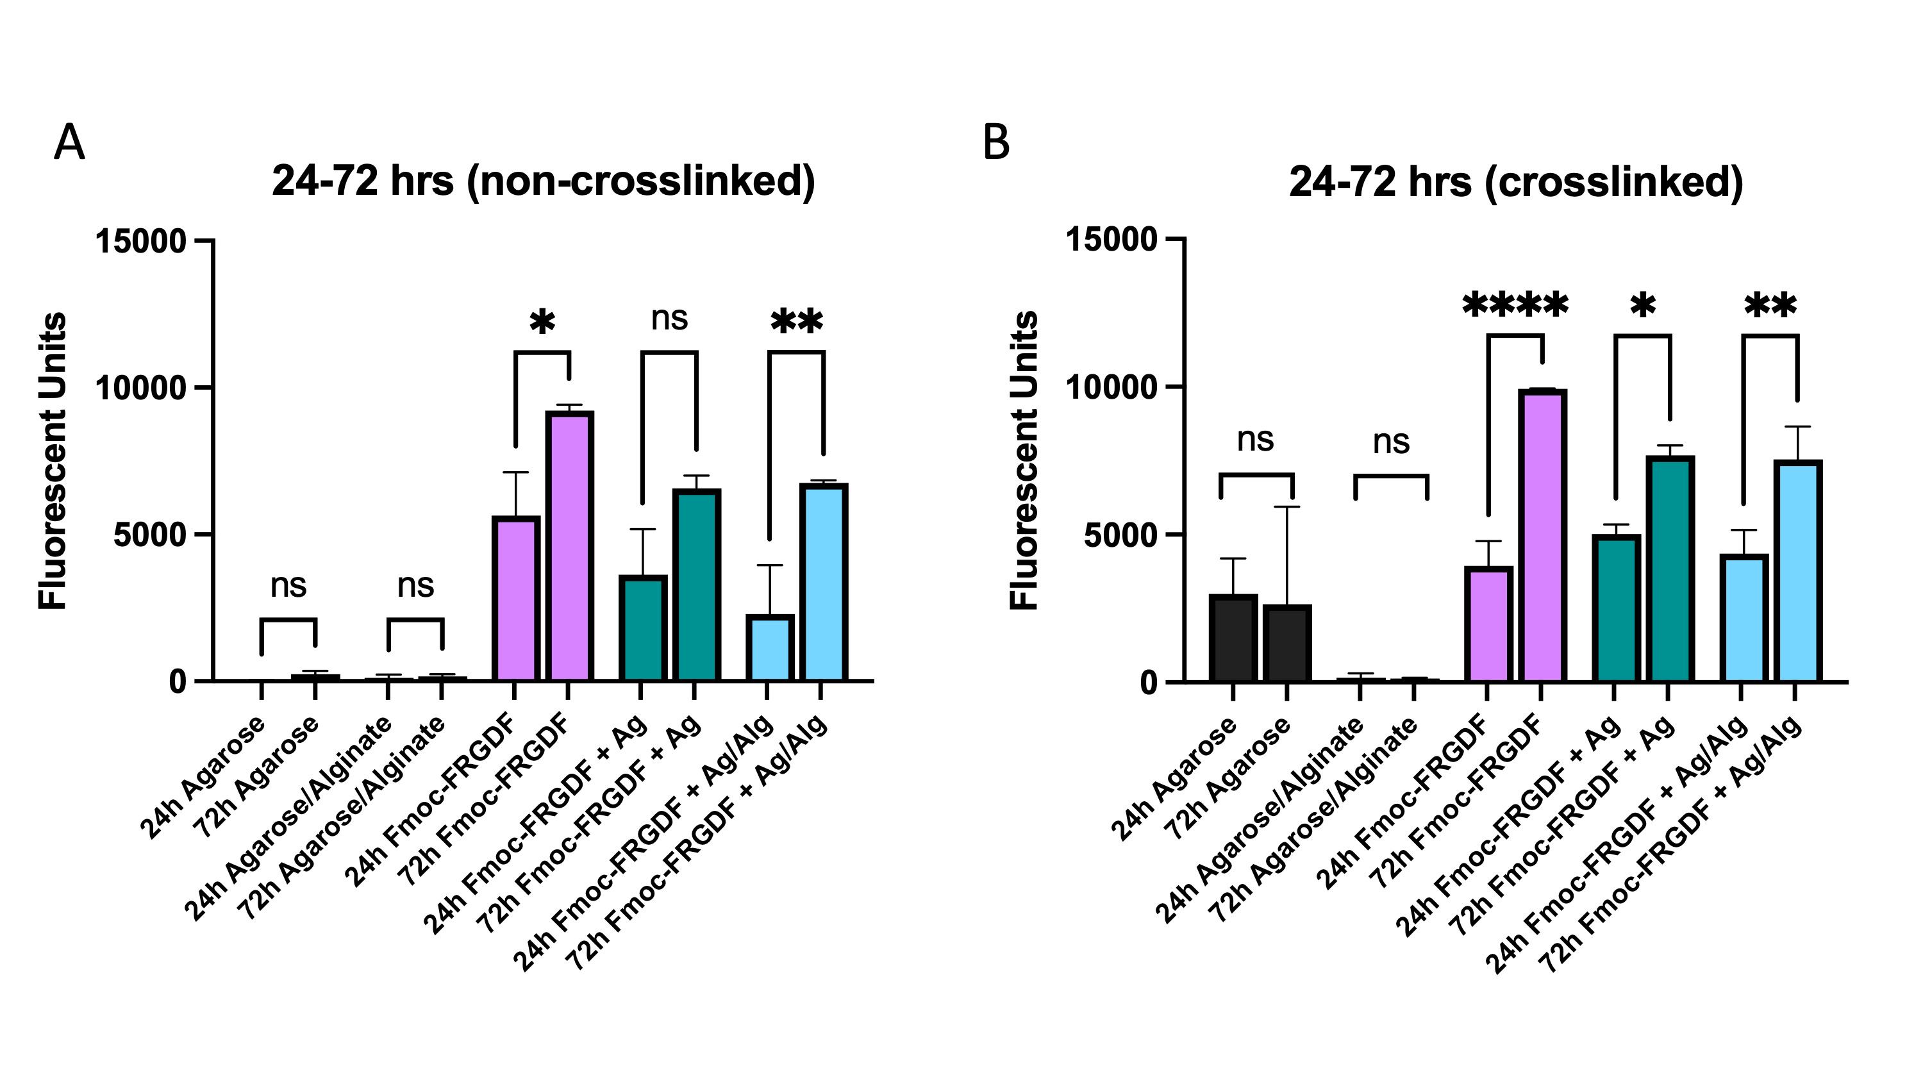
Supplementary Figure 4: Analysis of fibroblast proliferation between 24-72 hours (h) on peptide samples (Fmoc-FRGDF) and peptide-polysaccharide (Agarose (Ag) and Alginate (Alg)) blends on non-crosslinked (A) and crosslinked (B) hydrogels. A significant increase in cellular content was seen in non-crosslinked and crosslinked Fmoc-FRGDF as well as polysaccharide materials containing Fmoc-FRGDF over 72 hours with the exception of non-crosslinked Fmoc-FRGDF + Ag, which showed an increased trend over 72 hours that did not reach a statistically significant level. No increase in cellular content was not seen on agarose or alginate only polysaccharides (without Fmoc-FRGDF) over 72 hours for both non-crosslinked and crosslinked samples. Error bars represent SD.

Supplementary Table 1: Printing Parameters
 | Speed (mm/s) | Layer height (mm) | Lag on time (ms) | Lag off time (ms) | Pressure  (kPa)
Agarose 2% | 300 | 0.08 | 300 | 100 | 120
Alginate/Agarose 2% | 480 | 0.01 | 240 | 0 | 80
Fmoc-FRGDF 5mg/mL | N/A | N/A | 0 | 0 | 8
Fmoc-FRGDF 5mg/mL Agarose 2% | 600 | 0.2 | 160 | 0 | 54
Fmoc-FRGDF 5mg/mL Alginate/Agarose 2% | 400 | 0.3 | 250 | 0 | 117

