Optimal concession period design to cope with uncertainty in public-private partnership

Hongyu Jin and Chunlu Liu

Public-private partnership (PPP) has been widely used in delivering infrastructure projects, such as freeway, tunnel and bridge. One of the most important parameters in PPP contract that needs to be predetermined is the concession period. Formulation of the length of the concession period should consider not only the profits of the private investors, but also the influence of the concession period in risk control. This paper develops a concession period determination model based on expanded net present value and bargaining game theory. It is also considered that the influence of the risk preferences held by project parties on the length of the concession period. Additionally, the financial risks borne by both parties are measured to verify the risk control ability of the concession period. Refer to a real PPP project in Australia, project BA is created as a numerical example to verify the proposed method. The outcome shows that the project parties can create a win-win situation during the optimized concession period and that the probability of suffering risk events for both parties is controlled within the acceptable range. The decision process used in this paper demonstrates strong effectiveness and ability to determine the optimal length of a concession period.

Keywords: concession period; public-private partnership; real option; risk control

Introduction

Public-private partnership (PPP) is defined as “a long-term contractual arrangement between the public and the private sector to realize public infrastructure and services more cost effectively and efficiently than under conventional procurement” (Daube et al., 2008). In the past decades, PPP has gained popularity in delivering infrastructure projects with a long-term relationship between clients and contractors due to its ability to alleviate government financial pressure (Zou et al., 2014). The broad application of PPP schemes provides the incentive of pursuing a management strategy that can increase the project efficiency in time and cost for concessionaries. Scholars doing research on PPP-related topics address the following issues. First, the market risks during the concession period need to be handled and some scholars have tried to achieve a fair risk allocation between project participants (Hwang et al., 2013). Second, it is important to find a way to mobilize social capital participation (Liu et al., 2016). Third, if the market surroundings fluctuate to an unfavourable position or there is force majeure, the way to facilitate social capital exit while minimising the influence on governments is still an open question (Nuer, 2015). However, the premise in analysing all these problems is to determine the specific attributes value of the PPP project, e.g. concession pricing, concession period and minimum revenue guarantee.

This paper focuses on the determination methodology for the length of the concession

period. The concession period as one of the most important parameters is usually set as a default that is the same length as in similar projects (Song et al., 2015) or decided just based on the experts’ experience (Khanzadi et al., 2012). However, these practices tend to encourage project early termination, since they neglect the fact that market surroundings can be significantly different in different projects, which implies that the concession period should be decided independently even for similar projects. This research aim to find a method that can calculate the optimal concession period considering conditions of the market environment. The aim in determining the concession period is to achieve risk control between governments and private investors and ensure that the private investor can gain its expected investment return under the limitation of the revenue cap set by the governments.

Many concession period models are designed following the principle that the concession period should be long enough to guarantee that the private investors can reclaim their money through revenue in the operational stage. Hence, net present value (NPV) estimation is used to construct the core of these models. For example, Hanaoka and Palapus (2012) calculated the concession period based on the NPV for two build-operate-transfer road projects and used the Monte Carlo simulation as well as bargaining game theory to find the optimal project transfer point. Carbonara et al. (2014) developed a win-win model to take government profit into consideration. However, NPV analysis tends to neglect the option value of the project. The project manager holds the right to make decisions on the project activities and the decision choices create different types of option values for the project. Previous studies showed that the range of option values can be enormous and can affect investment decisions (e.g. Yeo and Qiu, 2003). This research reviews the capital existence opportunity as an abandonment option to see if the option value can influence the length of the concession period. Because only a few pieces of research test the effectiveness of their models in risk control, and none of them consider the influence of risk preference on the agreement on the length of the concession period, this study fills the gap in designing a concession period determination method based on the fair risk preferences of the project participants, as well as providing a method of risk verification.

Research background

NPV-based concession period design

NPV analysis requires figuring out the amounts of the cash inflow and cash outflow of a project on the side of the contractors. For a PPP project, the cash outflow covers the construction cost, the operation and maintenance cost, and other implicit costs, like negotiation costs, the cost of the land acquisition, and so on. The contractor can pay the construction cost as a lump-sum payment or pay individually according to the building process. The operation and maintenance fee is usually paid annually to maintain the operation of the project. The contractor starts to receive cash inflow when the project opens to the public. Hence, the NPV of a PPP project is found through Eq. (1):

(1)

where , . is the revenue earned in the operational

stage. is the overall construction cost. indicates other initial investment. is the revenue from operating the project at year t.is the operation and maintenance cost at year t. is the lifetime of the project. is the instant of time when the project opens to the public. is the discount rate. is the yearly construction cost at year t.

After clarifying the profitability of a project through NPV analysis, both private investors and governments want to know how much money will be earned during their operational stages, i.e. the concession period and post-transfer stage respectively. Predetermined parameters, like concession pricing and the concession period, need to be negotiated in the pre-construction stage. Private investors start receiving revenue when the project opens to the public and the governments earn money after the project is transferred from the private investors. Thus, the concession period, or in other words the length of time after which the project should be transferred from private investors to public parties, is an important contractual parameters that needs to be decided. Several methodologies are derived from NPV analysis for calculating the value of the optimal concession period, and the core of these methodologies is to define the boundaries of the private investors’ revenue (Carbonara et al., 2014; Hanaoka and Palapus, 2012; Zhang, 2009). Since private investors want to earn a profit that is at least higher than the minimum return on investment that they could accept, the lower revenue limit is defined as shown in Eq. (2):

(2)

where is the cumulative net present value for private investors during the concession period, whose value can be indicated as . gives the instant of time when the concession period ends.is the private investors’ expected minimum return on investment. In terms of the principle that an investment decision only can be made when the expected revenue exceeds the opportunity cost, the value ofshould be around the profit rate of a similar project.

On the other hand, the governments have the intention to control the private investors’ profit within a reasonable range, so they define an upper revenue limit for private investors as shown in Eq. (3):

(3)

where is the maximum return rate allowed by the government to the private sector. is usually decided during the pre-construction negotiation stage so as to avoid overly lucrative conditions for private investors. The sole independent variable in Eq. (2) and Eq. (3) is the length of the concession period. As shown in Figure 1, through solving these two inequalities, the minimum and maximum lengths of the concession period are produced. The project parties should settle the concession period within the range of.



Real options in PPP projects

The NPV method cannot adequately reflect the value of uncertainties in a project, which may lead to a fatal investment decision (Trigeorgis and Reuer, 2017). Even though some parameters, like traffic volume, can be measured in a stochastic way, the value of ‘rights’ embodied in the project is still waiting to be uncovered in traditional NPV analysis. Leviäkangas and Lähesmaa (2002) argued that NPV analysis cannot grasp all uncertain variables in a transport infrastructure project. However, real options analysis provides a way to evaluate the ‘rights’ offered by uncertainties and tries to reflect the true value of a project in dynamic market surroundings (Dixit and Pindyck, 1994). Real options analysis has been widely used in the field of PPP project management, as it allows for calculating the value of flexibilities in the lifecycle of PPP projects.

The private investors may hold different kinds of option rights during the operational stage. The option to expand means that if the market surroundings are experiencing an upward trend and the project is carried out in stages, the value added could come from the expansion opportunities in the future (Cheah and Garvin, 2009). The option to delay is produced when the project manager decides to delay the project to receive more market information, but sometimes the cost of delaying a project is also high (Kremljak et al., 2014). In most countries carrying out PPP projects, the exit mechanism for the project is specified in the contract documents and protected by the law of the land (Bulnina et al., 2015). Hence, the project investors hold the option to abandon, which means that if the market surroundings go into extremely unfavourable conditions, they could choose to quit and receive a certain amount of money in return.

There are two main real-options pricing models. One is the binomial lattice model whose basis is the discrete random walk, and the other one is the Black-Scholes pricing model. The binomial lattice model assumes that there are two directions for unstable variables to move: upward or downward. If the variable moves up, the value in the next stage should be the initial value multiplied by the quotient (u) and otherwise, multiplied by the quotient (d), and the probability of moving up is expressed as (p), where is the volatility of underlying assets. is the step interval. is the risk-free rate. The main strength of the binomial lattice model is that the option execution point can be easily observed in a tree chart. However, if the project has a long lifecycle or short step intervals, the calculation of the binomial lattice model becomes complicated and it is hard to display the tree chart with large branches. In this case, the Black-Scholes pricing model is more practical.

The real option value in highly unstable surroundings can be a huge number. Smit and Trigeorgis (2012) stated that the sum of NPV and option value equals the value of expanded NPV (ENPV), which can reflect the value of a project’s flexibility. In this research, ENPV analysis is adopted to predict the future cash inflow for the private investors instead of NPV. The concession period decision scope should change downward, as shown in Figure 1, and the concession period interval is expected to change from to , which is a neglected part of many other studies.

Optimal concession period determination process

In this part, an optimal concession period determination process is proposed, which contains the following steps: First, based on the project background, the Geometric Brownian motion (GBM) paths for uncertain variables in the project are simulated and ENPV for private investors as well as NPV for the governments are calculated. Second, according to the calculation results, the decision range of the concession period is determined to see, when the value of the real options is taken into consideration, to what extent the concession period decision range changes in an ENPV analysis. The optimal concession period during which both governments and private investors can achieve a win-win situation is also determined at this stage. Third, the financial risks are calculated to see if they can be controlled for both parties within the scope of the designed concession period. A risk verification process is set up to highlight the principle that the concession period determination should help to achieve not only fair revenue allocation, but also life-cycle risk control. Finally, a model for transferring the risk between the project participants based on their risk preferences is proposed. The overall flow chart of the optimal concession period determination process can be seen in Figure 2. The models mentioned in the process, i.e. concession period bargaining model, risk verification model, and risk transfer model, are illustrated afterwards.

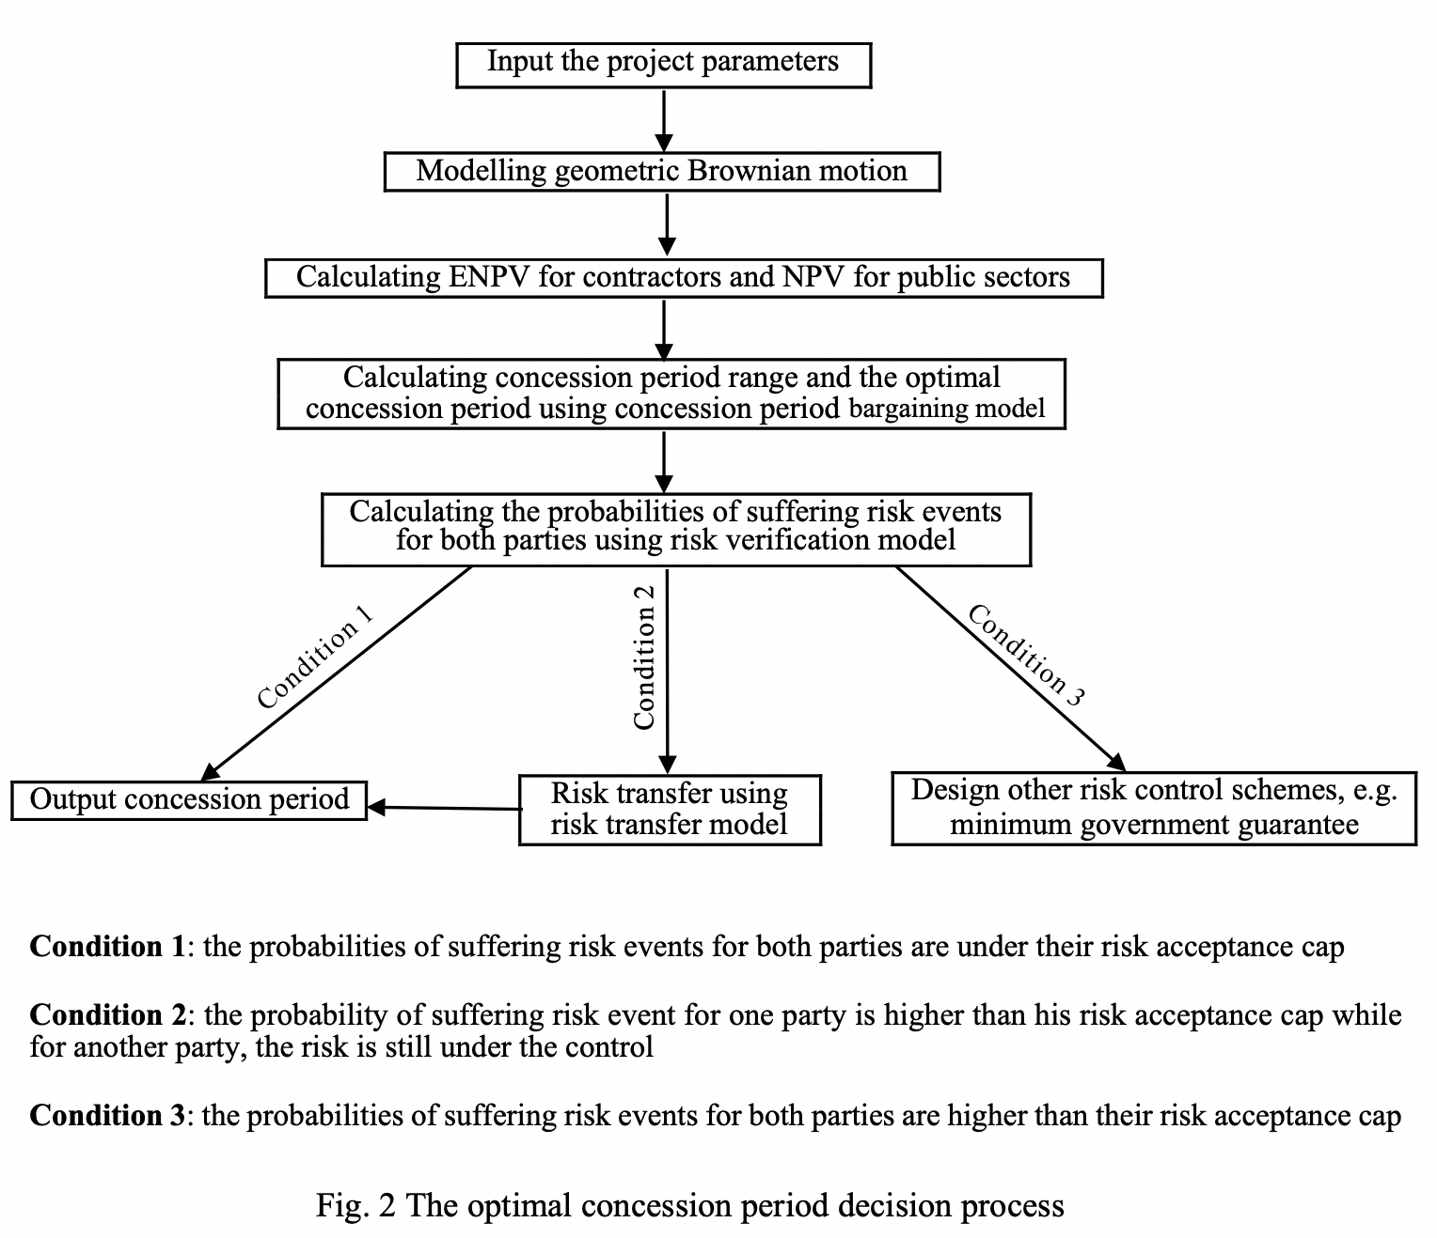

Concession period decision range and a bargaining model

After ENPV analysis for private investors, the concession period decision range can be produced. According to the principle that private investors expect to gain more profit through the project than the expected minimum return on investment, the lower limit of the concession period is decided by Eq. (4):

(4)

where is the function of the profit premium for private investors. is the value of real options that private investors hold within the period , which can be derived from the binomial lattice model or the Black-Scholes pricing model. is the NPV value for private investors within the period . equals the minimum value of obtained from . No moment before this threshold will be accepted by private investors, since they cannot receive the expected minimum return on investment within that period.

The upper limit of the concession period () is calculated by Eq. (5):

(5)

where is the function of the difference between the profit earned for private investors and the revenue cap. equals the maximum value of obtained from . No moment after this threshold will be accepted by the governments, as the private investors can earn excess profit in an overly long period. Moreover, a prolonged concession period squeezes the time during which the governments receive revenues. Every instant of time located within the interval of can fulfil the profit requirement of private investors, and meanwhile the governments achieve the target of limiting private investors’ revenue within a reasonable range.

The optimal length of the concession period is calculated following a three-stage bargaining process. As shown in Figure 3, in the first stage of the bargaining process, the private investor offer a concession period of . If the government accept the offer, they will gain the payoff whose value equals the extra money they can claim from the private investor for a profits control. The payoff for the private investor will be the money earned that is higher than their opportunity cost. The game will ends in stage three whether the government accepts the counteroffer proposed by the private investor or not. The private investor will offer to maximize their payoff at the final stage.

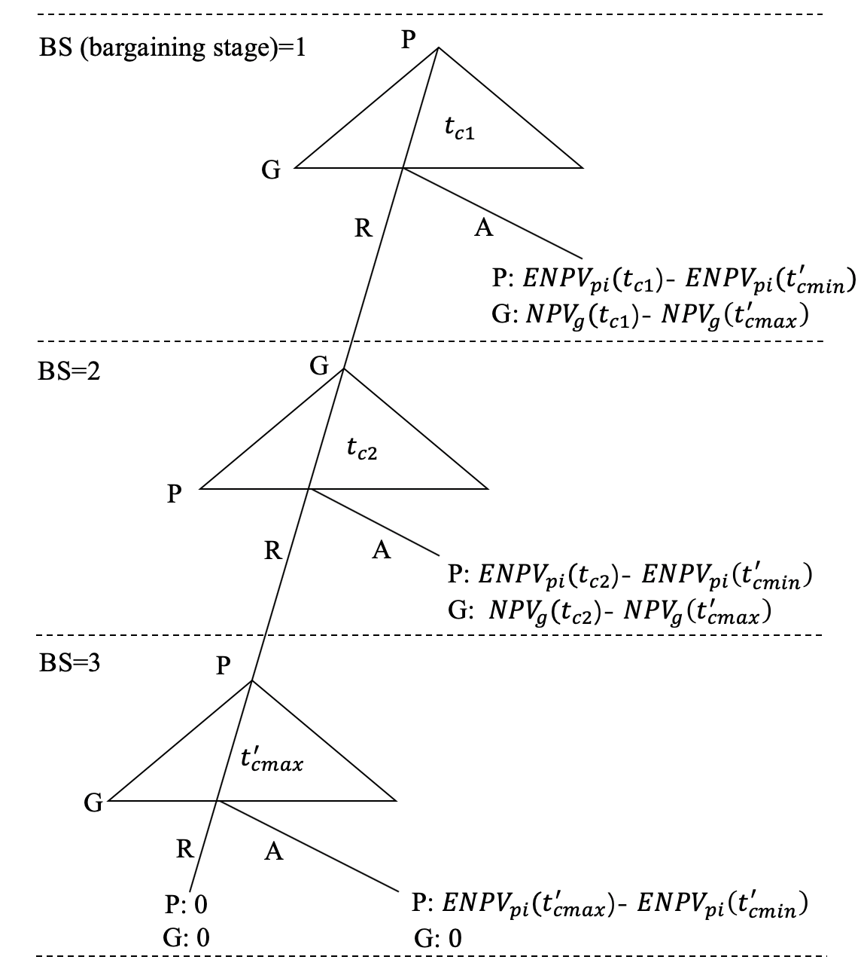

Fig. 3 A three-stage bargaining process

The optimal length of the concession period can be derived via a backward induction. In stage 2, in order to make it no difference for the private investor to accept or reject the offer, the value of should meet the following equation:

) = (6)

where is the discount factor for the private investor.

Similarly, the value of meets:

) = (7)

where is the discount factor for the government. By importing the value of derived from the Eq. (6), the value of can be obtained. The optimal length of the concession period equals as when the private investor propose in the first stage, the bargaining game can reach its equilibrium point.

The optimal concession period is calculated at this stage. However, the forecast traffic volume can show various fluctuating trends in different simulation paths, so the optimal concession period based on our predicting path may fail to control the risk of loss in other simulation paths. Thus, a risk verification model is designed to verify the ability of the optimal concession period for risk control.

Risk verification model

Before proposing the risk verification model, it is important to understand the relationship between the length of the concession period and the probabilities of suffering risk events for the project parties. With an increase in the length of the concession period, the probability of suffering risk events for private investors is expected to decrease, since they have more time to earn money. However, for the governments the probability value shows the opposite trend. It can be seen from Figure 4 that if the governments and private investors have high risk tolerance, there will be a new concession period interval produced based on their risk preferences. If the concession period determined before, i.e. , is located in the interval of [, ], the effectiveness of the designed concession period in risk control can be shown. Otherwise, there will be only one party that can achieve the goal of controlling risk. Nevertheless, it is also possible that both private investors and governments have low risk tolerance, e.g. their risk tolerance caps are lower than the fair risk allocation point. In this case, a concession period interval based on the risk preferences cannot be produced and the risk for both parties cannot be controlled through designing an optimal concession period.

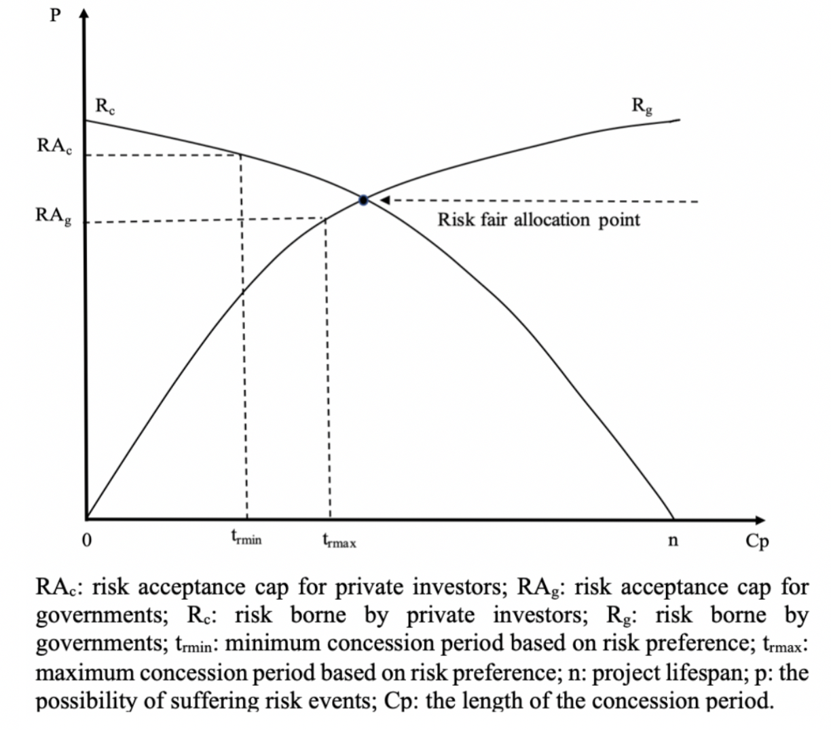

Fig. 4 Risk preference and the value of the concession period

A risk verification model, which carries out 1000 times path simulation, is proposed to verify the effectiveness of the determined concession period in risk control for other simulation paths. By assuming the distribution of the uncertain variables, i.e. GBM in this research, the probability of risk occurrence can be calculated. Then the revenue path over the whole project lifetime can be generated to calculate the occurrence rate of risk events of the 1000 times simulation path for private investors in the designed concession period and for governments in the post-transfer stage. The possibility of suffering risk events for both parties should not exceed their risk acceptance caps. The risk verification function is shown below:

(8)

where

and are the risk acceptance caps for private investors and governments respectively. is the number of simulation times, which is 1000 in this research. indicates the sequence of the simulated GBM path. The value of need to be verified to see whether it meets the requirement of the two prerequisites shown in Eq. (8). If the optimal concession period fails to pass the verification, the optimal concession period can be revised according to the risk preferences that project parties hold.

Risk transfer model based on project participants’ risk preferences

The risk verification process can produce difference outcomes. The best case would be that the proposed concession period can control risk occurrence rates for both parties under their risk acceptance caps while creating a win-win situation. If the concession period determined through the concession period bargaining model leads to a risk occurrence rate that is higher than the risk capacity of both parties, the designed concession period will not play a role in risk control. If only one party suffers a risk spillover, the final concession period will be decided by their risk preference. Thus, a risk transfer model is designed to cope with this condition. For better explanation, it is assumed that there is a risk holder 1 who suffers more risk than their risk capacity. Risk holder 1 wants to transfer the excess risk to risk holder 2, who suffers less risk than their risk capacity. During the risk transfer process, the concession period needs to be adjusted to achieve this risk re-allocation. The new concession period after the risk transfer process can be found following Eq. (9):

(9)

where R1 is the risk borne by risk holder 1. R2 is the risk borne by risk holder 2. RA1 and RA2 are the risk acceptance caps of risk holder 1 and 2 respectively. is the revised concession period after transferring the risk. is the occurrence rate of the risk events that risk holder 2 holds. The constraints show the principle that the risk held by risk holder 2 is still under the risk acceptance cap after the risk transfer process.

Numerical example

The proposed determination method is applied to Project BA to verify its applicability. Conducted as a freeway PPP project, the estimated construction cost is 4.8 billion Australian dollars. The road is toll free for the first three months, and afterwards the toll charge is 2.5 Australian dollars per vehicle for the following 10 months. After a 13-month trial period, and the toll is kept at 4.9 Australian dollars.

Concession period determination

Initially, it is necessary to clarify the project parameters that are used in the determination model. Some of the project parameters show uncertainty, as they change with the trends of the market surroundings. These parameters are given as follows: the initial yearly traffic volume forecast for the Brisbane airport link is. The volatility of the future traffic volume is 12.5%. The operational cost is assumed to be 0.8 Australian dollars per vehicle before the full charge of the toll road. Afterwards, the annual operational cost is set at 30% of the annual toll revenue. The maintenance cost is 4 billion Australian dollars in the initial year with a 3% annual growth rate according to the local consumer price index. The expected traffic growth rate of the Project BA is in line with the local yearly traffic growth rate of 2.9%. Since the decision model calculates the cash flows based on the randomly traffic volume. The discount rate used for calculating the project NPV is the risk-free rate, which is 2.6% that equals the 10-years yield of the Australia bond. The underlying asset value for the real options calculation equals the NPV value for the first operational year, which is Australian dollars.

In addition to the uncertainty parameters, the project itself has some inherent attributes: the construction period is 4 years, and the project life is 60 years. The construction cost is 4.8 billion, and it is assumed that there are no other transaction costs during the project lifecycle. The minimum return rate on investment is 10%, and the maximum return rate on investment allowed by the government is 20%. Both the private investor and governments can only tolerate a risk probability of less than 10%. The traffic volume simulation path can be produced via Eq. (10):

(10)

where indicates the current traffic volume and is the traffic volume in the next

year. is the year used for data analysis. is the expected traffic growth rate during is the annual volatility of the traffic volume accordingly.

Based on the generated GBM path, the ENPV value for the private investors can be calculated. What should be noted here is that the real option considered in this project is the abandonment option (viewed as an American put option). It is assumed that the project manager holds the right to quit the project once the traffic volume is 30% lower than the expected volume in the initial year. Therefore, the executive price of the option is 70% of the value of the underlying asset (i.e. traffic revenue). Since the Black-Scholes pricing model cannot be used for American options pricing, the binomial tree method is adopted, and the calculation outcome shows that the real option value is 167,240 Australian dollars over the whole project lifecycle.

By applying the concession period decision model, the minimum length of the concession period is calculated as 41 years, and the maximum length is 45 years, which means that the concession period should be located in the interval of 41 to 45 years. Given , the optimal concession period decided is 45 years during which a win-win situation can be created.

Risk verification

Figure 5 indicates that the probability of suffering loss from the project each year is less than 8%, which illustrates that the project itself has a low-risk inclination and provides a reason that the value of the abandonment option is so small. Next, a 1000 times path simulation is run to see the applicability of the designed concession period in risk control. The risk control ability of the designed concession period is measured via the risk verification model. The outcomes show that the possibilities of suffering risk events for private investors within the concession interval of 41 to 45 years are 4.6%, 4.2%, 4.5%, 3.6%, and 3.3% respectively, while for the governments at the post-transfer stage the percentages are 1.7%, 2.0%, 1.6%, 1.7%, and 2.3% respectively. The results of the risk verification process show that all the concession periods located in the interval are found to be eligible to control both parties’ risk within 10%. Since the possibilities of suffering risk events for both parties are within their risk acceptance caps, the risk transfer process is not needed for this project. Hence, the optimal concession period is kept at 45 years.

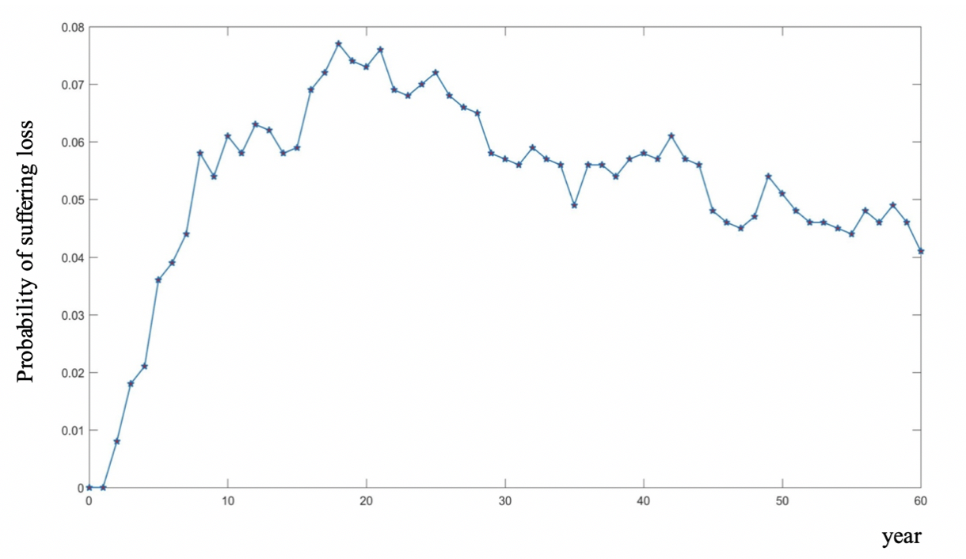

Fig. 5 The probability of suffering loss at each step interval

Conclusion

One of the keys to the successful operation of PPP projects is to determine the concession term properly. Previous models paid too much attention to the profitability of private investors while neglecting the capacity of the concession period in risk control. This research proposes an optimal concession period determination method aiming to create a win-win situation between private investors and governments as well as control the financial risk for both parties. Expanded NPV analysis is adopted ton reflect the income for the private investors more accurately. Through the risk verification process, 1000 times GBM paths of uncertain variables are generated. If the risk probability for one party exceeds their risk tolerance range while the risk for the other project party is still under control, the risk transfer model is designed to transfer the risk under this condition.

The Project BA is used as a numerical example to justify the proposed model. By passing through the concession period determination process, the optimal concession period is decided during which the private investor can earn higher than their expected return on investment while under the revenue control of the government. Additionally, the risk of deficit for each party is controlled to be under 10%. The application shows that the designed models are effective tools for PPP projects in the decision-making of the length of the concession period.

The real option chosen in this research is the option to abandon, but the analysis shows that there is no change in the concession period threshold whether the real option value is accounted for or not. This outcome may arise from the relatively small value of the abandonment option. However, there are many other real options embodied in PPP projects, and this paper cannot cover them all. An assumption that can be made here is that a project with a positive growth rate may involve a non-ignorable value of the expansion option, especially when the project operates in stages. Future research could focus on this and figure out the influence of the expansion option on the concession period thresholds.

References

Banister, D., 2005. Unsustainable transport: city transport in the new century. London, UK: Taylor & Francis.

Brandao, L. E. T., Saraiva, E., 2008. The option value of government guarantees in infrastructure projects. Construction Management and Economics, 26(11), 1171-1180.

Bulnina, I., Askhatova, L., Kabasheva, I., Rudaleva, I., 2015. Public and Private Partnership as a Mechanism of Government and Business Cooperation. Mediterranean Journal of Social Sciences, 6(1 S3), 453.

Carbonara, N., Costantino, N., Pellegrino, R., 2014. Concession period for PPPs: A win–win model for a fair risk sharing. International Journal of Project Management, 32(7), 1223-1232.

Cheah, C. Y., Garvin, M. J., 2009. Application of real options in PPP infrastructure projects: opportunities and challenges. Policy, Finance & Management for Public-Private Partnerships. Wiley-Blackwell, 229-249.

Daube, D., Vollrath, S., Alfen, H. W., 2008. A comparison of Project Finance and the Forfeiting Model as financing forms for PPP projects in Germany. International Journal of Project Management, 26(4), 376-387.

Dixit, A. K., Pindyck, R. S., 1994. Investment under uncertainty. Princeton, USA: Princeton university press.

Hanaoka, S., Palapus, H. P., 2012. Reasonable concession period for build-operate-transfer road projects in the Philippines. International Journal of Project Management, 30(8), 938-949.

Hull, J., 2010. Options, Futures, and Other Derivatives, 7/e (With CD). Delhi, India: Pearson Education India.

Hwang, B.-G., Zhao, X., Gay, M. J. S., 2013. Public private partnership projects in Singapore: Factors, critical risks and preferred risk allocation from the perspective of contractors. International Journal of Project Management, 31(3), 424-433.

Irwin, T., 2003. Public money for private infrastructure: deciding when to offer guarantees, output-based subsidies, and other fiscal support. Washington, USA: World Bank Publications.

Khanzadi, M., Nasirzadeh, F., Alipour, M., 2012. Integrating system dynamics and fuzzy logic modeling to determine concession period in BOT projects. Automation in Construction, 22, 368-376.

Kremljak, Z., Palcic, I., Kafol, C., 2014. Project evaluation using cost-time investment simulation. International Journal of Simulation Modelling, 13(4), 447-457.

Laffont, J.-J., Martimort, D., 2009. The theory of incentives: the principal-agent model. Princeton, USA: Princeton university press.

Leviäkangas, P., Lähesmaa, J., 2002. Profitability evaluation of intelligent transport system investments. Journal of Transportation Engineering, 128(3), 276-286.

Liu, J., Gao, R., Cheah, C. Y., Luo, J., 2016. Incentive mechanism for inhibiting investors' opportunistic behavior in PPP projects. International Journal of Project Management, 34(7), 1102-1111.

Nuer, A. T. K., 2015. Exit strategies for social venture entrepreneurs. Wageningen, Netherlands: Wageningen University.

Smit, H. T., Trigeorgis, L., 2012. Strategic investment: Real options and games. Princeton, USA: Princeton University Press.

Song, J., Song, D., Zhang, D., 2015. Modeling the concession period and subsidy for bot waste-to-energy incineration projects. Journal of Construction Engineering and Management, 141(10), 04015033.

Trigeorgis, L., Reuer, J. J., 2017. Real options theory in strategic management. Strategic Management Journal, 38(1), 42-63.

Vega-Redondo, F., 1996. Evolution, games, and economic behaviour. Oxford, UK: Oxford University Press.

Yeo, K., Qiu, F., 2003. The value of management flexibility—a real option approach to investment evaluation. International Journal of Project Management, 21(4), 243-250.

Zhang, X., 2009. Win–win concession period determination methodology. Journal of Construction Engineering and Management, 135(6), 550-558.

Zou, W., Kumaraswamy, M., Chung, J., Wong, J., 2014. Identifying the critical success factors for relationship management in PPP projects. International Journal of Project Management, 32(2), 265-274.