Article

Characterization of intervertebral disc changes in asymptomatic individuals with distinct physical activity histories using three different quantitative MRI techniques

Daniel L Belavy 1, Helena Brisby 2, Benjamin Douglas 3, Hanna Hebelka 2, Matthew J Quittner 1, Patrick J Owen 1, Timo Rantalainen 4, Guy Trudel 5*, MSc* and Kerstin Lagerstrand 2

1 Deakin University, Institute for Physical Activity and Nutrition, School of Exercise and Nutrition Sciences, Geelong, Victoria, Australia

2 University of Gothenburg, Institute of Clinical Sciences, Sahlgrenska Academy, Gothenburg, Sweden

3 Deakin University, School of Exercise and Nutrition Sciences, Geelong, Victoria, Australia

4 University of Jyväskylä and Gerontology Research Center, Faculty of Sport and Health Sciences, Jyväskylä, Finland

5 University of Ottawa, Department of Medicine, Division of Physical Medicine and Rehabilitation, Bone and Joint Research Laboratory, Canada

**\*** Correspondence: [kerstin.lagerstrand@vgregion.se](mailto:kerstin.lagerstrand@vgregion.se); Tel: +46 700824436

Received: date; Accepted: date; Published: date

**ABSTRACT: Background:** Assessments of intervertebral disc (IVD) changes, and IVD tissue adaptations due to e.g. physical activity remains challenging. Newer magnetic resonance imaging techniques can quantify detailed features of the IVD, where T2-mapping, T2-weighted (T2w) and Dixon imaging are potential candidates. Yet their relative utility has not been examined.The performance of these techniques was investigated to characterize IVD differences in asymptomatic individuals with distinct physical activity histories. **Methods**: 101 participants (54 women) aged 25-35years with distinct physical activity histories but without history of spinal disease were included. T11/12 to L5/S1 IVDs were examined with sagittal T2-mapping, T2w MRI and Dixon imaging. **Results**: T2-mapping differentiated Pfirrmann grade-1 from all other grades (p<0.001). Most importantly, T2-mapping was able to characterize IVD differences in individuals with different training histories (p<0.005). Dixon displayed weak correlations with the Pfirrmann scale and the other techniques but presented significantly higher water content in IVDs of the long-distance runners (<0.005). **Conclusions**: Findings suggested that T2-mapping best reflect IVD differences in asymptomatic individuals with distinct physical activity histories changes. Dixon characterized new aspects of IVD, probably associated with IVD hypertrophy. This complementary information may help to better understand the biological function of the disc.

**Keywords:** intervertebral disc; magnetic resonance imaging; sport medicine; T2-mapping; Dixon

INTRODUCTION

The intervertebral disc (IVD) consists of the outer annulus fibrosus and the gelatinous central nucleus pulposus [1]. The high content of type 1 collagen containing fibers in the annulus fibrosus creates a strong fibrous ring, whereas the nucleus pulposus matrix is built up by type 2 collagen and water binding proteoglycan molecules. The IVD degenerates with aging and if injured, structural changes might precipitate and maintain low back pain [2]. The degeneration of discs within the lumbar spine start early in life, as early as 20 years [3]. Thus, to measure subclinical changes within the IVD tissue might be of value to gain increased knowledge regarding the complex degenerative process and to understand the more advanced stages of degeneration. Furthermore, imaging data that can be linked to degeneration and used as markers for long-term follow-up could have wide applications in the search for novel therapies of the disc.

Qualitative or categorical scales have been used to grade IVD degeneration (e.g. the Pfirrmann scoring system [4]). In addition, quantitative MRI techniques have been developed that can detect degenerative IVD changes on a continuous scale of measurement. [5]. Also, advanced analysis software has enabled automated quantification of the IVD degeneration, as well as detailed characterization of different degeneration patterns [6]. However, comparisons of the usefulness of quantitative MRI has received little attention.

T2-mapping is commonly used in spine research for characterization of degenerative disc changes. With T2-mapping, objective and quantitative measures of the disc is provided, reflecting both water content and the orientation of collagen fibres. Moreover, the group of Belavy have recently reported significant differences in IVD composition between groups with different training histories [7-9] and has from a randomized controlled trial in patient with low back pain evaluated the effect of exercise recommended alternative MRI markers of IVD changes [10].

Another quantitative MRI technique for characterization of degenerative disc changes is T2-weighted (T2w) imaging [11-13]. Similar to T2-mapping, T2w imaging relies on T2 relaxation and, as such, reflects the water content as well as the matrix structure of the IVD [14]. T2w imaging is not currently used in the clinic to quantify IVD changes, since the contrast is influenced by several factors, including machine type, sensitivity of the coil, subject position, that limit its usefulness. In the clinical setting, however, T2w imaging is routinely used for visualization of the spine and has the advantage of being robust as well as fast in comparison with T2-mapping. As such, T2w imaging is an attractive technique to further adapt as a tool for quantification of degenerative disc changes. The Dixon technique [15], previously not applied for IVD evaluation, has been extensively used in the literature to quantify the fat content of the liver. Technological advances have recently been incorporated into the technique [16], providing resources for robust reconstruction of water/vascular regression images. As such, Dixon imaging should be able to detect differences in the water content of the IVD without reflecting the structure of the IVD matrix and, thus, reflect other aspects of disc degeneration than T2-mapping and T2w imaging techniques. This in combination with a very short scan time are promising features for clinical use in the IVD evaluation.

In this study, we investigated the performance of the three different quantitative techniques, T2-mapping, T2w and Dixon imaging, to characterize IVD differences in asymptomatic individuals with distinct physical activity histories.

MATERIAL AND METHODS

Ethical approval and subjects

This study was a secondary analysis of an existing dataset [9; 10] on the impact of physical activity and inactivity on the spine in an asymptomatic population. The data set consisted of 101 participants, 54% women and 46% men, mean age(SD) 30.0(3.6)years, 173.5(9.6)cm height, 69.9(13.4)kg mass, divided into four groups of individuals with distinct physical activity histories, but similar Pfirrmann grade distributions. Only people with a minimum of 5 years history at their current physical activity level were included in the study: either no sport (sedentary referents), cyclists reporting a minimum of 150 km cycled per week (high-volume road cyclists), 20–40 km per week running (joggers), or 50 + km per week running (long-distance runners). See previous work [9; 10] for further details.

Exclusion criteria included current spinal (cervical, thoracic or lumbar) pain, history of spinal surgery, history of traumatic injury to the spine, known scoliosis for which prior medical consultation was been sought, current or prior smoker, known claustrophobia and possible pregnancy.

All subjects gave their informed consent for inclusion before they participated in the study. The study was conducted in accordance with the Declaration of Helsinki. The study was approved by the Deakin University Faculty of Health human ethics advisory group.

Testing and MR scanning protocol

Participants were instructed to perform no exercise on the day of their scan. To avoid the impact of normal diurnal variation on the spine [17], all testing was performed after midday. Upon arriving at the radiology facility, participants were required to sit for a minimum of 20 minutes prior to entering the scanner to help standardize IVD hydration status. Participants sat for a mean(SD) of 46(17) minutes. Spine volume from the T11 vertebral body to the sacrum was imaged in all subjects using a 3T Phillips Ingenia scanner (Amsterdam, Netherlands). Three different scan protocols were used:

* Sagittal T2-mapping using a spin-echo multi-echo sequences (8 echo times: 15.75, 36.75, 57.75, 78.75, 99.75, 120.75, 141.75 and 162.75ms, repetition time: 2000ms, number of slices: 12, slice thickness 3mm; interslice distance: 1.5mm; field-of-view: 281x281 mm, resolution: 0.366 mm per pixel, acquisition time: 9min 30s).
* Sagittal T2w imaging (echo time: 70ms, repetition time: 2600ms, number of slices: 15, slice thickness: 3mm, interslice distance: 1.5mm, field-of-view: 357x357 mm, resolution: 0.532 mm per pixel, acquisition time: 3min).
* Sagittal Dixon imaging (echo times: 2.45/3.67ms, repetition time: 5.27ms, number of slices: 20, slice thickness 3mm; interslice distance: 0mm, bandwidth: 500, field-of-view: 400x400mm, resolution: 0.833mm per pixel, acquisition time: 1min 20s). A Dixon technique with asymmetrical echoes (mDIXON) was utilized [16].

Image analysis

To ensure blinding of the examiner in offline image measurements, each subject was assigned a random numeric code (obtained from [www.random.org](http://www.random.org)). A radiologist determined the Pfirrmann grade of each lumbar IVD using the T2w images. All Pfirrmann grades except Pfirrmann grade 5 IVDs were observed in the cohort (Table 2). An off-line software (ImageJ 1.38x (http://rsb.info.nih.gov/ij/) was used to perform all quantitative MR measurements. A custom written ImageJ plugin (“ROI Analyzer”; <https://github.com/tjrantal/RoiAnalyzer> https://sites.google.com/site/daniellbelavy/home/roianalyser) was used to implement the IVD measurements after manual segmentation of the IVD using the native “polygon selections” tool in ImageJ.

IVD T11/12 to L5/S1 were included in the analysis. Supernumerary lumbar IVDs (L6/S1; eight individuals) were excluded. One hypoplastic L5/S1 IVD at a sacralised L5 vertebral level was included in analysis. The image number corresponding to each vertebral and IVD level was noted. IVDs were segmented in five subregions from the anterior to posterior aspect of the disc (Figure 1) 15,16,18. Then, a custom written plugin measured the signal intensity of the whole IVD as well as the 5 subregions.

Depending on the MRI technique, the following calculations were performed:

* T2-mapping: To reconstruct T2-maps, the T2-time in each pixel was calculated from the spin-echo multi-echo images using a linear fit to the natural logarithm of the image intensity in each of the eight MR echoes.
* T2w imaging: For normalization, the ratio of the average T2w signal intensity (T2w-SI) in the nucleus to the average T2w-SI in the anterior and posterior subregions (annulus) was calculated.
* Dixon imaging: An iterative algorithm with least-squares estimation was used to maximize the noise performance of the water signal [16].

Detailed analysis of all MR images was then performed. In addition to mean values of the whole IVD, values of the nucleus sub-region and values of the ratio of the nuclear subregion to anterior and to posterior subregions (ratio nucleus/annulus) were determined for all techniques using the central three sagittal slices to capture the central (most hydrated) region of the nucleus and to be comparable to prior works [11; 12].

Moreover, three-dimensional (3D) plots of the IVD were generated for all MRI techniques (Figure 3). To generate the plots, the pre-processed data for the T2-mapping T2w imaging and Dixon imaging were interpolated across the width of the IVD in each subregion.

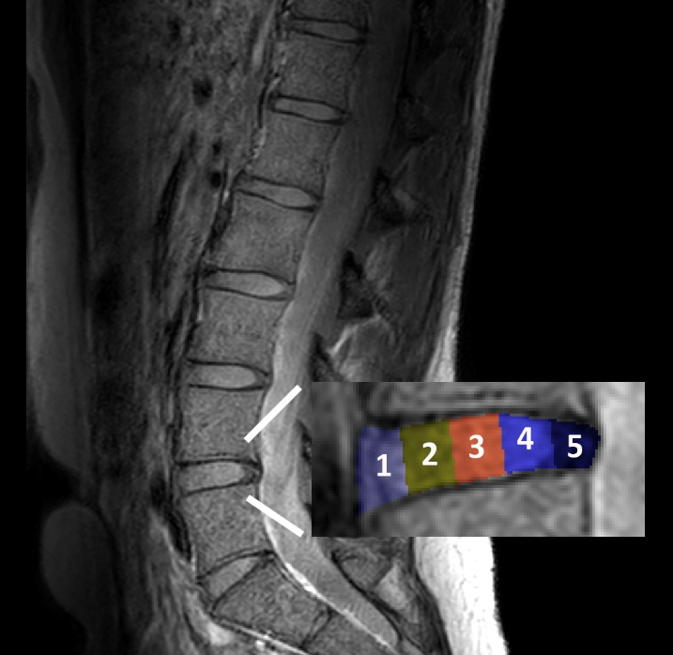

**Figure 1.** Graphical illustration of the segmentation of the IVD into five subregions from (1) anterior to (5) posterior aspect of the disc.

Statistical analyses

To examine the sensitivity of each MRI technique to differentiate between IVD characteristics in people with distinct training histories, IVD variables in each athletic group were compared to the sedentary referent group using unpaired t-tests. Sub-analysis was also performed to examine covariation of the MRI techniques, Pearson's product moment correlation between each variable was calculated. Also, unpaired t-tests were used to examine the difference in variables obtained from each MRI technique on Pfirrmann grades 2, 3 and 4 IVDs compared to the Pfirrmann grade 1 IVDs.

An alpha-level of 0.05 was considered statistically significance. The “R” statistical environment (version 2.10.1, [www.r-project.org](http://www.r-project.org)) was used for all analyses.

RESULTS

The T2-mapping and T2w imaging techniques

As previously reported [9; 10], the T2-time by T2-mapping of the whole IVD and nucleus as well as the nucleus/annulus ratio distinguished between various participants’ training histories (Table 1; Figure 2). These subtle differences between groups were not found with T2w imaging. The T2-mapping and T2w imaging techniques displayed large regional differences over the IVDs, with higher values centred at the nucleus (Figure 3). The T2-time and T2w-SI of the whole IVD and nucleus were decreased for Pfirrmann grades 2, 3 and 4 in comparison with grade 1 (Table 2; Figure 4). The nucleus/annulus ratio was also decreased in grades 2, 3 and 4 for the T2-time, but only in the higher Pfirrmann grades, 3 and 4, for T2w-SI (Table 2; Figure 4).

**Table 1.** Differences between T2-mapping, T2w imaging and Dixon imaging according to physical activity histories.

|  |  |  |  |  |
| --- | --- | --- | --- | --- |
|  | Participant group (number of IVDs) | | | |
|  | **Sedentary (n=144)** | **High-volume cycling (n=132)** | **Running: 20-40km (n=180)** | **Running: >50km (n=150)** |
| **Whole IVD** | | | | |
| T2-mapping (ms) | 104.4(1.7) | 121.6(1.7)‡ | 115.6(1.5)‡ | 117.9(1.6)‡ |
| T2w-SI (no unit) | 326.9(4.9) | 329.7(5.1) | 317.6(4.4) | 320.5(4.8) |
| Dixon (%) | 86.0(0.6) | 87.1(0.7) | 87.1(0.6) | 88.1(0.6)* |
| **Nucleus** | | | | |
| T2-mapping (ms) | 111.4(3.0) | 137.7(3.1)‡ | 129.8(2.7)‡ | 132.6(2.9)‡ |
| T2w-SI (no unit) | 423.6(8.9) | 434.0(9.3) | 426.4(7.9) | 421.6(8.7) |
| Dixon (%) | 87.2(0.6) | 88.1(0.7) | 88.1(0.6) | 89.4(0.6)* |
| **Nucleus/annulus ratio** | | | | |
| T2-mapping (ms) | 1.40(0.03) | 1.49(0.03)* | 1.48(0.02)* | 1.51(0.03)† |
| T2w-SI (no unit) | 3.31(0.07) | 3.29(0.07) | 3.46(0.06) | 3.27(0.07) |
| Dixon (%) | 1.01(0.00) | 1.00(0.00) | 1.01(0.00) | 1.01(0.00) |

Values are mean (SD). *: p <0.05; †: p <0.01; ‡: p <0.001 and indicate significance of difference to the sedentary group. Data from all IVDs T12/L1 to L5/S1 presented. IVD: intervertebral disc; T2: relaxation time; T2w-SI: T2-weighted signal intensity. Data on the impact of running9 and cycling10 on IVD T2-time have been published in prior work.



Figure 2. Differences of each MRI techniques in quantifying the intervertebral disc. Data are relative differences in physical activity histories compared to the sedentary group. See Table 1 for statistical comparisons.

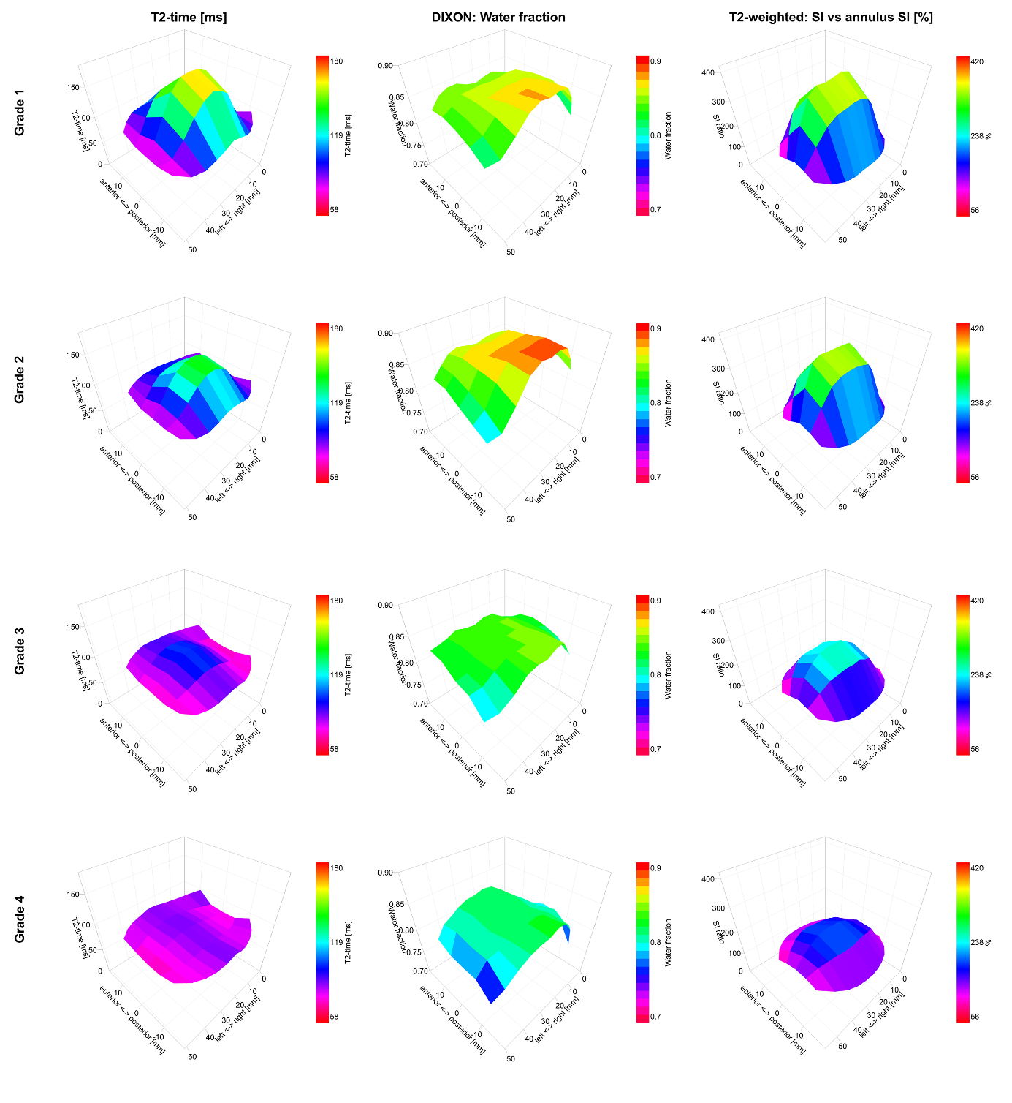

**Figure 3.** Graphical representations of the IVDs in terms of 3D plots for T2-mapping, T2w imaging and Dixon imaging. Values are averaged across each Pfirrmann grade for all IVDs T12/L1 to L5/S1 (606 IVDs from 101 subjects). Color keys indicate range of values.

**Table 2.** T2-mapping and T2w imaging reflected the IVD Pfirrmann grades, but Dixon imaging was less sensitive.

|  |  |  |  |  |
| --- | --- | --- | --- | --- |
|  | Pfirrmann grade (number of IVDs) | | | |
|  | **1 (n=47)** | **2 (n=457)** | **3 (n=60)** | **4 (n=42)** |
| **Whole IVD** | | | | |
| T2-mapping (ms) | 133.9(17.3) | 118.1(56.8)‡ | 94.4(26.2)‡ | 86.8(23.9)‡ |
| T2w-SI (no unit) | 368(42) | 337(138)‡ | 266(63)‡ | 201(58)‡ |
| Dixon (%) | 87.0(7.3) | 87.8(24.0) | 84.8(11.1) | 82.4(10.1)† |
| **Nucleus** | | | | |
| T2-mapping (ms) | 166.0(25.0) | 137.1(81.8)‡ | 103.9(37.7)‡ | 89.0(34.4)‡ |
| T2w-SI (no unit) | 551(72) | 492(236)‡ | 377(109)‡ | 271(99)‡ |
| Dixon (%) | 87.2(7.9) | 88.1(25.9) | 84.8(11.9) | 81.9(10.9)† |
| **Nucleus/annulus ratio** | | | | |
| T2-mapping (ms) | 1.8(0.3) | 1.5(0.9)‡ | 1.3(0.4)‡ | 1.0(0.4)‡ |
| T2w-SI (no unit) | 3.7(0.7) | 3.5(2.3) | 2.7(1.1)‡ | 2.0(1.0)‡ |
| Dixon (%) | 1.00(0.03) | 1.01(0.10) | 1.00(0.05) | 0.99(0.04) |

Values are mean (SD). *: p <0.05; †: p <0.01; ‡: p <0.001 and indicate significance of difference in mean to the Pfirrmann grade 1 category. Data from all IVDs T12/L1 to L5/S1 (606 discs from 101 subjects) presented. IVD: intervertebral disc; T2: relaxation time; T2w-SI: T2-weighted signal intensity.



Figure 4. Differences of each MRI techniques in quantifying the intervertebral disc. Data are relative differences in Pfirrmann grade 2, 3 and 4 compared to grade 1. See Table 2 for statistical comparisons.

The Dixon imaging technique

In comparison with the sedentary group, higher water content by Dixon of the IVD was detected in the long-distance runners, but not in groups with other training histories (Table 1; Figure 2). The Dixon imaging technique displayed small and non-significant differences in the water content over the IVD and between nucleus and annulus (Figure 3). The nucleus/annulus ratio was close to 1 (Table 2). The water content was also shown to be insensitive to general degeneration changes; whole IVD and the nucleus water content only detected differences between Pfirrmann grades 4 and 1 (Table 2; Figure 4).

Correlation analyses

There was a strong correlation between T2-mapping and T2w imaging regarding whole IVD and a moderate correlation (r=0.66, p<0.001) regarding nucleus/annulus ratio. For Dixon imaging, the whole IVD and the nucleus correlated only weakly (r all<0.29) with the T2-time and the T2w signal (Table 3).

**Table 3.** Quantification of the IVD by T2-mapping correlated moderately with T2w-SI and weakly with Dixon.

|  |  |  |  |  |  |  |  |  |  |  |  |  |  |  |  |
| --- | --- | --- | --- | --- | --- | --- | --- | --- | --- | --- | --- | --- | --- | --- | --- |
|  | | | Whole IVD | | | | Nucleus | | | | Nucleus/annulus ratio | | | | |
|  |  | T2-mapping | | Dixon | T2w-SI | T2-mapping | | Dixon | T2w-SI | T2-mapping | | Dixon | T2w-SI | |
| **Whole IVD** | T2-mapping |  | | **0.10 \*** | **0.51‡** | **0.93 ‡** | | **0.10 \*** | **0.46 ‡** | **0.43 ‡** | | 0.05 | **0.24 ‡** |
| Dixon |  | |  | **0.28‡** | **0.13 †** | | **0.99 ‡** | **0.25 ‡** | **0.16 ‡** | | **0.38 ‡** | **0.16 ‡** |
| T2w-SI |  | |  |  | **0.56 ‡** | | **0.29 ‡** | **0.92 ‡** | **0.56 ‡** | | **0.16 ‡** | **0.49 ‡** |
| **Central IVD** | T2-mapping |  | |  |  |  | | **0.13 †** | **0.61 ‡** | **0.69 ‡** | | 0.03 | **0.41 ‡** |
| Dixon |  | |  |  |  | |  | **0.26 ‡** | **0.16 ‡** | | **0.51 ‡** | **0.16 ‡** |
| T2w-SI |  | |  |  |  | |  |  | **0.73 ‡** | | **0.13 †** | **0.74 ‡** |
| **Nucleus/ annulus ratio** | T2-mapping |  | |  |  |  | |  |  |  | | 0.03 | **0.66 ‡** |
| Dixon |  | |  |  |  | |  |  |  | |  | 0.05 |
| T2w-SI |  | |  |  |  | |  |  |  | |  |  |

Values are Pearson’s correlation co-efficient. Data from all IVDs T12/L1 to L5/S1 (606 discs from 101 subjects) presented. *: p <0.05; †: p <0.01; ‡: p <0.001 and indicate significance of the correlation. IVD: intervertebral disc; T2: relaxation time; T2w-SI: T2-weighted signal intensity.

DISCUSSION

In this study, three quantitative MRI techniques (T2-mapping, T2w imaging and Dixon imaging) were used to characterize the IVDs in a young, asymptomatic, population with different training histories. Compared with T2w imaging, T2-mapping was the most sensitive technique to detect IVD changes. While there was a good correlation between the T2-mapping and the T2w imaging technique, only T2-mapping detected differences associated with physical activity history in cyclists, joggers and long-distance runners compared to sedentary referents. Also, only T2-mapping consistently distinguished between Pfirrmann grades 1 and 2.

To our knowledge, this is the first work that evaluated the feasibility of the Dixon imaging technique to characterize IVD hydration. As shown in this study, long-distance runners presented significantly higher water content than the other groups. All groups displayed differences in the T2-value, but only in the long-distance runners did the IVD changes correspond to an increased water signal. The Dixon images did not display large differences in the water content between nucleus pulposus and annulus fibrosus. In fact, the images displayed only a slow variation across the IVD, contrary to the T2-maps and T2w images that display large drops at the outer edges of annulus fibrosus where the water is strongly bound to the extracellular matrix. This can be explained by Dixon imaging only detected the water content without reflecting the structure of the IVD matrix as both T2 contrast techniques do. Moreover, Dixon imaging did not correlate with the Pfirrmann scoring system or with the other MRI techniques. Hence, the technique characterized aspects of the IVD structure that complemented the information obtained by the other techniques. Previous studies on the impact of physical activity and inactivity on the spine in an asymptomatic population report significant differences in IVD height relative to the vertebral body in long-distance runners [9; 10]. The increased height might be an indicator of IVD hypertrophy, measured as an increased water content in this cohort. Future studies are encouraged to validate this finding and investigate the additional value of including MRI techniques for water content quantification in spine examination protocols.

IVD images generated with T2-mapping display the water content of the IVD [18]. The T2-time obtained by T2-mapping has also been shown to depict the structural integrity of the disc matrix [19], displaying a stronger correlation with collagen structure than with changes in the cartilage matrix of the IVD. Hence, both the whole IVD and the nucleus T2-values should be able to reflect changes due to IVD degeneration. Our findings confirmed this and showed high a correlation between IVD T2-times and degeneration according to the Pfirrmann scoring system. The significantly higher T2-times measured in physical trained individuals might indicate reduced IVD degeneration, as previously reported [9; 10]. The T2w signal intensity also reflect the IVD T2-time, but only qualitatively. However, by normalizing the nucleus T2w signal with the annulus signal, the IVD evaluation was improved but with limited sensitivity compared with the T2-mapping technique. The limited sensitivity may stem from the heterogeneity of the coil sensitivity. Our findings suggest that T2-mapping should be the preferred T2 contrast technique to characterize preclinical degenerative IVD changes in asymptomatic individuals. This will permit research advances not only in determining risk factors for IVD degeneration with age or with various lifestyle and pathological situations but also allow intervention trials. Challenges with the T2-mapping technique prevent its implementation to clinical practice. T2-mapping is slower than current clinical T2w imaging techniques, taking approximately 10 minutes per scan, and complex postprocessing of the data is needed to model the MR signal into T2-time. However, advances in artificial intelligence may soon provide the clinician with tools for time efficient and automated T2-mapping analyses.

Limitations

In this study, the whole IVDs were delineated in addition to five sub-regions, the central nucleus and the anterior and posterior annulus. Current MRI technology cannot produce images that precisely can separate nucleus from annulus. Therefore, it is possible that nucleus tissue was incorporated in the anterior and posterior subregions, labelled as annulus tissue. Anatomical-based manual segmentation was impractical for a study of over 100 patients using three MRI techniques measuring 6 IVD levels (909 disks). Therefore, multiple sagittal slices were segmented in 5 subregions [20]. Since this limitation applied to all techniques and therefore should not affect the inter-technique comparisons, the main goal of our study. Only one radiologist determined the Pfirrmann grade of the IVDs based on published data of excellent interobserver agreement of the Pfirrmann scoring system [21].

CONCLUSIONS

Among the three quantitative techniques, T2-mapping best reflected changes in IVD degeneration according to the Pfirrmann scoring system. Most importantly, T2-mapping characterized IVD differences in individuals with different training histories. The Dixon imaging technique identified significantly higher water content in the IVDs of long-distance runners compared to the other training groups, probably associated with IVD hypertrophy. Also, Dixon displayed a weak correlation with the Pfirrmann scale and the other MRI techniques. Hence, Dixon may present information on new aspects of the IVD irrespective of matrix changes and add complementary information to the assessment and understanding of the biology of the IVD.

**ACKNOWLEDGEMENTS:** The authors thank the participants for taking part in this study and the staff of Imaging at Olympic Park for their support implementing this study. Gerontology Research Center is a joint effort between the University of Jyvaskyla and the University of Tampere. This project was supported by the School of Exercise and Nutrition Sciences, Deakin University (Grant ID: Belavy 2014-2017).

**AUTHOR CONTRIBUTIONS:** *Belavy*: Secured funding. Conception and design of the experiments. Data and statistical analysis. Interpretation of the data. Drafting the article. Approving the final version of the manuscript. *Brisby*: Revising and approving the final version of the manuscript. *Douglas*: Data analysis. Statistical analysis. Interpretation of the data. Contribution to drafting the article. Critical revision of the manuscript. Approved final version of manuscript. *Hebelka*: Revising and approving the final version of the manuscript. *Quittner*: Subject recruitment. Data collection. Approved final version of manuscript. *Owen*: Data and statistical analysis, revising and approving the final version of the manuscript. *Rantalainen*: Conception and design of the experiments, data acquisition, revising and approving the final version of the manuscript. *Trudel*: Conception and design of spinal imaging, revising and approving the final version of the manuscript. *Lagerstrand*: Conception and design of the study/approaches to comparing MR techniques. Interpretation of the data. Drafting the article. Approving the final version of the manuscript

**CONFLICTS OF INTEREST:** The authors declare no conflict of interest.

REFERENCES

1 Raj PP (2008) Intervertebral disc: anatomy-physiology-pathophysiology-treatment. Pain Pract 8:18-44

2 Dowdell J, Erwin M, Choma T, Vaccaro A, Iatridis J, Cho SK (2017) Intervertebral Disk Degeneration and Repair. Neurosurgery 80:S46-S54

3 Boos N, Weissbach S, Rohrbach H, Weiler C, Spratt KF, Nerlich AG (2002) Classification of age-related changes in lumbar intervertebral discs: 2002 Volvo Award in basic science. Spine (Phila Pa 1976) 27:2631-2644

4 Pfirrmann CW, Metzdorf A, Zanetti M, Hodler J, Boos N (2001) Magnetic resonance classification of lumbar intervertebral disc degeneration. Spine (Phila Pa 1976) 26:1873-1878

5 Samartzis D, Borthakur A, Belfer I et al (2015) Novel diagnostic and prognostic methods for disc degeneration and low back pain. Spine J 15:1919-1932

6 Waldenberg C, Hebelka H, Brisby H, Lagerstrand KM (2018) MRI histogram analysis enables objective and continuous classification of intervertebral disc degeneration. Eur Spine J 27:1042-1048

7 Belavy DL, Quittner MJ, Ridgers N, Ling Y, Connell D, Rantalainen T (2017) Running exercise strengthens the intervertebral disc. Sci Rep 7:45975

8 Belavy DL, Quittner M, Ridgers ND et al (2019) Beneficial Intervertebral Disc and Muscle Adaptations in High-Volume Road Cyclists. Med Sci Sports Exerc 51:211-217

9. Belavy DL, Albracht K, Bruggemann GP, Vergroesen PP, van Dieen JH (2016) Can Exercise Positively Influence the Intervertebral Disc? Sports Med 46:473-485

10. Owen PJ, Miller CT, Rantalainen T et al (2020) Exercise for the intervertebral disc: a 6-month randomised controlled trial in chronic low back pain. Eur Spine J. 10.1007/s00586-020-06379-7

11 Videman T, Gibbons LE, Kaprio J, Battie MC (2010) Challenging the cumulative injury model: positive effects of greater body mass on disc degeneration. Spine J 10:26-31

12 Luoma K, Vehmas T, Riihimaki H, Raininko R (2001) Disc height and signal intensity of the nucleus pulposus on magnetic resonance imaging as indicators of lumbar disc degeneration. Spine (Phila Pa 1976) 26:680-686

13 Tertti M, Paajanen H, Laato M, Aho H, Komu M, Kormano M (1991) Disc degeneration in magnetic resonance imaging. A comparative biochemical, histologic, and radiologic study in cadaver spines. Spine (Phila Pa 1976) 16:629-634

14 Mwale F, Iatridis JC, Antoniou J (2008) Quantitative MRI as a diagnostic tool of intervertebral disc matrix composition and integrity. Eur Spine J 17 Suppl 4:432-440

15 Dixon WT (1984) Simple proton spectroscopic imaging. Radiology 153:189-194

16 Takasu M, Kaichi Y, Tani C et al (2015) Iterative decomposition of water and fat with echo asymmetry and least-squares estimation (IDEAL) magnetic resonance imaging as a biomarker for symptomatic multiple myeloma. PLoS One 10:e0116842

17 Tyrrell AR, Reilly T, Troup JD (1985) Circadian variation in stature and the effects of spinal loading. Spine (Phila Pa 1976) 10:161-164

18 Marinelli NL, Haughton VM, Munoz A, Anderson PA (2009) T2 relaxation times of intervertebral disc tissue correlated with water content and proteoglycan content. Spine (Phila Pa 1976) 34:520-524

19 Antoniou J, Pike GB, Steffen T et al (1998) Quantitative magnetic resonance imaging in the assessment of degenerative disc disease. Magn Reson Med 40:900-907

20 Mok GSP, Zhang D, Chen SZ, Yuan J, Griffith JF, Wang YXJ (2016) Comparison of three approaches for defining nucleus pulposus and annulus fibrosus on sagittal magnetic resonance images of the lumbar spine. J Orthop Translat 6:34-41

21 Urrutia J, Besa P, Campos M et al (2016) The Pfirrmann classification of lumbar intervertebral disc degeneration: an independent inter- and intra-observer agreement assessment. Eur Spine J 25:2728-2733

|  |  |
| --- | --- |
|  | © 2020 by the authors. Submitted for possible open access publication under the terms and conditions of the Creative Commons Attribution (CC BY) license (http://creativecommons.org/licenses/by/4.0/). |