Randomized clinical trial
Randomized trial of general strength and conditioning versus motor control and manual therapy for chronic low back pain on physical and self-report outcomes.
Scott D Tagliaferri (MSc)¹, Clint T Miller (PhD)¹, Jon J Ford (PhD)^{2,3}, Andrew J Hahne (PhD)³, Luana C Main (PhD)¹, Timo Rantalainen (PhD)^{1,4}, David A Connell (PhD)⁵, Katherine J Simson (Hons)¹, Patrick J Owen (PhD)¹ , Daniel L Belavy (PhD)¹
¹ Deakin University, Institute for Physical Activity and Nutrition, School of Exercise and Nutrition Sciences, Geelong, Victoria, Australia.
²Advance HealthCare, 157 Scoresby Rd, Boronia, VIC 3155, Australia.
³Low Back Research Team, College of Science, Health & Engineering, La Trobe University, Bundoora, Victoria, Australia
⁴Gerontology Research Center and Faculty of Sport and Health Sciences, University of Jyväskylä, Jyväskylä, Finland.
⁵Imaging@Olympic Park, AAMI Park, 60 Olympic Boulevard, Melbourne, VIC 3004, Australia.
Corresponding author: A/Prof Daniel L Belavy, PhD; Deakin University, Institute for Physical Activity and Nutrition, School of Exercise and Nutrition Sciences, Geelong, Victoria, Australia; E-mail: d.belavy@deakin.edu.au, belavy@gmail.com.
Received: date; Accepted: date; Published: date
Abstract: Exercise and spinal manipulative therapy are commonly used for the treatment of chronic low back pain (CLBP) in Australia. Pain intensity is a common outcome; however, it is only one measure of intervention efficacy in clinical practice. Therefore, we evaluated the effectiveness of two common clinical interventions on physical and self-report measures in CLBP. Participants were randomized to a 6-month intervention of general strength and conditioning (GSC; n=20; up to 52 sessions) or motor control exercise plus manual therapy (MCMT; n=20; up to 12 sessions). Trunk extension and flexion endurance, leg muscle strength and endurance, paraspinal muscle volume, cardio-respiratory fitness and self-report measures of kinesiophobia, disability, quality of life and pain intensity were assessed at baseline and 3- and 6-month follow-up. Pain intensity differed favoring MCMT between-groups at week 14 and 16 of treatment (both, p=0.003), but not at 6-month follow-up. Both GSC (mean change[95%CI]: -10.7[-18.7, -2.8]mm; p=0.008) and MCMT (-19.2[-28.1, -10.3]mm; p<0.001) had within-group reductions in pain intensity at six months, but did not achieve clinically meaningful thresholds (20mm) within- or between-group. At 6-month follow-up, GSC increased trunk extension (mean difference [95% CI]: 81.8[34.8, 128.8]s; p=0.004) and flexion endurance (51.5[20.5, 82.6]s; p=0.004), as well as leg muscle strength (24.7[3.4, 46.0]kg; p=0.001) and endurance (9.1[1.7, 16.4]reps; p=0.015) compared to MCMT. GSC reduced disability (-5.7[-11.2, -0.2]pts; p=0.041) and kinesiophobia (-6.6[-9.9, -3.2]pts; p<0.001) compared to MCMT at 6-month follow-up. Multifidus volume increased within-group for GSC (p=0.003), but not MCMT or between-groups. No other between-group changes were observed at six months. Overall, GSC improved trunk endurance, leg muscle strength and endurance, self-report disability and kinesiophobia compared to MCMT at six months. These results show that GSC may provide a more diverse range of treatment effects compared to MCMT.
Keywords: Exercise; Spine; Physiotherapy; Physical therapy; Rehabilitation

1. Introduction
Low back pain (LBP) occurs in 40-85% of people at some point in their lives [1,2] and remains the leading cause of reduced function and years lived with disability worldwide [3,4]. Most recent estimates suggest direct and indirect costs of LBP in Australia were AU$9.17 billion per year [5] and in excess of US$100 billion per year in the United States [6]. Many individuals with back pain achieve recovery in the first six weeks [7]. However, persistent LBP (beyond six weeks) is highly prevalent, with up to 71% of people with acute LBP not fully recovered at 1 year [8]. Persistent LBP beyond 12 weeks is defined as chronic LBP (CLBP) [9,10], and accounts for majority of the costs of the condition [11].
Pain intensity is a common and important clinical outcome measure used in people with CLBP [12]. Conservative approaches, such as exercise training [13] and spinal manipulative therapy [14], are as effective as surgery for reducing pain intensity, yet is more cost effective and has a lower risk of complications [15]. Additionally, people with CLBP present as a heterogenous population which highlights the need to provide individualized treatment approaches [16]. Therefore, it is now recommended that treatment of CLBP should not solely focus on pain intensity [17]. We have already reported intervertebral disc outcomes from this trial, an important part of the ‘bio’ in biopsychosocial [18]. Muscular strength and endurance [19], paraspinal muscular atrophy [20], cardiorespiratory fitness [21], kinesiophobia [22] and quality of life [23] are additional clinical measures that could be targeted by treatment in individuals with CLBP. To adopt a more robust biopsychosocial and individualized approach, these outcomes should also be considered by clinicians when treating someone with CLBP [17].
General strength and conditioning [24,25] and motor control exercise with adjunct spinal manipulative therapy [26] are commonly implemented clinical modalities that have been extensively studied for pain intensity. However, less is known about how these interventions can impact additional outcomes in CLBP [13]. These interventions may have additional benefits that are worth exploring, as this could assist with clinical justification and improving treatment efficacy. Therefore, the aims were to assess the efficacy of general strength and conditioning (GSC) compared to motor control exercise and manual therapy (MCMT) for treating CLBP on pain intensity and a range of important clinical outcomes that could assist with treatment justification.

2. Materials and Methods
We have previously reported the protocol of this randomized clinical trial (RCT) [27], and in this paper we cite some of the a priori declared secondary outcomes. The primary outcomes of the RCT have been published elsewhere [18]. In short, the primary outcomes of the trial focused on anabolic mechanisms of exercise on the intervertebral disc, with no benefits found for intervertebral disc measures [18]. Participants were randomized to one of two groups: 1) GSC; participants completed a periodized GSC program under the supervision of an exercise physiologist with the assistance of student exercise physiologists (n=20) or 2) MCMT; participants underwent motor control exercise and manual therapy with a qualified physiotherapist (n=20). The study was approved by Deakin University Human Research Ethics Committee (project ID: 2015-191) and registered with the Australian New Zealand Clinical Trials Registry (ACTRN12615001270505). Participants provided medical clearance and written consent prior to study participation.

2.1. Participants
Participants were recruited from the general public between the inner and eastern suburbs of Melbourne (Victoria, Australia). Distribution of print and web-based advertising included local businesses, medical/health centers, Deakin University staff and students and social media. Potential participants registered their interest through a study website. Applicants were screened by phone against inclusion and exclusion criteria to determine eligibility prior to attending an assessment session.

2.1.1. Inclusion and Exclusion
Eligible participants were aged 25-45 years old with non-specific CLBP (>3 months) between the T12 vertebra and gluteal fold with pain of 2-8 on the numerical rating scale of 0-10. Exclusion criteria included previous or planned spinal surgery, traumatic spinal injury (e.g. fracture or car accident), cauda equina symptoms, known structural scoliosis, radiculopathy, or non-musculoskeletal causes of LBP. Other exclusion criteria included the inability to communicate in English, current LBP treatment (to isolate the effect of exercise), current compensable claim for their LBP, current pregnancy, considering pregnancy within the next six months, having given birth within last nine months, current smoker, current anaemia, body mass ≥120 kg, history of seizures, epilepsy, stroke or head injury, taking medications for mental illness, have metal implants unsuitable for magnetic resonance imaging (MRI), having had nuclear medicine performed in last three months or are unable to attend two 1-hour training sessions per week for six months and three 1-hour testing sessions plus additional MRI scans. Individuals undertaking more than 150 minutes per week of self-reported moderate-vigorous exercise (including any participation in structured sport or gym-based activities) were excluded to see if increases in exercise influenced the intervertebral disc outcomes of the wider study [18].

2.1.2. Randomization
An off-site researcher who had no contact with participants complete randomization (using block randomization with random block lengths and stratification for gender) [27]. Concealed allocation was achieved by the offsite researcher allocating participants in accordance with the randomization schedule.

2.2. Interventions
2.2.2. Exercise: General Strength and Conditioning
Participants in GSC underwent six months of supervised gym-based sessions. Sessions were supervised at the Deakin Clinical Exercise Centre or Burwood YMCA (Burwood, Victoria, AUS). In the first three months, participants attended two 1-hour training sessions per week, followed by a self-selected one or two sessions per week for the second three months. Participants began each session with 20 minutes of aerobic conditioning of running or walking on a treadmill, starting at 65% and progressing to 85% of heart rate maximum. Resistance training consisted of lift (e.g. squat, deadlift), push (e.g. chest press), pull (e.g. cable row), trunk extension (e.g. supine bridge) and flexion (e.g. curl-up) exercises with phases of muscular strength, hypertrophy and endurance (Supplementary Table 1). Progression was applied on a time contingent basis [28]. Pain neuroscience education regarding central hypersensitivity in chronic pain was provided to participants in the first session [29]. Participants were also instructed to complete 20-40 minutes of three weekly independent home-based aerobic training sessions at 65-85% of heart rate maximum during the 6-month protocol [30]. The mode of home training was walking or jogging. Furthermore, participants were instructed to complete 5-10 minutes of mental rehearsal tasks of movements associated with kinesiophobia in the first six weeks [31].

2.2.2. Control: Motor Control Exercise plus Manual Therapy
Participants in MCMT received 10 physiotherapy sessions of 30 minutes in the first three months and two 30-minute sessions at any period in the second three months. Treatment took place at Advance HealthCare (Boronia, Victoria, AUS). Exercises targeted the transversus abdominis, multifidus and pelvic floor muscles plus postural correction to restore optimal motor control during non-weight bearing activities [32]. Exercises and progressions followed previous protocols of motor control exercise [26,33]. Targeting activation of the deep core muscles during specific functional activities were only included as a progression if they formed part of the participants goals (e.g. walking). Progression of exercises was on a pain-contingent basis [28]. Spinal manipulative therapy followed key principles including anterior-posterior and transverse mobilizations to lumbar spinal joints as well as soft tissues to the lumbo-pelvic region [34], with techniques and dosage based on the needs of the participant and determined at the discretion of the treating physiotherapist following clinical examination. To overcome any distress that may alter motor control (e.g. inability to relax the abdominal wall), participants were provided with basic cognitive-behavioral education to reassure the participant about the safety of motor control exercise. A home exercise program was provided to participants to complete each day between sessions, consisting of motor control, pelvic floor and postural education exercises.

2.3. Outcomes
Testing sessions were completed at baseline, three and six months. In addition to this, participants were requested to complete online pain questionnaires every fortnight.

2.3.1. Physical Outcomes
Isometric trunk extension and isometric trunk flexion used assess local muscle endurance [35]. One-repetition maximum (1-RM) leg press and maximum repetitions at 70%1-RM was used to evaluate lower body strength and local muscle endurance [27]. Cardio-respiratory fitness was determined using an individualized ramp protocol on a motorized treadmill. Full details are reported in the protocol paper [27].

2.3.2. Paraspinal Muscle Size
MRI was used to evaluate paraspinal muscle size (multifidus, psoas major, quadratus lumborum and erector spinae; Figure 1). The scanner operator was blinded to group allocation. Participants were asked to lay supine with a cushion wedged between both knees and hands placed above their head. A Phillips Ingenia 3.0 T scanner (Philips Healthcare, NSW, Australia) was used to collect 65 true-axial slices with a Dixon sequence (slice thickness: 3.5mm, inter-slice distance: 0mm, repetition time: 3.6ms, echo times: 1.21/2.3ms, field-of-view: 250APx300RLmm interpolated to 432x432pixels, bandwidth: 1526.3Hz) to encompass the paraspinal muscles from the sacrum up to and including T12. To blind the image analysis to allocation and study time-point, each dataset was assigned a random number prior to image analysis (obtained from www.random.org). ImageJ 1.50i (https://imagej.nih.gov/ij/) was used to trace around each muscle on the left and right sides. A custom ImageJ plugin (ROI Analyzer; https://github.com/tjrantal/RoiAnalyzer; https://sites.google.com/site/daniellbelavy/home/roianalyser) was then used to measure muscle area. Total volume (from first through to fifth vertebral level) and each lumbar level size was calculated. Data were averaged across left and right sides prior to further analysis.

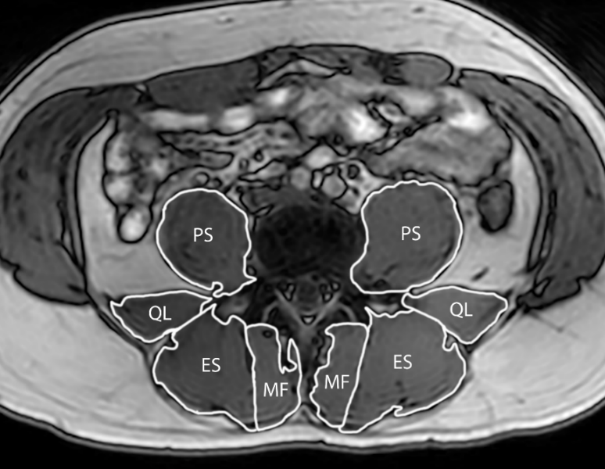

Figure 1. T2-weighted MRI image of the lumbar spine at the L4 vertebrae, showing traces of the multifidus (MF), erector spinae (ES), quadratus lumborum (QL) and psoas major (PS).

2.3.3. Self-Report Outcomes
The modified Oswestry disability index was used to measure self-reported disability due to LBP [36]. The questionnaire consists of 10 items addressing various aspects of physical function. The Tampa scale of kinesiophobia is a 17-item questionnaire which assesses fear of (re)injury due to movement or activities [37]. Questions are scored on a 4-point Likert scale ranging from strongly disagree (one) to strongly agree (four). The 36-Item short-term health survey (SF-36) was used to assess quality of life [38]. The SF-36 assesses health over the previous four weeks in eight domains, which is then weighted to construct the physical and mental component summary scores [39]. Average pain intensity of the low back across the prior week was measured by the 0-100mm VAS [40]. A link to an online database (Qualtrics, Seattle, Washington, USA) for the pain questionnaire was sent fortnightly via email to the participant.

2.4. Statistical Analysis
The original sample size calculation was based on primary intervertebral disc outcomes [27]. All statistical analyses were conducted using Stata/SE version 15 (StataCorp, College Station, Texas, USA). Normality of distribution and equality of variance were assessed using Shapiro-Wilk’s test and Levene’s test, respectively. Non-normally distributed data underwent natural log transformation, but all data presented were derived from raw data. Independent t-tests were used to determine within-group changes. Linear mixed models with random effects accounting for heterogeneity of variance according to study date and an intent-to-treat approach were used to determine between-group effects [41]. Missing data was dealt with using a maximum likelihood estimation within linear mixed models, satisfying intent-to-treat principles [42]. Significance levels of p<0.05 were used for all statistical tests.

3. Results
3.1. Descriptive Characteristics
Descriptive characteristics of participants at baseline are presented in Table 1. Eight (20%) participants of the 40 (MCMT, n=5; GSC, n=3) dropped out over the 6-month intervention (Figure 2). The MCMT group attended a mean of 9/12 (77%) sessions, while GSC completed a mean of 31/52 (60%) available sessions. No serious adverse events occurred.

Table 1. Descriptive characteristics of participants at baseline of those randomized to general strength and conditioning (GSC) and motor control manual therapy (MCMT).
 | GSC (n=20) | MCMT (n=20)
Age, yrs | 34.8 (4.9) | 34.6 (7.2)
Male, n (%)  Female, n (%) | 11 (55)  9 (45) | 10 (50)  10 (50)
Height, cm | 169.6 (7.7) | 172.5 (9.1)
Weight, kg | 77.8 (13.5) | 76.9 (16.8)
Body Mass Index, (kg/m²) | 27.1 (4.9) | 25.4 (4.2)
Medication, n (%)^{b} | 0 (0) | 1 (5)
Low Back Pain (0-100)^{c} | 41.4 (17.8) | 48.9 (19.1)
Values are displayed as mean (standard deviation) unless specified.
^{b}Reported medication at baseline included any analgesic medication (n=1, paracetamol/codeine).
^{c}Average low back pain intensity over the prior week measured by the visual analogue scale.

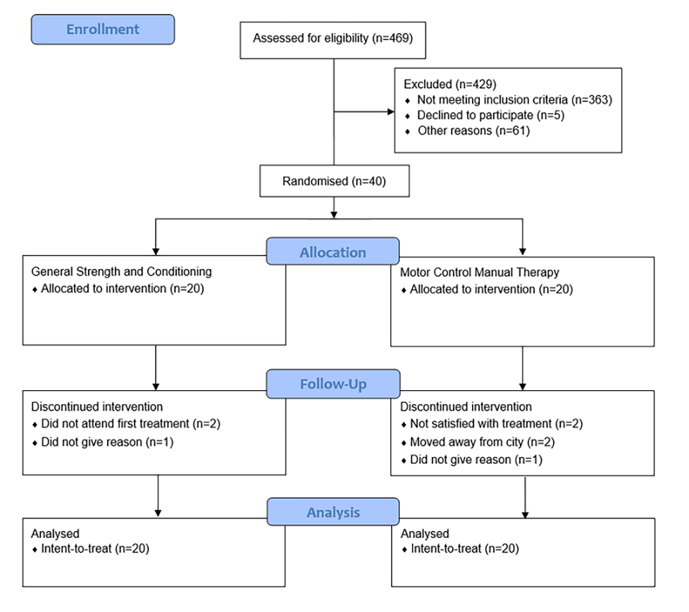
Figure 2. CONSORT diagram.

3.2. Physical Outcomes
Table 2 represents the changes in functional outcomes from baseline to three and six months. Trunk extension endurance increases were greater in GSC than MCMT at both three (mean[SD] difference, 105[92]%; p=0.007) and six months (88[27]%; p=0.004). Greater increases in trunk flexion endurance were seen in GSC at three (94[39]%; p=0.034) and six months (121[39]%; p=0.004). No difference in 1-RM leg press between groups was seen at three months, but increases were greater in GSC at six months (69[37]%; p=0.023). Leg endurance favored GSC at three (140[62]%; p=0.019) and six months (85[63]%; p=0.015). Cardio-respiratory fitness favored GSC (105[3]%; p=0.025) at three months only.

3.3. Self-Reported Outcomes
Reductions in pain intensity favored MCMT at week 14 and 16 (both, p=0.003) only (Figure 3). Within-group changes in pain intensity were observed for both MCMT (p<0.001) and GSC (p=0.008) at six months. Table 3 shows the changes in other self-reported outcomes. Each group had reductions in the Oswestry disability index at both follow-ups, which were greater in GSC at three (86[12]%; p=0.015) and six months (54[5]%; p=0.041). GSC had greater improvements in the Tampa scale of kinesiophobia compared to MCMT at three (175[33]%; p<0.001) and six months (152[33]%; p<0.001).

3.4. Paraspinal Muscle Size
Multifidus volume did not differ between groups at three or six months (Table 4). Within-group increases in multifidus volume were observed for GSC at six months only (p=0.003). A between-group difference was seen for L5 multifidus size favoring GSC at three months only (174[2]%; p=0.035, Supplementary Table 2). Within-group increases in multifidus size for GSC were seen at six months at L3 (p=0.008), L4 (p=0.013) and L5 (p=0.001) vertebral levels, but not MCMT. Erector spinae, psoas major and quadratus lumborum size before and after the intervention at each lumbar vertebral level are displayed in Supplementary Tables 3-5.
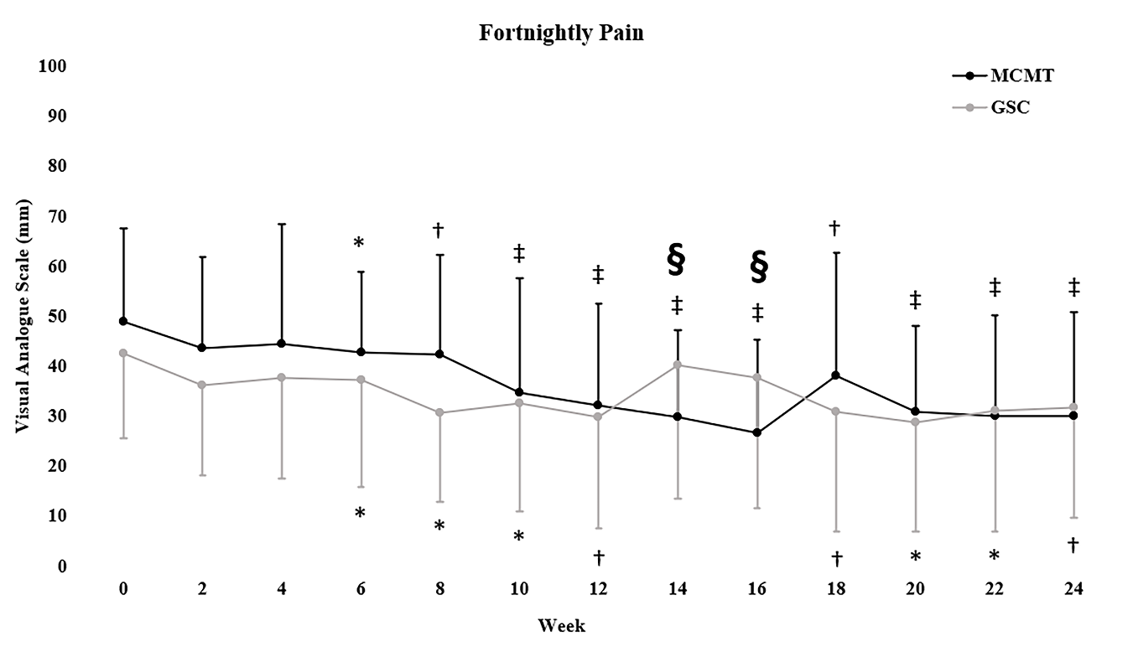
Figure 3. Mean ± standard deviation fortnightly pain (VAS) data. §P <0.01 indicates significant between-group effect at that week. *P <0.05, †P <0.01, ‡P<0.001 indicate within-group change. Symbols above error bars refer to significant changes within the MCMT group, symbols below the error bars to the GSC group.

Table 2. Intent-to-treat analysis using linear mixed models on physical outcomes at baseline, three and six months in participants randomized to general strength and conditioning (GSC) and motor control manual therapy (MCMT).
 | Baseline values and within-group changes
 | GSC |  |  | MCMT |  |  | GSC vs MCMT
 |  | Mean (SD)  Mean (95% CI) | P-value |  | Mean (SD)  Mean (95% CI) | P-value | Net difference  (95% CI) | Group x Time
Trunk Extension Endurance (s)*
Baseline |  | 101.9 (58.2) | <0.001 |  | 88.8 (35.9) | 0.305 | 51.5 (4.5, 98.4) | 0.007
∆ 3 months |  | 74.8 (38.8, 110.8) |  |  | 23.3 (-6.0, 52.6)
∆ 6 months |  | 133.7 (97.7, 169.7) | <0.001 |  | 51.8 (22.5, 81.1) | <0.001 | 81.8 (34.8, 128.8) | 0.004
Trunk Flexion Endurance (s)*
Baseline |  | 81.4 (71.5) | 0.001 |  | 60.4 (40.5) | 0.864 | 19.3 (-11.7, 50.5) | 0.034
∆ 3 months |  | 30.4 (5.6, 55.1) |  |  | 11.0 (-6.7, 28.7)
∆ 6 months |  | 68.4 (43.6, 93.2) | <0.001 |  | 16.8 (-0.9, 34.5) | 0.053 | 51.5 (20.5, 82.6) | 0.004
1-RM Leg Press (kg)
Baseline |  | 141.1 (44.2) | <0.001 |  | 130.4 (43.6) | 0.040 | 16.6 (-4.5, 37.7) | 0.123
∆ 3 months |  | 29.6 (13.0, 46.2) |  |  | 13.1 (0.6, 25.5)
∆ 6 months |  | 47.7 (30.7, 64.7) | <0.001 |  | 23.1 (10.6, 35.5) | <0.001 | 24.7 (3.4, 46.0) | 0.023
Leg Press Endurance (repetitions)
Baseline |  | 18.6 (5.4) | 0.001 |  | 21.9 (5.8) | 0.280 | 8.7 (1.4, 15.9) | 0.019
∆ 3 months |  | 10.7 (4.6, 16.9) |  |  | 1.9 (-1.5, 5.4)
∆ 6 months |  | 15.4 (9.1, 21.7) | <0.001 |  | 6.2 (2.7, 9.7) | 0.001 | 9.1 (1.7, 16.4) | 0.015
Peak Oxygen Consumption (ml/kg/min)
Baseline |  | 38.0 (8.4) | 0.027 |  | 38.8 (6.7) | 0.333 | 3.2 (0.4, 6.0) | 0.025
∆ 3 months |  | 2.2 (0.2, 4.1) |  |  | -1.0 (-3.0, 1.0)
∆ 6 months |  | 2.4 (0.4, 4.3) | 0.019 |  | 1.1 (-1.0, 3.2) | 0.295 | 1.3 (-1.6, 4.2) | 0.380
Data are: baseline unadjusted mean ± standard deviation (SD); within-group unadjusted mean absolute change with 95% confidence intervals (CI); net difference (95% CI) were calculated by subtracting unadjusted within-group absolute changes from baseline to three and six months for MCMT and GSC.
*Analysis used natural log transformed data.

Table 3. Intent-to-treat analysis using linear mixed models on self-reported outcomes at baseline, three and six months in participants randomized to general strength and conditioning (GSC) and motor control manual therapy (MCMT).
 | Baseline values and within-group changes
 | GSC |  |  | MCMT |  |  | GSC vs MCMT
 |  | Mean (SD)  Mean (95% CI) | P-value |  | Mean (SD)  Mean (95% CI) | P-value | Net difference  (95% CI) | Group x Time
Oswestry Disability Index (0-100)
Baseline |  | 24.5 (12.1) | <0.001  <0.001 |  | 23.4 (8.5) | 0.031  <0.001 | -6.7 (-12.2, -1.3)  -5.7 (-11.2, -0.2) | 0.015  0.041
∆ 3 months |  | -11.3 (-15.0, -7.6) |  |  | -4.5 (-8.5, -0.4)
∆ 6 months |  | -13.5 (-17.2, -9.8) |  |  | -7.7 (-11.8, -3.5)
Tampa Scale of Kinesiophobia (17-68)
Baseline |  | 38.7 (5.6) | <0.001  <0.001 |  | 38.6 (6.0) | 0.658  0.321 | -6.7 (-10.0, -3.4)  -6.6 (-9.9, -3.2) | <0.001  <0.001
∆ 3 months |  | -6.0 (-8.7, -3.4) |  |  | 0.4 (-1.5, 2.4)
∆ 6 months |  | -7.4 (-10.0, -4.7) |  |  | -1.0 (-3.0, 1.0)
SF-36 Physical Health (0-100)
Baseline |  | 42.6 (8.4) | <0.001  <0.001 |  | 41.2 (9.6) | 0.001  <0.001 | -0.7 (-6.7, 5.3)  0.6 (-5.5, 6.7) | 0.813  0.843
∆ 3 months |  | 7.5 (3.7, 11.3) |  |  | 8.2 (3.5, 12.9)
∆ 6 months |  | 10.4 (6.6, 14.2) |  |  | 9.7 (4.9, 14.5)
SF-36 Mental Health (0-100)
Baseline |  | 31.5 (12.4) | 0.098  0.001 |  | 33.4 (13.9) | 0.959  0.106 | 7.1 (-3.8, 18.0)  7.5 (-3.5, 18.6) | 0.202  0.179
∆ 3 months |  | 6.8 (-1.2, 14.7) |  |  | -0.2 (-7.6, 7.2)
∆ 6 months |  | 13.7 (5.7, 21.6) |  |  | 6.2 (-1.3, 13.7)
Data are: baseline unadjusted mean ± standard deviation (SD); within-group unadjusted mean absolute change with 95% confidence intervals (CI); net difference (95% CI) were calculated by subtracting unadjusted within-group absolute changes from baseline to three and six months for MCMT and GSC.
*Analysis used natural log transformed data.
 | Baseline values and within-group changes
 | GSC |  |  | MCMT |  |  | GSC vs MCMT
 |  | Mean (SD)  Mean (95% CI) | P-value |  | Mean (SD)  Mean (95% CI) | P-value | Net difference  (95% CI) | Group x Time
Multifidus Volume (cm³)
Baseline |  | 18.2 (4.0) | 0.102 |  | 18.0 (5.5) | 0.477 | 0.6 (-0.1, 1.4) | 0.096
∆ 3 months |  | 0.4 (-0.1, 1.0) |  |  | -0.2 (-0.7, 0.3)
∆ 6 months |  | 0.8 (0.3, 1.3) | 0.003 |  | 0.2 (-0.3, 0.7) | 0.463 | 0.6 (-0.1, 1.4) | 0.116
Erector Spinae Volume (cm³)
Baseline |  | 45.9 (11.2) | 0.506 |  | 48.7 (15.3) | 0.884 | 0.5 (-1.2, 2.2) | 0.570
∆ 3 months |  | 0.4 (-0.8, 1.6) |  |  | -0.1 (-1.3, 1.1)
∆ 6 months |  | 0.1 (-1.1, 1.3) | 0.810 |  | 0.1 (-1.1, 1.4) | 0.822 | 0.0 (-1.7, 1.7) | 0.998
Psoas Major Volume (cm³)
Baseline |  | 32.8 (9.7) | 0.697 |  | 32.5 (11.5) | 0.157 | 0.3 (-1.1, 1.7) | 0.677
∆ 3 months |  | -0.2 (-1.4, 0.9) |  |  | -0.5 (-1.3, 0.2)
∆ 6 months |  | 0.2 (-0.9, 1.4) | 0.686 |  | 0.0 (-0.7, 0.8) | 0.967 | 0.2 (-1.2, 1.7) | 0.761
Quadratus Lumborum Volume (cm³)
Baseline |  | 11.2 (3.4) | 0.428 |  | 11.6 (4.4) | 0.697 | 0.0 (-0.8, 0.9) | 0.933
∆ 3 months |  | 0.2 (-0.3, 0.6) |  |  | 0.1 (-0.6, 0.9)
∆ 6 months |  | 0.1 (-0.4, 0.5) | 0.813 |  | 0.3 (-0.5, 1.0) | 0.472 | -0.2 (-1.0, 0.6) | 0.614
Data are: baseline unadjusted mean ± standard deviation (SD); within-group unadjusted mean absolute change with 95% confidence interval (CI); net difference (95% CI) were calculated by subtracting unadjusted within-group absolute changes from baseline to three and six months for MCMT and GSC.
Table 4. Intent-to-treat analysis using linear mixed models on average total of multifidus, erector spinae, psoas major and quadratus lumborum volume at baseline, three and six months in participants randomized to motor control manual therapy (MCMT) and general strength and conditioning (GSC).

4. Discussion
The main findings of this RCT were that both groups had reductions in pain intensity in individuals with CLBP after six months. GSC also led to improved functional measures of trunk muscle endurance and leg muscle strength and endurance when compared to MCMT. Additionally, improvements in self-reported disability and kinesiophobia were greater following GSC than MCMT at six months.

4.1 Physical Outcomes
Trunk extension endurance improved in both groups at six months with between-group measures favoring GSC. Kell et al. [24] showed 16 weeks of resistance training was superior to aerobic training and a usual care control for improving trunk extension endurance. Javadian et al. [43] showed the addition of motor control training to an 8-week general exercise program did not lead to greater improvements in trunk endurance. Motor control exercise targets deep paraspinal muscles over global trunk muscles [32]. Specificity (e.g. training for a specific adaptation) is an important training variable with GSC training movements of trunk extension and flexion, and may reflect the results seen in our study [44]. Thus, if improving trunk endurance is a goal of treatment, further benefits can be achieved through GSC compared to MCMT.
Measures of leg muscle strength and endurance significantly favored GSC compared to MCMT at six months. Two prior RCTs of progressive resistance training in CLBP have assessed leg muscle strength with similar results to our study [25,45]. For motor control exercise, Aasa et al. [46] assessed isometric leg strength and compared this to a high-load deadlift exercise, with no difference seen between interventions. The differences observed between Aasa et al. [46] may exist due to the greater volume and frequency of training undertaken in the GSC group in our study [47]. Furthermore, a meta-analysis showed that loads >60%1-RM improve maximal strength more than training loads ≤60%1-RM [48]. MCMT implemented a low-load exercise intervention (~30% effort) focusing on spinal musculature and was not expected to lead to strength gains in the lower body directly [33]. GSC may be used for additional benefits in improving muscular leg strength when compared to MCMT.
No differences were seen in cardio-respiratory fitness between groups at the end of the intervention. Supporting our results, Chan et al. [49] showed no improvement in cardio-respiratory fitness over an 8-week period. However, Kell et al. [24] showed significant improvements in maximal oxygen consumption following supervised and periodized aerobic training. Compared to Chan et al [49], the participants in Kell et al. [24] had cardio-respiratory fitness levels below age-matched normative data [50]. Despite targeting a population not meeting the minimum daily physical activity recommendations, our participants did not have reduced cardio-respiratory fitness levels compared to age-matched norms [50]. Furthermore, increased supervision may have impacted the significant change favoring GSC at three months, when supervision was at its highest, and therefore the stimulus of aerobic training may have been insufficient after three months [51]. Assessing cardio-respiratory fitness should help to determine a sufficient dose of aerobic exercise for individuals with CLBP.

4.2 Self-Reported Outcomes
Both groups had reductions in pain intensity, however no differences were seen between groups at six months. There was a between group differences in pain intensity at week 14 and 16, with increases observed for GSC. This phase for GSC consisted of greater time under tension and eccentric contraction duration, therefore it is possible increases in pain intensity could be related to delayed-onset muscle soreness [52,53]. Furthermore, within-group changes in pain intensity remained below clinically meaningful thresholds of 20/100mm of the VAS (GSC mean change, -11mm; MCMT mean change, -19mm) [54]. The results from the current study support that pain intensity should not be the sole outcome to differentiate treatment efficacy.
GSC showed greater reductions in self-reported disability compared to MCMT at both follow-ups. The within-group change was only clinically meaningful for the GSC group (defined as <10/100 point change on the Oswestry Disability index) but did not reach this threshold between-groups [55]. A previous meta-analysis showed motor control exercise to be superior to general exercise for improving self-reported disability [56]. However, previous RCTs [24,25,45] of progressive resistance training were not included in the meta-analysis [56]. Given the moderate correlation between kinesiophobia and disability, it is possible the reductions in kinesiophobia in GSC were enough to further reduce perceptions of disability [57]. Our results show both MCMT and GSC can reduce self-report disability, however greater benefits exist with GSC at three and six months.
GSC significantly improved kinesiophobia compared to MCMT in our study. Previous research by Moticone et al. [58] demonstrated that motor control exercise alone did not improve kinesiophobia when compared to motor control exercise plus cognitive behavioral therapy. Therefore, it is likely the cognitive behavioral therapy resulted in improved kinesiophobia [58]. Cognitive behavioral therapy aims to identify and modify harmful cognitive behaviors (e.g. fear-avoidance and pain catastrophizing) in those with CLBP [59]. In the MCMT group in our study, cognitive behavioral therapy was only targeted at the safety of motor control exercise and may have not been adequate to alter kinesiophobia. However, mental rehearsal of feared movements and pain education in conjunction with exercise in GSC may have modified negative cognitions towards LBP, and subsequently reduced kinesiophobia [59]. Results from our study show GSC has benefits for reducing kinesiophobia compared to MCMT.

4.3 Paraspinal Muscle Size
No between-group differences were seen in any MRI outcomes at six-months, however a significant within-group change in multifidus volume was observed for GSC. Danneels et al. [60] similarly showed that motor control exercise did not improve lumbar multifidus size. However, the addition of dynamic-static trunk resistance training led to significant increases [60]. Contrastingly, Chung et al. [61] showed motor control exercise increased lumbar multifidus size. Although, Chung et al. [61] only used a per-protocol analysis, which may overestimate the magnitude of change [62]. Berglund et al. [63] provided evidence that exercise may increase multifidus size, but was not conclusive regarding which type of exercise may be more beneficial. Generally, loads of 40-80%1-RM are recommended to maximize muscular hypertrophy [48]. Motor control exercise recruits the multifidus at less than 30%1-RM, which is unlikely to promote muscular hypertrophy [33]. Our results support the notion that resistance training at loads of 40-80%1-RM may be required to increase multifidus size.

4.4 Strengths and Limitations
This study was strengthened by an offsite researcher with no participant contact conducting randomization. MRI data was processed and analyzed by a blinded assessor. Finally, an experienced therapist oversaw each of the two interventions to ensure protocol adherence and consistency.
For limitations, five participants dropped out from MCMT (25%), while three dropped out from GSC (15%). To minimize the risk of bias due to attrition, a full case intent-to-treat analysis was completed [64]. There were differences between groups in the number of sessions and face-to-face time with clinicians, however, this was a pragmatic approach reflective of current clinical practice [65]. Additionally, most of the improvements were already favorable towards GSC at three months. Therefore, the total number of sessions to achieve differences in these outcomes may not be as large as the maximum number of sessions in our study. We requested that participants complete an exercise diary for their home program, however due to poor adherence and reporting, we were unable to provide detail on their adherence. Furthermore, given we screened 469 individuals with only 40 eventually included in the trial, these results may only be generalizable to a smaller population of individuals with CLBP who fit within our inclusion and exclusion criteria [66]. Lastly, given the primary aim of the trial was targeted at anabolism of the intervertebral disc, within this sample, we did not consider if there were specific sub-groups that may benefit from particular treatments [67]. For example, in the MCMT group, not all participants presented with hypomobility that could benefit from spinal manipulative therapy, meaning that individuals may have not been best matched to this treatment approach [26]. Future trials may want to assess if sub-groups can have additional treatment benefits from matched treatments to maximize treatment efficacy [67].

5. Conclusions
In our study, both MCMT and GSC had reductions in pain intensity, however the results did not reach clinically meaningful within- or between-group thresholds. GSC produced significantly greater improvements in trunk endurance, leg muscle strength and endurance, self-report disability and kinesiophobia compared to MCMT. Therefore, GSC may achieve a more diverse range of treatment effects than MCMT and should be considered by clinicians when these are important outcomes to be improved for their patient. These results highlight the additional clinical benefits of GSC, when compared to MCMT, when treatment of CLBP is sought by patients or endorsed by clinicians.

Supplementary Materials: The following are available online at www.mdpi.com/xxx/s1.
Table S1: Periodization model for the 6-month general strength and conditioning (GSC) intervention.
Table S2: MRI outcomes for multifidus size of the middle three slices of each spinal level (L1-L5) at baseline, three and six months in participants randomized to motor control manual therapy (MCMT) and general strength and conditioning (GSC).
Table S3: MRI outcomes for erector spinae size of the middle three slices of each spinal level (L1-L5) at baseline, three and six months in participants randomized to motor control manual therapy (MCMT) and general strength and conditioning (GSC).
Table S4: MRI outcomes for psoas major size of the middle three slices of each spinal level (L1-L5) at baseline, three and six months in participants randomized to motor control manual therapy (MCMT) and general strength and conditioning (GSC).
Table S5: MRI outcomes for quadratus lumborum size of the middle three slices of each spinal level (L1-L5) at baseline, three and six months in participants randomized to motor control manual therapy (MCMT) and general strength and conditioning (GSC).
Author Contributions: SDT – Statistical analysis, preparation of manuscript. CTM – Conception and design of experiments, data collection, revision of manuscript. JJF – Conception and design of experiments, revision of manuscript. AJH – Conception and design of experiments, off-site randomization, revision of manuscript. LCM – Conception and design of experiments, collection of questionnaire data, revision of manuscript. TR - Conception and design of experiments, revision of manuscript. DC – Collection of MRI data, revision of manuscript. KS – Data collection, revision of manuscript. PJO – Data collection, revision of manuscript. DLB – Conception and design of experiments, data collection, revision, conception, and design of manuscript
Funding: This project was supported by internal institutional funding (to DLB).
Acknowledgments: The authors thank the participants for taking part in this study and the staff of Imaging at Olympic Park for their support implementing this study. Scott Tagliaferri is supported by an Australian Government Research Training Program (RTP) Scholarship. Gerontology Research Center is a joint effort between the University of Jyvaskyla and the University of Tampere.
Conflicts of Interest: The authors declare no conflict of interest.
Ethics approval: The study was granted ethical approval from the Deakin University Human Research Ethics Committee on 12 October 2015 (project ID: 2015-191).
Trial Registration: Australian New Zealand Clinical Trials Registry (ACTRN12615001270505).
Data sharing statement: Upon request.

References
1. Hoy D, Bain C, Williams G, March L, Brooks P, Blyth F, et al. A systematic review of the global prevalence of low back pain. Arthritis & Rheumatology. 2012;64(6):2028-37.
2. Andersson GB. Epidemiological features of chronic low-back pain. The Lancet. 1999;354(9178):581-5.
3. Vos T, Flaxman AD, Naghavi M, Lozano R, Michaud C, Ezzati M, et al. Years lived with disability (YLDs) for 1160 sequelae of 289 diseases and injuries 1990–2010: A systematic analysis for the global burden of disease study 2010. The Lancet. 2012;380(9859):2163-96.
4. Murray CJ, Vos T, Lozano R, Naghavi M, Flaxman AD, Michaud C, et al. Disability-adjusted life years (DALYs) for 291 diseases and injuries in 21 regions, 1990–2010: A systematic analysis for the Global Burden of Disease Study 2010. The Lancet. 2013;380(9859):2197-223.
5. Walker B, Muller R, Grant W. Low back pain in Australian adults: The economic burden. Asia Pacific Journal of Public Health. 2003;15(2):79-87.
6. Martin BI, Deyo RA, Mirza SK, Turner JA, Comstock BA, Hollingworth W, et al. Expenditures and health status among adults with back and neck problems. JAMA. 2008;299(6):656-64.
7. Costa L, Maher CG, Hancock MJ, McAuley JH, Herbert RD, Costa LO. The prognosis of acute and persistent low-back pain: A meta-analysis. Canadian Medical Association Journal. 2012;184(11):613-E24.
8. Itz CJ, Geurts J, Van Kleef M, Nelemans P. Clinical course of non‐specific low back pain: A systematic review of prospective cohort studies set in primary care. European Journal of Pain. 2013;17(1):5-15.
9. Qaseem A, Wilt TJ, McLean RM, Forciea MA. Noninvasive treatments for acute, subacute, and chronic low back pain: A clinical practice guideline from the American College of Physicians. Annals of Internal Medicine. 2017;166(7):514-30.
10. Koes BW, van Tulder M, Lin C-WC, Macedo LG, McAuley J, Maher C. An updated overview of clinical guidelines for the management of non-specific low back pain in primary care. European Spine Journal. 2010;19(12):2075-94.
11. Dagenais S, Caro J, Haldeman S. A systematic review of low back pain cost of illness studies in the United States and internationally. The Spine Journal. 2008;8(1):8-20.
12. Searle A, Spink M, Ho A, Chuter V. Exercise interventions for the treatment of chronic low back pain: A systematic review and meta-analysis of randomised controlled trials. Clinical Rehabilitation. 2015;29(12):1155-67.
13. Owen PJ, Miller CT, Mundell NL, Verswijveren SJ, Tagliaferri SD, Brisby H, et al. Which specific modes of exercise training are most effective for treating low back pain? Network meta-analysis. British Journal of Sports Medicine. 2019;1.
14. Rubinstein SM, de Zoete A, van Middelkoop M, Assendelft WJ, de Boer MR, van Tulder MW. Benefits and harms of spinal manipulative therapy for the treatment of chronic low back pain: Systematic review and meta-analysis of randomised controlled trials. The BMJ. 2019;364:689.
15. Chou R, Baisden J, Carragee EJ, Resnick DK, Shaffer WO, Loeser JD. Surgery for low back pain: A review of the evidence for an American Pain Society clinical practice guideline. Spine. 2009;34(10):1094-109.
16. O'Sullivan P, Caneiro JP, O'Keeffe M, O'Sullivan K. Unraveling the complexity of low back pain. Journal of Orthopaedic & Sports Physical Therapy. 2016;46(11):932-7.
17. Tagliaferri SD, Miller CT, Owen PJ, Mitchell UH, Brisby H, Fitzgibbon B, et al. Domains of chronic low back pain and assessing treatment effectiveness: A clinical perspective. Pain Practice. 2019;1.
18. Owen PJ, Miller CT, Rantalainen T, Simson KJ, Connell D, Hahne AJ, et al. Exercise for the intervertebral disc: a 6-month randomised controlled trial in chronic low back pain. European Spine Journal. 2020.
19. Taylor JB, Goode AP, George SZ, Cook CE. Incidence and risk factors for first-time incident low back pain: A systematic review and meta-analysis. The Spine Journal. 2014;14(10):2299-319.
20. Ranger TA, Cicuttini FM, Jensen TS, Peiris WL, Hussain SM, Fairley J, et al. Is the size and composition of the paraspinal muscles associated with low back pain? A systematic review. The Spine Journal. 2017;17:1729–48.
21. Duque I, Parra J-H, Duvallet A. Maximal aerobic power in patients with chronic low back pain: A comparison with healthy subjects. European Spine Journal. 2011;20(1):87-93.
22. Chou R, Shekelle P. Will this patient develop persistent disabling low back pain? JAMA. 2010;303(13):1295-302.
23. Lamé IE, Peters ML, Vlaeyen JW, Kleef Mv, Patijn J. Quality of life in chronic pain is more associated with beliefs about pain, than with pain intensity. European Journal of Pain. 2005;9(1):15-24.
24. Kell RT, Asmundson GJ. A comparison of two forms of periodized exercise rehabilitation programs in the management of chronic nonspecific low-back pain. The Journal of Strength & Conditioning Research. 2009;23(2):513-23.
25. Kell RT, Risi AD, Barden JM. The response of persons with chronic nonspecific low back pain to three different volumes of periodized musculoskeletal rehabilitation. The Journal of Strength & Conditioning Research. 2011;25(4):1052-64.
26. Ford JJ, Hahne AJ, Surkitt LD, Chan AY, Richards MC, Slater SL, et al. Individualised physiotherapy as an adjunct to guideline-based advice for low back disorders in primary care: A randomised controlled trial. British Journal of Sports Medicine. 2016;50(4):237-45.
27. Simson KJ, Miller CT, Ford J, Hahne A, Main L, Rantalainen T, et al. Optimising conservative management of chronic low back pain: Study protocol for a randomised controlled trial. Trials. 2017;18(1):184-96.
28. Macedo LG, Latimer J, Maher CG, Hodges PW, McAuley JH, Nicholas MK, et al. Effect of motor control exercises versus graded activity in patients with chronic nonspecific low back pain: A randomized controlled trial. Physical Therapy. 2012;92(3):363-77.
29. Clarke CL, Ryan CG, Martin DJ. Pain neurophysiology education for the management of individuals with chronic low back pain: A systematic review and meta-analysis. Manual Therapy. 2011;16(6):544-9.
30. Kodesh E, Weissman-Fogel I. Exercise-induced hypoalgesia–interval versus continuous mode. Applied Physiology, Nutrition, and Metabolism. 2014;39(7):829-34.
31. Caneiro J, O’Sullivan P, Lipp OV, Mitchinson L, Oeveraas N, Bhalvani P, et al. Evaluation of implicit associations between back posture and safety of bending and lifting in people without pain. Scandinavian Journal of Pain. 2018.
32. Saragiotto BT, Maher CG, Yamato TP, Costa LO, Menezes Costa LC, Ostelo RW, et al. Motor control exercise for chronic non specific low back pain. The Cochrane Library. 2016.
33. Ford J, Hahne A, Chan AY, Surkitt L. A classification and treatment protocol for low back disorders: Part 3 - Functional restoration for intervertebral disc related disorders. Physical Therapy Reviews. 2012;17(1):55-75.
34. Maitland G. The Maitland concept: Assessment, examination and treatment by passive movement. Physical therapy of the low back. Clinical Physical Therapy. 1987;13:135-56.
35. Ito T, Shirado O, Suzuki H, Takahashi M, Kaneda K, Strax TE. Lumbar trunk muscle endurance testing: An inexpensive alternative to a machine for evaluation. Archives of Physical Medicine and Rehabilitation. 1996;77(1):75-9.
36. Fritz JM, Irrgang JJ. A comparison of a modified Oswestry low back pain disability questionnaire and the Quebec back pain disability scale. Physical Therapy. 2001;81(2):776-88.
37. Miller RP, Kori SH, Todd DD. The Tampa scale: A measure of kinisophobia. The Clinical Journal of Pain. 1991;7(1):51.
38. Ware Jr JE, Sherbourne CD. The MOS 36-item short-form health survey (SF-36): Conceptual framework and item selection. Medical Care. 1992:473-83.
39. Ware JE, Keller SD, Kosinski M. SF-36 physical and mental health summary scales: Health Assessment Lab Boston; 1994.
40. Ohnhaus EE, Adler R. Methodological problems in the measurement of pain: A comparison between the verbal rating scale and the visual analogue scale. Pain. 1975;1(4):379-84.
41. Abraha I, Montedori A. Modified intention to treat reporting in randomised controlled trials: Systematic review. BMJ. 2010;340:c2697.
42. Horton NJ, Kleinman KP. Much ado about nothing: A comparison of missing data methods and software to fit incomplete data regression models. The American Statistician. 2007;61(1):79-90.
43. Javadian Y, Behtash H, Akbari M, Taghipour-Darzi M, Zekavat H. The effects of stabilizing exercises on pain and disability of patients with lumbar segmental instability. Journal of back and musculoskeletal rehabilitation. 2012;25(3):149-55.
44. Radaelli R, Fleck SJ, Leite T, Leite RD, Pinto RS, Fernandes L, et al. Dose-response of 1, 3, and 5 sets of resistance exercise on strength, local muscular endurance, and hypertrophy. The Journal of Strength & Conditioning Research. 2015;29(5):1349-58.
45. Jackson JK, Shepherd TR, Kell RT. The influence of periodized resistance training on recreationally active males with chronic nonspecific low back pain. The Journal of Strength & Conditioning Research. 2011;25(1):242-51.
46. Aasa B, Berglund L, Michaelson P, Aasa U. Individualized low-load motor control exercises and education versus a high-load lifting exercise and education to improve activity, pain intensity, and physical performance in patients with low back pain: A randomized controlled trial. Journal of Orthopaedic & Sports Physical Therapy. 2015;45(2):77-85.
47. Grgic J, Schoenfeld BJ, Davies TB, Lazinica B, Krieger JW, Pedisic Z. Effect of resistance training frequency on gains in muscular strength: A systematic review and meta-analysis. Sports Medicine. 2018:1-14.
48. Schoenfeld BJ, Grgic J, Ogborn D, Krieger JW. Strength and hypertrophy adaptations between low-vs. high-load resistance training: A systematic review and meta-analysis. The Journal of Strength & Conditioning Research. 2017;31(12):3508-23.
49. Chan CW, Mok NW, Yeung EW. Aerobic exercise training in addition to conventional physiotherapy for chronic low back pain: A randomized controlled trial. Archives of Physical Medicine and Rehabilitation. 2011;92(10):1681-5.
50. Shvartz E, Reibold R. Aerobic fitness norms for males and females aged 6 to 75 years: A review. Aviation, Space, and Environmental Medicine. 1990;61(1):3-11.
51. Jordan JL, Holden MA, Mason EE, Foster NE. Interventions to improve adherence to exercise for chronic musculoskeletal pain in adults. The Cochrane Library. 2010:1-62.
52. Pettitt RW, Udermann BE, Reineke DM, Wright GA, Battista RA, Mayer JM, et al. Time-course of delayed onset muscle soreness evoked by three intensities of lumbar eccentric exercise. Athletic Training and Sports Health Care. 2010;2(4):171-6.
53. Veqar Z, Kalra R. Causes and management of delayed onset muscle soreness: A review. Elixir Human Physio. 2013;55:13205-11.
54. Mannion AF, Balagué F, Pellisé F, Cedraschi C. Pain measurement in patients with low back pain. Nature Reviews Rheumatology. 2007;3(11):610.
55. Vianin M. Psychometric properties and clinical usefulness of the Oswestry Disability Index. Journal of Chiropractic Medicine. 2008;7(4):161-3.
56. Gomes-Neto M, Lopes JM, Conceição CS, Araujo A, Brasileiro A, Sousa C, et al. Stabilization exercise compared to general exercises or manual therapy for the management of low back pain: A systematic review and meta-analysis. Physical Therapy in Sport. 2017;23:136-42.
57. Crombez G, Vlaeyen JW, Heuts PH, Lysens R. Pain-related fear is more disabling than pain itself: Evidence on the role of pain-related fear in chronic back pain disability. Pain. 1999;80(1-2):329-39.
58. Monticone M, Ferrante S, Rocca B, Baiardi P, Dal Farra F, Foti C. Effect of a long-lasting multidisciplinary program on disability and fear-avoidance behaviors in patients with chronic low back pain: Results of a randomized controlled trial. The Clinical Journal of Pain. 2013;29(11):929-38.
59. Henschke N, Ostelo RW, van Tulder MW, Vlaeyen JW, Morley S, Assendelft WJ, et al. Behavioural treatment for chronic low back pain. The Cochrane Library. 2010.
60. Danneels L, Vanderstraeten G, Cambier D, Witvrouw E, Bourgois J, Dankaerts W, et al. Effects of three different training modalities on the cross sectional area of the lumbar multifidus muscle in patients with chronic low back pain. British Journal of Sports Medicine. 2001;35(3):186-91.
61. Chung S, Lee J, Yoon J. Effects of stabilization exercise using a ball on mutifidus cross-sectional area in patients with chronic low back pain. Journal of Sports Science & Medicine. 2013;12(3):533.
62. Gupta SK. Intention-to-treat concept: A review. Perspectives in Clinical Research. 2011;2(3):109-12.
63. Berglund L, Aasa B, Michaelson P, Aasa U. Effects of Low-Load Motor Control Exercises and a High-Load Lifting Exercise on Lumbar Multifidus Thickness. Spine. 2017;42(15):E876-E82.
64. Higgins JP, Green S. Cochrane handbook for systematic reviews of interventions 5.1.0. The Cochrane Collaboration. 2011:33-49.
65. Hoffmann TC, Maher CG, Briffa T, Sherrington C, Bennell K, Alison J, et al. Prescribing exercise interventions for patients with chronic conditions. Canadian Medical Association Journal. 2016;188(7):510-8.
66. Kamper SJ. Generalizability: Linking evidence to practice. Journal of Orthopaedic & Sports Physical Therapy. 2020;50(1):45-6.
67. Saragiotto BT, Maher CG, Hancock MJ, Koes BW. Subgrouping patients with nonspecific low back pain: Hope or hype? Journal of Orthopaedic & Sports Physical Therapy. 2017;47(2):44-8.

© 2020 by the authors. Submitted for possible open access publication under the terms and conditions of the Creative Commons Attribution (CC BY) license (http://creativecommons.org/licenses/by/4.0/).

