Thermal comfort properties of bifacial fabrics

Licheng Zhua, Xungai Wangb, a, Ian Blanchonettec and Maryam Naebeb

a Wuhan Textile University, Wuhan, China

b Deakin University, Geelong, Australia, Institute for Frontier Materials

c CSIRO Manufacturing, Geelong, Australia

Corresponding author:

Maryam Naebe, Deakin University, Waurn Ponds Campus, Locked Bag 20000, Geelong, VIC 3220, Australia

Email: maryam.naebe@deakin.edu.au

**Abstract**

Bifacial fabrics, with a single jersey on one face and a plain weave on the other, were produced on a purpose-built machine. Thermal comfort properties of bifacial fabrics were compared with conventional woven and knitted fabrics and the effect of weft density and loop length of bifacial fabrics on their thermal comfort properties was investigated. While different fabric structures were produced with the same wool, acrylic and polyester yarns, the findings confirmed that the bifacial fabric is warmer (lower total heat loss) and more breathable (higher permeability index ($i_{m}$)) than the corresponding woven and knitted fabrics. Increasing loop length of bifacial fabrics enhanced evaporative resistance, air permeability, warm feeling, thermal resistance and water vapour permeability index, yet reduced total heat loss. An increase in weft density of bifacial fabrics led to higher evaporative resistance, warmer feeling, higher thermal resistance, and lower air permeability and total heat loss. However, permeability index did not change with an increase in weft density. This study suggests that thermal comfort properties of bifacial fabrics can be optimized by modifying structural parameters to engineer high performance textiles.

**Keywords**

Bifacial fabric, woven fabric, knitted fabric, comfort properties, heat transfer properties, moisture transfer properties

**Introduction**

The thermal properties of apparel fabrics are one of the most important properties affecting human perception of comfort.1 Since temperature differentials typically exist between the skin and the outside environment, the skin releases heat, leading to comfort or discomfort depending on the rate of heat loss. The apparel fabrics between the skin and the environment have a significant influence on the heat loss.2

Heat released from the skins is normally in two forms, evaporation and sensible heat transfer3-6 (including conduction, convection and radiation)7. However, in actual wearing circumstances, it is impossible to separate heat and moisture transfer through clothing. Therefore, assessing the combination of the evaporation and heat transfer is a key part of determining the thermal comfort properties of fabrics.

The permeability index ($i_{m}$), as defined by the relationship between thermal resistance and evaporative resistance, is generally used to determine the thermal comfort properties or breathability of fabrics. The permeability index is a measure of the efficiency of evaporative heat transport in a clothing system.8 An of zero means that no evaporative heat transfer can occur in the clothing system, while an $i_{m}$ of one is the theoretical maximum evaporative heat transfer in the clothing system. A permeability index of 0.3 is thought to give the optimum thermal comfort by clothing.9

There are several variables that affect the permeability index (thermal comfort properties) in a steady state, such as fabric thickness, air permeability, moisture regain, thermal conductivity and drying time.10 While the correlation between air permeability and permeability index is positive, correlation between the permeability index and the other variables is negative.

Total heat loss is another measure of thermal comfort, which is different from the permeability index in three ways.1, 8 Total heat loss and the permeability index are measured under different conditions (ambient temperature and humidity). The total heat loss is the amount of heat flux including dry and evaporative heat exchanges, while the permeability index is the efficiency of evaporative heat transfer through a clothing system. The total heat loss is expressed in watts per square meter (W/m2), while the permeability index is dimensionless. Since the total heat loss is the amount of heat flux transferring through a clothing system, the lower the value of total heat loss, the warmer the clothing is in cold environments.

Inspired by natural leaves with different appearances and functionalities on two faces, bifacial fabrics for apparel uses were designed and manufactured.11 Bifacial fabrics show a unique appearance, with a knitted structure on one face and a woven structure on the other, as shown in Figure 1. We have reported that the evaporative resistance of bifacial fabrics is slightly higher than that of comparable knitted and woven fabrics, and water spreading and absorption on the woven face of bifacial fabrics are quicker than that on their knitted face.12{Zhu, 2017 #663} The thermal resistance of bifacial fabrics is also higher than that of the knitted and woven fabrics, and the bifacial fabrics have lower air permeability, yet are warmer to touch than knitted and woven fabrics.13 In addition, water spreading, evaporative and thermal resistance on two faces of the bifacial fabric are different.12, 13 This is due to the unique pore distribution across its thickness direction.14 Bifacial fabrics also have unique mechanical properties,15 such as two breakages (two peaks in the load-extension curves) in both the warp and weft directions.

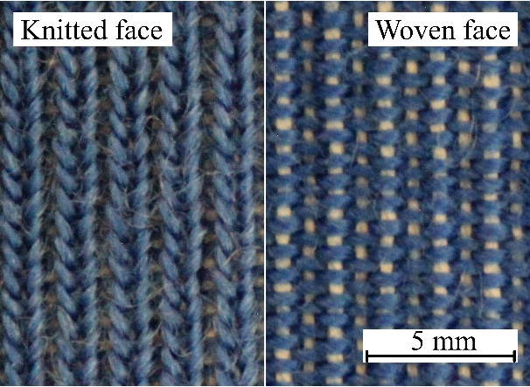 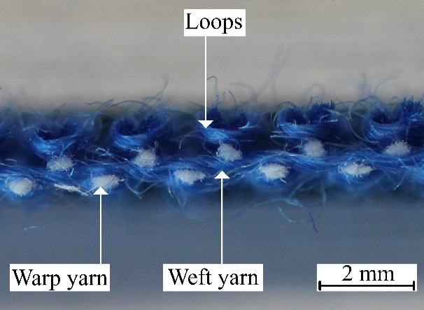

(a) (b)

Figure 1. Appearances of (a) two faces and (b) cross-section in the warp direction of the bifacial fabric.12

In this study, the thermal comfort properties (permeability index and total heat loss) of woven, knitted and bifacial fabrics are compared. The effect of weft density and loop length of bifacial fabrics on thermal resistance, evaporative resistance, thermal-contact feeling, permeability index and total heat loss are investigated. This information may help to design and manufacture high performance fabrics with tuneable comfort.

# Experimental details

## Materials

Table 1 shows the details of the fabrics produced. Woven (plain weave) and knitted (single jersey) fabrics were produced on a weaving machine (CCI, Taiwan) and a knitting machine (Shima Seiki SES, Japan), respectively. The bifacial fabrics were manufactured on a purpose-built machine.12

It is well known that materials (fibres and yarns) have significant influence on fabric properties. Therefore, in this study all fabrics were produced with the same yarns to remove the fibre and yarn influence. As a result, the differences in the fabric properties can be considered to be caused by fabric structures.

Properties of fabrics manufactured in this study were compared to a bench-mark fabric (BM) to provide an estimation where bifacial fabrics stand in the existing commercial fabric spectrum. It was difficult to find the BM fabric in the market similar to the fabrics used in this study with exactly the same materials and structural parameters. Therefore, a pure wool single jersey knitted fabric with a similar thickness was selected as the BM fabric.

Table 1. The details of fabric samples investigated in this study.

|  |  |  |  |  |  |  |  |
| --- | --- | --- | --- | --- | --- | --- | --- |
| Fabric | | Warp yarns | | Weft/loop yarns | | Loop length (mm) | Weft density  (picks/cm) |
| Material | Count | Materiala | Count |
| W | Woven | 100% polyester | 56 tex | 35% acrylic 65% wool | 65 tex | N/A | 22 |
| K | Knitted | N/A | | 35% acrylic 65% wool | 65 tex | 5.5 | N/A |
| BF1 | Bifacial | 100% polyester | 56 tex | 35% acrylic 65% wool | 65 tex | 5.5 | 14 |
| BF2 | Bifacial | 100% polyester | 56 tex | 35% acrylic 65% wool | 65 tex | 5.5 | 18 |
| BF3 | Bifacial | 100% polyester | 56 tex | 35% acrylic 65% wool | 65 tex | 5.5 | 22 |
| BF4 | Bifacial | 100% polyester | 56 tex | 35% acrylic 65% wool | 65 tex | 5 | 18 |
| BF5 | Bifacial | 100% polyester | 56 tex | 35% acrylic 65% wool | 65 tex | 6 | 18 |
| BM | BMb | N/A |  | 100% wool | 75/2 tex | 6.2 | N/A |

a Weft/loop yarns are the same except their colours;

b Bench-mark fabrics (single jersey, gauge: 14, fibre diameter: 21.9 µm, and cover factor: 1.28).

## Methods

Fabric thickness, gram per square meter (GSM), thermal-contact feeling, evaporative resistance and thermal resistance were determined as described previously.12,13 Briefly, the fabric thickness was measured according to ASTM D1777-96 (2011) using an Absolute Digimatic ID-C 1012PB thickness gauge (Mitutoyo Corp, Japan). The thermal-contact feeling was measured using a Thermo Labo Ⅱ (KES-F7, KATO Tech Co. Japan). Tests of thermal resistance ($R_{cf}$) and evaporative resistance ($R_{ef}$) were conducted using a Sweating Guarded Hotplate/Espec Chamber (Measurement Technology Northwest, USA) according to standard test method ASTM F1868-12 part A and B, respectively.

**Permeability index**

The permeability index for a fabric system alone was calculated using Equation (1).8

(1)

where $i_{m}$ is the permeability index (dimensionless); $R_{cf}$ is the fabric intrinsic insulation value12 calculated using Equation (2);16 and the $R_{ef}$ is the fabric intrinsic evaporative resistance12 calculated using Equation (3). 16

(2)

where $R_{ct}$ is the total resistance to dry heat transfer provided by the fabric system and air layer (K·m2/W); is the bare plate thermal resistance (K·m2/W); is the area of the plate test section (m2); is the temperature at the plate surface (℃); $T_{a}$ is the air temperature (℃) and $H_{c}$ is the power input (W).

${R_{ef}=R}_{et}-R_{ebp}=\left(P_{s}-P_{a}\right)\frac{A}{H_{E}}-R_{ebp}$ (3)

where $R_{et}$ is the resistance to evaporative heat transfer provided by the fabric system and air layer (kPa·m2/W); is the bare plate evaporative resistance (kPa·m2/W); is the area of the plate test section (m2); is the water vapour pressure at the plate surface (kPa); $P_{a}$ is the water vapour pressure in the air (kPa) and $H_{E}$ is the power input (W).

**Total heat loss**

Tests of total heat loss were carried out using the Sweating Guarded Hotplate/Espec Chamber (Measurement Technology Northwest, USA) according to standard test method ASTM F1868-12 (part C). The temperature of the test plate, guard section and bottom plate was controlled at 35 ± 0.1 ℃, while the ambient temperature and air velocity were 25 ± 0.1 ℃ and 1 ± 0.1 m/s, respectively. The relative humidity was maintained at 65 ± 4 % during a test.

Once thermal resistance of the bare plate ($R_{cbp}$) was obtained, three samples (50 cm × 50 cm) from each fabric were measured to achieve the total resistance to dry heat transfer ($R_{ct}$) provided by the fabric system and air layer. Then the intrinsic thermal resistance ($R_{cf}^{'}$) provided by the fabric sample alone was calculated by subtracting the thermal resistance for the air layer ($R_{cbp}$) from the total thermal resistance ($R_{ct}$). Finally, the average of three measurements was reported as the intrinsic thermal resistance of the fabric.

The $R_{ef}^{'}$ of the sample was achieved in a similar manner to the $R_{cf}^{'}$. After the bare plate evaporative resistance ($R_{ebp}$) was obtained, three samples (50 cm × 50 cm) from each fabric were measured to achieve the total evaporative resistance ($R_{et}$). Then the resistance to evaporative heat transfer ($R_{ef}^{'}$) provided by the fabric sample alone was calculated by subtracting the evaporative resistance for the air layer and liquid barrier ($R_{ebp}$) from the total evaporative resistance ($R_{et}$). Finally, the average of three trials was reported.

The total heat loss of the samples was calculated using the Equation (4).16

(4)

where is the total heat loss (W/m2); is the average intrinsic thermal resistance (K·m2/W); and the $R_{ef}^{'}$ is the average intrinsic evaporative resistance (kPa·m2/W) of the fabric.

**Statistical analysis**

Results of thermal-contact feeling (n=20, number of tests), thermal resistance (n=6, number of tests) and evaporative resistance (n=6, number of tests) were tested statistically for significance of differences using a one-way analysis of variance (ANOVA; SPSS Statistics 23, IBM).

# Results and discussion

***Permeability index***

Average of thickness, gram per square meter (GSM) and volumetric density and the standard deviation (s.d) of fabrics are summarised in Table 2. Table 3 shows the permeability index of the bench-mark (BM), woven, knitted and bifacial fabrics. The permeability index of the bifacial fabric is higher than the woven and knitted fabrics but slightly lower than the BM fabric.

Table 2. Thickness, gram per square meter (GSM) and volumetric density (mean ± s.d) of fabric samples.

|  |  |  |  |
| --- | --- | --- | --- |
| Fabric | Thickness (mm) | GSM (g/m2) | Volumetric density (g/cm3) |
| W | 0.86 ± 0.01 | 203 ± 2.3 | 0.237 ± 0.003 |
| K | 1.23 ± 0.03 | 246 ± 4.1 | 0.199 ± 0.003 |
| BF1 | 1.28 ± 0.03 | 299 ± 3.8 | 0.234 ± 0.003 |
| BF2 | 1.55 ± 0.04 | 330 ± 6.7 | 0.213 ± 0.004 |
| BF3 | 1.73 ± 0.03 | 400 ± 4.5 | 0.231 ± 0.003 |
| BF4 | 1.34 ± 0.03 | 311 ± 3.6 | 0.232 ± 0.003 |
| BF5 | 1.93 ± 0.05 | 393 ± 7.1 | 0.204 ± 0.004 |
| BM | 1.59 ± 0.04 | 245 ± 3.2 | 0.154 ± 0.002 |

Table 3. Thermal resistance, evaporative resistance and the corresponding permeability index ($i_{m}$) of the BM, W, K and BF3 fabrics.

|  |  |  |  |  |
| --- | --- | --- | --- | --- |
| Fabric | (K·m2/W) b | (Pa·m2/W) b |  | Air permeability (cm3/cm2/s)13 |
| BM | 0.034 ± 0.001 | 4.24 ± 0.08 | 0.48 | 117 ± 4 |
| W | 0.032 ± 0.001 | 5.33 ± 0.09 | 0.36 | 44 ± 4 |
| K | 0.034 ± 0.001 | 5.08 ± 0.04 | 0.41 | 114 ± 4 |
| BF3 knitted facea | 0.042 ± 0.003 | 6.05 ± 0.05 | 0.42 | 33 ± 1 |
| BF3 woven face | 0.050 ± 0.001 | 6.38 ± 0.09 | 0.47 | 33 ± 1 |

a The knitted face was adjacent to the test plate;

b The difference between two faces of the bifacial fabric is statistically significant at the 0.05 level.

In this study, knitted fabrics with a greater air permeability showed a higher permeability index than woven fabrics. Even though the woven and knitted fabrics have similar volume porosity,14 the knitted fabric has larger pores inside than the woven fabric, which may enhance the air permeability and result in higher thermal and lower evaporative resistance, leading to higher permeability index. Interestingly, the bifacial fabric with lower air permeability has a slightly higher permeability index than that of the knitted fabric. Earlier studies showed that the bifacial fabric has a larger amount of pores and larger pores than the knitted and woven fabrics,14 thus resulting in higher permeability index. The lower air permeability of the bifacial fabrics is caused by the unique structure with more covered pores in the thickness direction, which can be observed on its cross-sections.14

Bifacial fabrics have unique evaporative and thermal resistance properties because of the different morphologies, with a knitted structure on one face and a woven structure on the other.12, 13 Specifically, there are more and bigger pores in the knitted structure than that in the woven structure.14 These properties influence the water vapour permeability index, which is higher on the woven face (0.47) than that on the knitted face (0.42). Both of these values are higher than the quoted optimum thermal comfort value of 0.3.9 The bifacial fabric still has good thermal comfort. Because the value of the optimum permeability index is a starting point to prevent evaporation of the accumulated moisture,10 and above that point the breathability of fabrics increases gradually. In addition, the permeability index of the bifacial fabric is quite close to the BM fabric.

***Total heat loss***

The total heat loss of the bench-mark, woven, knitted and bifacial fabrics is shown in Table 4. The bifacial fabric with the greatest thickness and weight (Table 2) has the lowest total heat loss. The difference on two faces of the bifacial fabric is caused by the different morphology as discussed in previous studies.12-14

Table 4. Total heat loss ($Q_{t}$) of the BM, W, K and BF3 fabrics.

|  |  |  |  |
| --- | --- | --- | --- |
| Fabrics | (K·m2/W) b | (Pa·m2/W) b | (W/m2) |
| BM | 0.037 ± 0.0001 | 4.08 ± 0.13 | 600.8 |
| W | 0.035 ± 0.0002 | 4.94 ± 0.28 | 556.8 |
| K | 0.037 ± 0.0017 | 4.36 ± 0.05 | 584.1 |
| BF3 knitted facea | 0.043 ± 0.0008 | 6.12 ± 0.24 | 491.3 |
| BF3 woven face | 0.046 ± 0.0004 | 6.56 ± 0.06 | 470.6 |

a The knitted face was adjacent to the hot plate;

b The difference between two faces of the bifacial fabric is statistically significant at the 0.05 level.

The bifacial fabric shows the lowest heat loss compared to the other fabrics (Table 4), as a result of its dense structure (Table 2). The dense structure decreases air permeability and thus increases the evaporative resistance, while the air layer is primarily responsible for a higher thermal resistance.3, 17 3, 17 Bifacial fabrics have higher evaporative and thermal resistance, so lose less heat in total, and can perform better in cold environments, which shows advantages of the unique bifacial structure in keeping warm.

## Effect of weft densities and loop lengths of bifacial fabrics on thermal comfort properties

## Evaporative resistance

The effect of weft densities and loop lengths on the evaporative resistance of bifacial fabrics is shown in Figures 2 and 3, respectively. Increasing weft density and loop length of bifacial fabrics increases evaporative resistance.

Figure 2. Effect of weft density on evaporative resistance of bifacial fabrics (BF1, 2 and 3) (■ – knitted face down; ▲ – woven face down, error bars show the standard deviation).

Figure 3. Effect of loop length on evaporative resistance of bifacial fabrics (BF4, 2 and 5) (■ – knitted face down; ▲ – woven face down, error bars show the standard deviation).

Increasing weft density decreases the spaces between weft yarns (D2 < D1, Figure 4 (a) and (b)) in the woven structure of bifacial fabrics, resulting in narrower channels between the yarns.18 These channels are the main aisles for transferring water vapour, and determine the ability of water vapour to transfer through the fabric. Therefore, the narrower channels decrease the water vapour transfer and lead to a higher evaporative resistance.

When the loop length of bifacial fabrics increases, weft density is kept constant. The loops expand themselves in two directions (thickness and weft), due to their needle and sinker arcs being fixed by the woven structure.18 In the thickness direction, loop arms bend gradually, and fabric thickness increases accordingly (H2 > H3, Figure 4 (b) and (c)). The thickness of the air layer entrapped in the fabric increases as well, and leads to an increase in evaporative resistance. The loops also extend their arms in the weft direction. This movement allows the loop arms to fill more spaces between the wales, which results in smaller channels on the knitted face of bifacial fabrics. Therefore, evaporative resistance of bifacial fabrics increases with an increase in loop length.

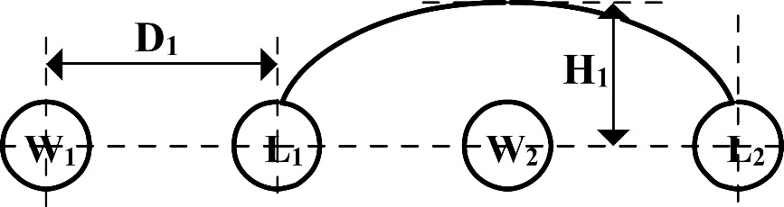

(a)

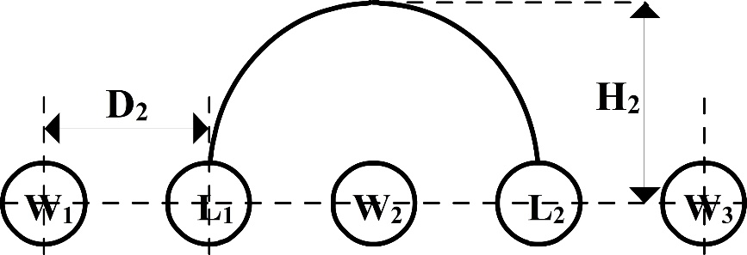

(b)

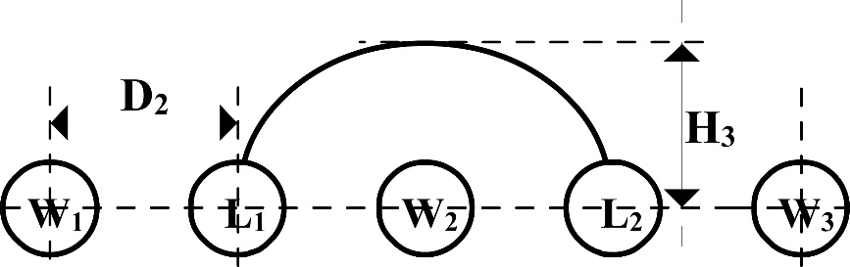

(c)

Figure 4. Schematics of relationship between thickness and parameters (loop length and weft density) of bifacial fabrics with (a) primary mode, (b) the effect of weft density (D1>D2, H1<H2) and (c) the effect of loop length (H2>H3). (W1, W2 and W3 - weft yarns; L1, L2 - loop yarns; D1, D2 - distance between weft/loop yarns; H1, H2 and H3 - height of loops in the thickness direction).

## Thermal resistance

The effects of weft density and loop length on thermal resistance of bifacial fabrics are shown in Figures 5 and 6, respectively. Both figures show an increasing trend of thermal resistance with an increase in both weft density and loop length.

Figure 5. Effect of weft density on thermal resistance of bifacial fabrics (BF1, 2 and 3) (■ – knitted face down; ▲ – woven face down, error bars show the standard deviation).

Figure 6. Effect of loop length on thermal resistance of bifacial fabrics (BF4, 2 and 5) (■ – knitted face down; ▲ – woven face down, error bars show the standard deviation).

Increasing weft density gives a higher fabric weight. Fabrics with higher weight tend to be warmer (higher thermal resistance) than lighter fabrics. Increasing weft density also decreases the distance between weft yarns. However, the loop length does not change to adapt to the narrow space between weft yarns, and the loop arms have to bend more sharply to link the needle and sinker arcs of loops. This movement increases both fabric thickness and air layer thickness within the fabric, which determines thermal resistance. Therefore, increasing weft density also increases thermal resistance of bifacial fabrics.

Since the needle and sinker arcs of loops are fixed by the woven structure of the bifacial fabric and limited by the distance between weft yarns (weft density), the straight distance between the needle and sinker arcs remains constant (Figure 4 (b) and (c)). Once loop length increases, the length of loop arms increases in fabric thickness direction, and the loop arms become longer and bend more heavily (Figure 4 (b)). This results in a higher fabric thickness and thicker air layer, leading to a higher thermal resistance.

## Thermal-contact feeling

Figure 7 and 8 show that increasing weft density or loop length generally enhances the warm feeling of bifacial fabrics, where the feeling may be different on two faces. A higher $q_{max}$ means the higher rate of heat energy transfers between the skin and the fabric surface, thus the fabric is cooler to touch.

Figure 7. Effect of weft density on thermal-contact feeling of bifacial fabrics (BF1, 2 and 3) (■ – knitted face; ▲ – woven face, error bars show the standard deviation).

Figure 8. Effect of loop length on thermal-contact feeling of bifacial fabrics (BF4, 2 and 5) (■ – knitted face; ▲ – woven face, error bars show the standard deviation).

With an increase of warp or weft density in normal woven fabrics, the warp or weft yarns bend more heavily at the intersections. This means that the contact area on the intersections will be decreased when it is touched under a certain pressure. Therefore, increasing weft density decreases the contact area on the woven face of bifacial fabrics, leading to a warmer feeling.19

In bifacial fabrics, the sinker arcs of knitted loops are fixed by the woven structure, and they link to each other using their needle and sinker arcs (Figure 9). Increasing loop length gives loops extra yarns, and these yarns have to expand in the fabric thickness direction (H2 in Figure 4 (b)). In this way, the loop arms effectively bend and the bending points are the salient points. With continuous bending of the loop arms, the points become high and sharp, and the knitted face then is much rougher. As explained earlier, the rougher knitted face feels warmer due to smaller contact areas.

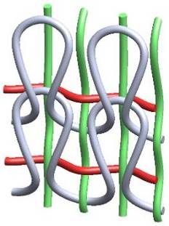 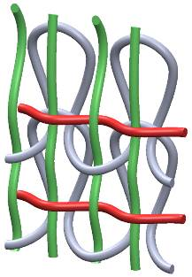

(a) (b)

Figure 9. 3D sketches of the two faces of the bifacial fabric structure. (a) knitted face and (b) woven face.(warp yarns (green), weft yarns (red) and loop yarns (gray))12

**Permeability index**

The effect of weft density on permeability index of bifacial fabrics is given in Figure 10. When weft density increases, the permeability index of bifacial fabrics approximately remains constant. Increasing weft density of bifacial fabrics increases the evaporative resistance and the thermal resistance. This is due to the smaller distance between weft and loop yarns in the bifacial fabric with higher weft density (D2 < D1, Figure 4), which causes smaller pores within the woven structure of bifacial fabrics. Moreover, the fabric weight and thickness of air layer trapped in the knitted structure of bifacial fabrics increase as shown in Table 2. The air layer is primarily responsible for thermal resistance. Therefore, the permeability index remains constant according to the Equation 1.

Figure 10. Effect of weft density of bifacial fabrics on permeability index (BF1, 2 and 3) (■ – knitted face down; ▲ – woven face down).

The rule explained above can also be applied to the effect of loop length of bifacial fabrics on the permeability index (Figure 11). The air layer primarily affects thermal resistance of bifacial fabrics, while the evaporative resistance is determined by the air permeability. Though higher loop length in the knitted structure increases air permeability,18 there are no changes in spaces between weft yarns in the woven structure. As shown in Figure 4 (b) and (c), increasing loop length does not change the distance between weft/loop yarns (D2). Therefore, when the loop length increases, the thermal resistance increases more than evaporative resistance, and leads to a higher permeability index of bifacial fabrics.

Figure 11. Effect of loop length of bifacial fabrics on permeability index (BF4, 2 and 5) (■ – knitted face down; ▲ – woven face down).

## Total heat loss

Figure 12 shows the effect of weft density of bifacial fabrics on the total heat loss. Increasing weft density decreases the total heat loss. As discussed earlier, increasing weft density increases fabric weight and decreases spaces between weft yarns. Therefore, evaporative and thermal resistance increase and the calculated total heat loss decreases (Equation 2).

Figure 12. Effect of weft density of bifacial fabrics on total heat loss (BF1, 2 and 3) (■ – woven face down; ▲ – knitted face down).

The effect of loop length of bifacial fabrics on the total heat loss is shown in Figure 13. The total heat loss of bifacial fabrics decreases with an increase of loop length. Increasing loop length of bifacial fabrics may expand the pores in the knitted structure, thus increases the thickness of the entrapped air layer. This leads to higher evaporation insulation and heat flux as discussed earlier, and results in lower total heat loss.

Figure 13. Effect of loop length of bifacial fabrics on total heat loss (BF4, 2 and 5) (■ – woven face down; ▲ – knitted face down).

In overall both weft density and loop length affect fabric thickness and fabric weight, which in turn may affect fabric porosity. Since porosity directly influences the fabric’s thermal comfort properties, porosity of the bifacial fabric was further discussed.14 It was found that thermal comfort properties were determined by the distribution of pores and their connections, so do as air permeability of fabrics.

# Conclusion

In this study, thermal comfort properties of the woven, knitted and bifacial fabrics were investigated. The effect of weft density and loop length of bifacial fabrics on thermal comfort properties was also studied. The key findings are summarised as follows.

The permeability index of the bifacial fabric is higher than that of the woven and knitted fabrics, while the total heat loss is lower. It suggests that the bifacial fabric is warmer and more breathable than equivalent woven and knitted fabrics when using similar yarn types.

An increase in loop length and weft density enhances thermal resistance, warmth to touch and reduces water vapour transfer through bifacial fabrics. Increasing loop length increases the permeability index of bifacial fabrics, while permeability index is almost constant with changes in weft density. The total heat loss of the bifacial fabric reduces with increasing weft density and loop length.

Increasing weft density or loop length increases the thickness and weight of bifacial fabrics, and the distribution of pores and their connections in the thicker fabric significantly affects thermal properties. Increasing weft density or loop length changes the fabric porosity, affecting thermal properties and decreasing the fabric’s air permeability, with higher weft density reducing the cross-sectional area of aisles for air flow. Longer loop length provides a thicker knitted structure in the bifacial fabric, with a thicker air layer leading to higher thermal resistance and lower evaporative resistance.

This work shows that the thermal comfort properties of bifacial fabrics can be optimized by changing loop length and weft density, and bifacial fabrics with different thermal comfort properties can be engineered for different applications. It should be noted that the above conclusions may only apply to the fabrics produced in this study. More work is still required to verify these conclusions with different yarns and different bifacial fabric structures.

# Acknowledgements

We would like to thank Mr Andrew Jones, Mr Doug Dower and Mr Peter Herwig from CSIRO Manufacturing for woven and knitted fabrication. Appreciation is also extended to Professor Wu Chen for facilitating the bifacial fabric sample production at Wuhan Textile University.

# Funding

*We gratefully acknowledge support from the MoE Innovation Team Project in Biological Fibres Advanced Textile Processing and Clean Production for the fabric sample preparations. We also acknowledge the PhD scholarship support from Deakin University for the first author of this paper.*

# References

1. Choudhury AKR, Majumdar PK and Datta C. Factors affecting comfort: human physiology and the role of clothing. In: Song G, (ed.). *Improving comfort in clothing*. 1st ed. Cambridge: Woodhead Publishing Limited & The Textile Institute, 2011, p. 10-60.

2. Matusiak M. Investigation of the thermal insulation properties of multilayer textiles. *Fibres Text East Eur*. 2006; 14: 98-102.

3. Holcombe B and Hoschke B. Dry heat transfer characteristics of underwear fabrics. *Text Res J*. 1983; 53: 368-374.

4. Prahsarn C, Barker R and Gupta B. Moisture vapor transport behavior of polyester knit fabrics. *Text Res J*. 2005; 75: 346-351.

5. Woodcock AH. Moisture transfer in textile systems, Part I. *Text Res J*. 1962; 32: 628-633.

6. Farnworth B. Mechanisms of heat flow through clothing insulation. *Text Res J*. 1983; 53: 717-725.

7. Baxter S. 4-Heat and water vapour transfer through fabrics. *J Text Inst Trans*. 1946; 37: T39-T57.

8. Rengasamy RS. Improving moisture management in apparel. In: Song G, (ed.). *Improving comfort in clothing*. 1st ed. Cambridge: Woodhead Publishing Limited & The Textile Institute, 2011, p. 182-215.

9. Verdu P, Rego JM, Nieto J, et al. Comfort analysis of woven cotton/polyester fabrics modified with a new elastic fiber, part 1 preliminary analysis of comfort and mechanical properties. *Text Res J*. 2009; 79: 14-23.

10. Bedek G, Salaün F, Martinkovska Z, et al. Evaluation of thermal and moisture management properties on knitted fabrics and comparison with a physiological model in warm conditions. *Appl Ergon*. 2011; 42: 792-800.

11. Zhu L, Naebe M, Blanchonette I, et al. Physical properties of novel co-woven-knitted fabrics. In: *The 89th Textile Institute World Conference*, Wuhan, China, 2-6 November 2014, paper no. O-PS-1-PPT-1440, p.229-234.

12. Zhu L, Naebe M, Blanchonette I, et al. Moisture transfer properties of bifacial fabrics. *Text Res J*. 2017; 87: 1096-1106.

13. Zhu L, Naebe M, Blanchonette I, et al. Heat transfer properties of bifacial fabrics. *Text Res J*. 2016; 10.1177/0040517516669077

14. Zhu L, Wang X, Hinestroza JP, et al. Determination of the porosity in a bifacial fabric using three dimensional reconstruction. *Text Res J*. 2017; 10.1177/0040517517698987

15. Zhu L, Naebe M, Blanchonette I, et al. Mechanical properties of bifacial fabrics. *Text Res J*. 2017; 10.1177/0040517517700193

16. ASTM International F1868-12:2012. Standard test method for thermal and evaporative resistance of clothing materials using a sweating hot plate. ASTM International, West Conshohocken, PA, United States, 10.1520/F1868-12, [www.astm.org](http://www.astm.org).

17. Morris MA. Thermal insulation of single and multiple layers of fabrics. *Text Res J*. 1955; 25: 766-773.

18. Zhu L, Naebe M, Blanchonette I, et al. The effect of structural parameters on air permeability of bifacial fabrics. In: *The 13th Asian Textile Conference*, Geelong, Australia, 3-6 November 2015, paper no. 81, p.928-931.

19. Kawabata S and Akagi Y. Relation between thermal feeling and thermal absorption property of clothing fabric. *J Text Mach Soc Jap*. 1977; 30: T13-T22.