Improving the tensile properties of wet spun silk fibers using rapid Bayesian algorithm
Ya Yao¹, Benjamin J. Allardyce^{1*}, Rangam Rajkhowa¹, Dylan Hegh¹, Alessandra Sutti¹, Surya Subianto¹, Sunil Gupta², Santu Rana², Stewart Greenhill², Svetha Venkatesh², Xungai Wang¹ and Joselito M. Razal^{1*}
¹ Deakin University, Institute for Frontier Materials, Geelong, Australia
² Deakin University, Applied Artificial Intelligence Institute (A²I²), Geelong, Australia
* Email: joselito.razal@deakin.edu.au; ben.allardyce@deakin.edu.au

Abstract:
Wet spinning of silkworm silk has the potential to overcome the limitations of the natural spinning process, producing fibers with exceptional mechanical properties. However, the complexity of the extraction and spinning processes have meant that this potential has so far not been realized. The choice of silk processing parameters including fiber degumming, dissolving and concentration, are critical in producing a sufficiently viscous dope, while avoiding silk’s natural tendency to gel via self-assembly. This study utilized recently developed rapid Bayesian optimization to explore the impact of these variables on dope viscosity. By following the dope preparation conditions recommended by the algorithm, a 13% (w/v) silk dope was produced with a viscosity of 0.46 Pa.s, approximately five times higher than the dope obtained using traditional experimental design. The tensile strength, modulus and toughness of fibers spun from this dope also improved by a factor of 2.20×, 2.16× and 2.75× respectively. These results represent the outcome of just five sets of experimental trials focusing on just dope preparation. Given the number of parameters in the spinning and post spinning processes, the use of Bayesian optimization represents an exciting opportunity to explore the multivariate wet spinning process to unlock the potential to produce wet spun fibers with truly exceptional mechanical properties.

Keywords:
Regenerated silk, wet spinning, Adaptive Experimental Optimization, mechanical properties.

Table of Contents Graphic:
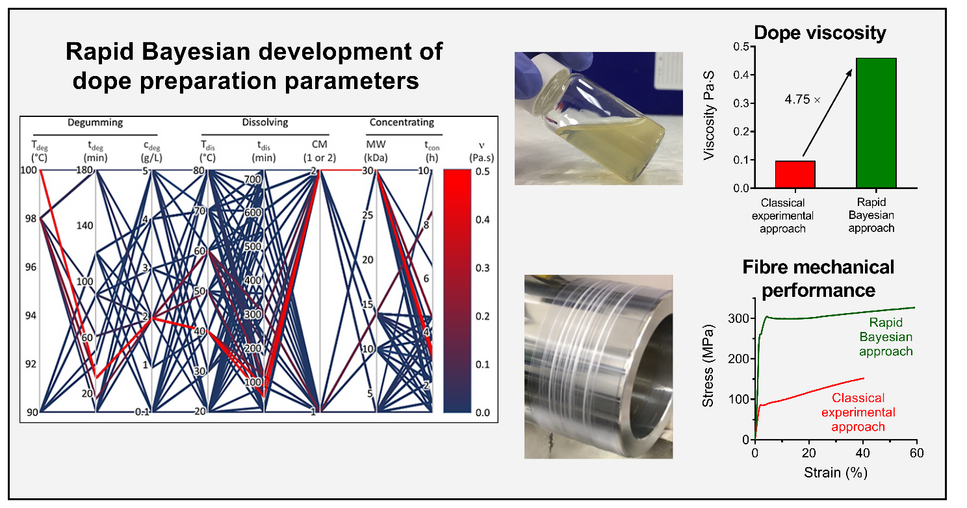

Introduction
Silk is one of the toughest known natural materials.¹ It has been used for centuries in a broad range of applications because of its combination of high tensile strength, toughness and excellent biocompatibility.² In many cases, silk outperforms synthetic polymer fibers.^{3, 4} Silk-based materials are now widely investigated in tissue engineering as lightweight spacers in tissue grafts,⁵ as scaffolds for producing mineralized tissues in bones and teeth,⁶ and as carriers for drug delivery.⁷ Among all naturally produced silks, spider silk shows the highest tensile strength and extensibility, and higher toughness than other high performance fibers such as Kevlar.⁸ However, spider silk is difficult to produce in large quantities since spiders have not been successfully domesticated. Other approaches such as the production of recombinant spider silk are making their way to the market, however, such methods remain considerably more expensive than traditional methods of producing silk.
In contrast, the most extensively utilized silks are from the domesticated Bombyx mori (B. mori) silkworm. Silkworm silks have been produced commercially for centuries in huge quantities to meet the needs of the textile industry.⁹ However, despite their similarities, silkworm silks, while still offering good mechanical properties, are mechanically inferior to spider silks. This has led to significant research on the artificial production of silk fibers using the protein extracted from commercially available silkworm silk fibers, towards achieving properties comparable or even better than the natural spider silk.¹⁰⁻¹³ More recent efforts to wet spin silk have ranged from methods to spin hollow core fibers¹⁴ to the development of spinning systems that are more biomimetic^{15, 16} as well as the adaptation of wet spinning as a method to recycle textile fibres.¹⁷
To produce regenerated silk dope from cocoons, one commonly used method consists of degumming the silk cocoons by boiling in an alkaline solution and then dissolving the degummed silk by heating in concentrated lithium bromide solution. The resulting solution is then dialyzed against deionized water and concentrated using reverse dialysis to produce the final spinning dope. This process is deceptively simple: each step of this process is controlled by multiple parameters, each of which can have a significant impact on the properties of the resulting silk dope (Figure 1). These parameters include degumming conditions (temperature, time, choice of alkaline), fiber dissolving conditions (time and temperature) and dope concentration methods (dialysis membrane molecular weight cut-off and reverse dialysis time). All of these variables must be carefully optimized to produce a spinning solution with a viscosity that is sufficiently high to form fibers but does not gel during preparation.¹⁸
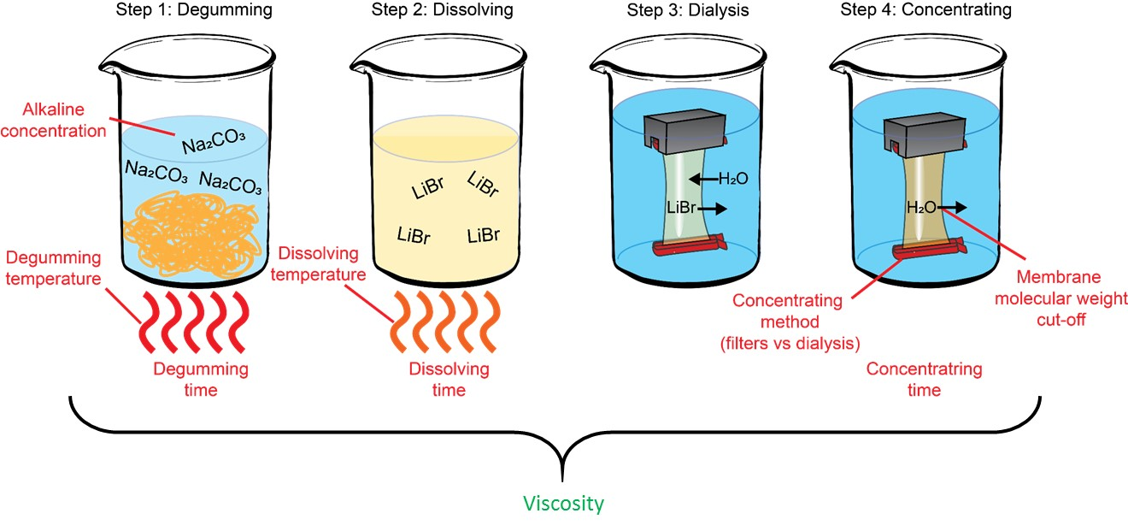
Figure 1. Variables in the dope preparation process. Red text = independent variables, green text = dependent variable.

Given the large number of possible combinations of these variables, most studies simplify the parameter-space exploration by manipulating a small number of variables at a time, thus reducing the likelihood of successful outcomes through sequential space reduction.^{17, 19-21} A recent comprehensive analysis of the literature on regenerated silk fibroin (RSF) fibers suggests that producing RSF fibers with desirable mechanical properties through simple iterative development of existing solutions will take significant time.¹⁸ There is therefore a need to develop a system that allows for rapid exploration of the multi-variate set in order to discover conditions that may lead to spun fibers with exceptional mechanical properties.
A more sophisticated approach to optimizing wet spinning is proposed here based on Adaptive Experimental Optimization (AEO) protocols. AEO approaches are iterative, suggesting the minimum number of experimental conditions needed to reach a pre-set target, as chosen according to Bayesian mathematics.^{22, 23} AEO protocols are mathematically proven methods that enable nimble exploration of an experimental space of process parameters, with the aim of reaching a set target value for a measured output.²³ In the case of silk wet spinning, all dope preparation steps are considered variables, and dope viscosity is a suitable, process-relevant output for optimization.
The advantage of an AEO approach is that the experiment is treated as a “black box” problem, with no prior knowledge, opening up the possibility to explore otherwise not usually selected experimental conditions. Pre-designed constraints on the selection of parameter values can also be added, allowing the experimenter to set up multiple samples at any one time, thus further minimizing overall optimization time.²² Furthermore, AEO allows to incorporate constraints on a parameter conditional on the values of other parameters. It is generally acknowledged that spinning dopes with high viscosity lead to fibers with better mechanical properties than those produced from low viscosity dopes.¹⁸ For example, recent innovations in dry spinning^{24, 25} have led to significant advances in the mechanical properties of fibers through the use of highly concentrated dopes. Since viscosity can be easily quantified, this study used dope viscosity as the output parameter. To fully demonstrate the usefulness of an AEO approach towards wet spinning, a traditional systematic study of effects of degumming, dissolving and concentrating steps on dope viscosity was first performed. This traditional method of experimental design is referred to in this study as the “classical experimental approach”. The results of these initial experiments were used in the AEO software, which was then used to recommend multiple sets of promising experiments. The viscosity of the dope was measured for each trial. After running five trials, the dope that produced the highest viscosity was spun using the chosen spinning parameters. Finally, the mechanical properties of the best fibers produced using the AEO approach was compared with the best fibers produced using traditional experimental design approaches, in order to quantify the improvements obtained by using AEO, aside from the obvious savings of time and cost of experimentation.

Materials and methods

Materials
Reeled, undegummed B. mori silk was purchased from SRR Silk Reeling Unit (Ramanagaram Karnataka, India). Unscented olive oil soap was purchased from Vasse Virgin (Wilyabrup, Western Australia). Lithium bromide (LiBr, 99.0%, VWR-Chemicals, USA), sodium carbonate (Na₂CO₃, 99.9%, Sigma-Aldrich, St. Louis, MO, USA), polyethylene glycol (PEG; 20 kDa, Sigma-Aldrich, Germany) and ammonium sulfate ((NH₄)₂SO₄, 99.0%, Sigma-Aldrich) were used without further purification. Cellulose dialysis tubing membranes (Sigma-Aldrich) with 3.5, 10 and 14 kDa molecular weight cut-off (MWCO) and Amicon Ultra centrifuge filters (MWCO of 10 and 30 kDa) were purchased from Sigma-Aldrich.

Degumming of raw B. mori silk
B. mori silk fibers were degummed according to a previously reported method, albeit with some modifications.²⁶ Raw silk was degummed for a varying length of time (5, 15, 30, 60, 90 and 180 min), at each of two temperatures (90 and 98 °C), and using either 1 or 2 g/L sodium carbonate; all degumming solutions contained 1 g/L unscented olive oil soap (Vasse Virgin, Wilyabrup, Western Australia, Australia) as a wetting agent. The degumming process was carried out using an Ahiba IR Pro rotary textile dyeing machine (Datacolor, Lawrenceville, USA) with a solid (g) : liquor (mL) ratio of 1:50. After thorough washing with deionized water, the degummed silkworm silk fibers were dried overnight at room temperature in a fume hood.

Preparation of regenerated silk solution for spinning
The degummed silk fibroin solutions were prepared for wet spinning by dissolving the fibers in 9.3 M LiBr solution (7.5 ml solution per 1 g of silk fibers) at three different dissolving temperature (30, 45 and 60 ˚C) for a time between 1 and 5 h. The insoluble portions were removed by centrifugation (7000 rpm, 15 min, 20 °C). The solution was then dialyzed against flowing deionized water for 3 days to a concentration of approximately 6% (w/v) using cellulose tubes (14 kDa MWCO). The solution was then concentrated to 8% (w/v) using different methods: method 1 (reverse dialysis) or method 2 (centrifugal filter units). Then 0.5 ml silk solution were injected with pipette to four plastic trays separately drop by drop. Then after drying in the oven for 3 h, the tray and dried silk were weighted again to calculate the weight of silk solution. The average value was used to calculate the concentration. Treatment details for degumming, dissolving and concentrating of different samples are summarized in Table S1 with the changing variables highlighted in blue.

Rheological behavior of spinning solution
The rheological properties of the silk spinning dopes were measured using an ARES-G2 Rheometer, Advanced Rheometer Expansion System (TA System, U.K), with a cone and plate geometry (50 mm, 4° angle). To evaluate the flow behavior, the viscosity of each spinning dope was measured at different shear rates in rate-controlled mode. After obtaining the shear sweep curves of each dope, the viscosity at the shear rate of 1737 s⁻¹ was plotted since it represented the shear rate produced using the selected spinning conditions in the wet spinning trials (see below). All viscosity measurements were calculated as the mean ± standard deviation of three experimental replicates (three independently made silk batches).
Silk Molecular weight
The molecular weight of silk solutions prepared using the different processing conditions was determined using sodium dodecyl sulfate–polyacrylamide gel electrophoresis (SDS-PAGE) based on the Laemmli method.²⁷ First, the total protein concentration of each sample was determined using a modified version of the BCA assay (Pierce Rapid Gold BCA Assay; ThermoFisher Scientific, Waltham, USA) using a standard curve generated using commercially available silk fibroin solution (Sigma-Aldrich). Then, for SDS-PAGE, 30 µg of silk protein from each sample was loaded onto a NuPAGE 3-8% Tris-acetate gel (ThermoFisher) alongside two protein standards to cover the entire molecular weight range of silk fibroin: the HiMark™ Unstained Protein Standard and the Novex™ Sharp Pre-stained Protein Standard (ThermoFisher). The gel was run at 150 V (voltage constant) for 1h, stained for 3 h using a Colloidal Blue staining kit (ThermoFisher) then de-stained overnight in Milli-Q water. The gels were then visualized using a Gel Doc XRS+ Gel Documentation System (Bio-Rad, Hercules, CA, USA).

Wet-spinning of RSF fibers
RSF fibers were spun at room temperature using a lab scale wet spinning line (Figure S1). In brief, the prepared spinning dope was extruded directly into coagulation bath containing 30% (w/v) aqueous ammonium sulphate at room temperature. The spinning needle with a diameter of 0.16 mm was placed horizontal to the coagulation bath. A syringe pump (KDS 100 Legacy, KD Scientific, Holliston, MA, USA) was used to extrude the spinning dope at a flow rate of 2.5 mL/h. The pump speed was calculated to be 2.1 m/min based on the diameter of the needle and the flow rate. The coagulated fiber was then collected on a take-up roller directly. The rotation rates of the take-up roller were set as 2.1, 4.2, 8.4, 12.6, 16.8 and 21 m/min, equivalent to spinning ratios of 1, 2, 4, 6, 8, and 10 respectively. We labeled the samples as RSF-1×, RSF-2×, RSF-4×, RSF-6×, RSF-8×, RSF-10× to represent spinning ratios of 1, 2, 4, 6, 8 and 10 respectively. The spun fibers were immersed in (NH₄)₂SO₄ coagulation bath at room temperature for 6 h to further solidify the RSF fibers. After immersing, the wet spun fibers were washed with deionized water for 3 h to remove the coagulants. Finally, the RSF fibers were dried in the fume hood

Fiber characterization
The samples were gold - coated using a SCD 050 sputter - coater (Bal-Tec, Leica Microsystems), and observed using a field emission scanning electron microscope (FE-SEM, Zeiss Supra 55VP or Zeiss Leo 1530) at an accelerating voltage of 5 kV and working distance of 5 - 10 mm. The tensile strength of the obtained fibers was measured using an Agilent T150 UTM nanomechanical tensile tester (Agilent Technologies, Chandler, AZ) equipped with a 50 mN load cell. Fibers with a gauge length of 10 mm were conditioned for 24 h at 21 ± 2 ˚C and 65 ± 2 % relative humidity (RH) prior to testing. At least 12 samples from each spinning experiment were analyzed using a tension trigger of 0.3 mN and a strain rate of 0.003 s⁻¹. The cross section was imaged by SEM. The cross section was imaged by contours of the silk fibers using ImageJ (NIH, Bethesda, MD). The toughness (MJ/m³) of each fiber specimen was calculated assuming a silk density of 1.35 g/cm.^{4, 28} The tensile strength, Young’s Modulus, tensile strain and toughness were obtained from the resultant stress-strain curves. Young’s modulus was calculated by measuring the slope of the linear region of the stress-strain curve within the initial steep elastic region (before the yield point).
Adaptive Experimental Optimization (AEO)
Bayesian optimization was used to improve the properties of the spinning dope. In this work, dope viscosity was selected as the target (or output variable) for the algorithm. The overall iteration optimization process included the following five steps, based on a previous report.²² Briefly, the steps were: step 1 – a Gaussian function was generated in such a way to capture key process parameters and outputs; Step 2 – the algorithm provided the next set of values of experimental parameters by optimizing an acquisition function; Step 3 – the recommended experiments were conducted; Step 4 – the results were provided to the algorithm and the target utility was computed; Step 5 – results were checked to see if the product met the target specifications. Step 2 required a global optimization of the acquisition function under the constraints on search ranges of some parameters conditional on the values of other parameters. In particular, there were two constraints types: in the dissolution and in the concentration process.
In the dissolution process, the constraints involved dissolution temperature and dissolution time. If the dissolving temperature was below 30 °C, then the dissolving time was set between 1 to 12 h. If the dissolving temperature was between 30 to 60 °C, then the dissolving time was set between 30 min to 6 h. Finally, if the dissolving temperature was above 60 °C, then dissolving time was set between 15 min to 6 h. In the concentration process, two different methods were used, each with different MWCO values and time ranges. Method 1 consisted of reverse dialysis against PEG; dialysis tubing with MWCO values of 3.5, 10 and 14 kDa were selected and dialysis time range was set to 1 to 24 h. Method 2 used centrifugal filter units with MWCO values of 3, 10 and 30 kDa. The time range for method 2 was 1 to 10 h. These constraints emerged from the need to limit the search space to more physically relevant ranges for the dissolution step, and additionally from the need to use different membranes for the two systems, due to the membranes being not available with the same MWCO values across the two systems. AEO allows to incorporate such complex constraints without much effort unlike traditional design of experiments methods. Like all methods in literature, Bayesian AEO does have limitations. These limitations primarily arise from the assumptions made in the Bayesian AEO framework about the kind of functions that could be efficiently optimized. Bayesian AEO offers provably efficient convergence rate only when the function is reasonable smooth (see Srinivas et al²⁹. for a detailed discussion). Intuitively, if a function is not smooth, it is not possible to extrapolate the function values at unobserved locations in the space through a function model and therefore, the usual efficiency guarantees of Bayesian AEO may not hold. Fortunately, real-world functions are usually smooth in most of the input space and therefore, Bayesian AEO continues to be effective.

Results and discussion
A traditional, iterative experimental approach for the optimization of silk spinning dope was first undertaken before Bayesian AEO was employed. Different sodium carbonate concentrations, degumming temperatures and degumming times were tested while keeping all subsequent parameters the same to find the degumming conditions that produced silk solution with the highest possible viscosity (Table S1). Silk degummed using each of these conditions²⁶ was then dissolved at different temperatures and for different time, followed by dialysis and finally by concentrating the silk solution to between 8 and 16% (w/v). The viscosity of the resulting silk solution (herein referred to as “dope”) was determined as a quantitative measure of the effectiveness of the chosen conditions.

The effect of degumming conditions on the viscosity, molecular weight and sericin removal of silk dopes
In order to understand the impact of changing the parameters of degumming, dissolving and concentrating steps, changes in dope viscosity were measured when changing one variable while keeping all other variables constant (Figure 2). The absolute viscosities of each set of results varied significantly, making comparisons confusing. Therefore, the viscosities in Figure 2 were presented as a “Relative change in viscosity” whereby the viscosity of the point in each graph was defined as 100% and changes in viscosity presented in each graph are presented as a percentage of this initial viscosity. The actual viscosities of every set of experimental conditions is presented in Table S2. To further investigate what drives these changes in viscosity, changes in molecular weight (measured by SDS - PAGE) were also measured and plotted underneath the appropriate graph (Figure 2, gel images). Finally, for parameters where the degumming conditions were changed, the weight loss was measured (Figure 2a, 2b and 2c; orange diamonds), since weight loss can give some insight to the amount of residual sericin that may be present and may influence dope viscosity.
Since alkaline protein hydrolysis is a non - specific process, degumming conditions should be as mild as possible in order to maintain an “as-intact-as-possible” fiber,³⁰ with low hydrolytic degradation of silk fibroin, while still removing all sericin.³¹ Based on our previous work using the same variety of silk,^{26, 32} we have found that although both fibroin degradation and sericin removal occur simultaneously, a weight loss of between 27 and 28% represents the point at which sericin is essentially all removed. Any additional weight loss above 28% can be attributed to the loss of fibroin through degradation.²⁶ This is in line with the proportion of sericin reported by others, which varies between 20 and 30%,³³ depending on the strain of Bombyx mori.
It was found that, with all other conditions kept the same, the dope viscosity decreased by approximately 70% when the degumming temperature was increased from 90 to 98 °C (Figure 2a, green square). The changes in molecular weight in response to degumming temperature were less noticeable: compared with the 90 °C degummed silk, fibroin degummed at 98 °C showed less intense staining of the 25 kDa light chain, but the MW distribution of the heavy chain was unaffected by the higher degumming temperature (Figure 2a, gel image). Measurement of the weight loss of these two samples (Figure 2a, orange diamonds) revealed that the 90 °C degummed silk had a weight loss of 26.5%, compared with the 27.6% weight loss of the 98 °C degummed silk. It therefore appears that the large drop in viscosity of the 98 °C degummed silk may be attributed primarily to the loss of residual sericin rather than by significant differences in MW.
The viscosity of dope solutions also decreased with increasing degumming time (Figure 2b, green square), which was expected since degumming time is known to cause significant alkaline hydrolysis to silk fibroin.^{20, 21, 34-36} The most significant decrease in viscosity was observed from 5 to 30 min; after 30 min degumming, the drop in viscosity as degumming time increased was much less dramatic. Again, this initial rapid decrease in viscosity is most likely due to the contribution of sericin, since the weight loss of the 5 and 15 min degummed samples were 22.4 % and 25.1 % respectively (Figure 2b, orange diamonds). This finding is consistent with previous reports, which also found that small amounts of residual sericin significantly increased the viscosity of silk fibroin dope.³⁷ By contrast the molecular weight of fibroin from these short degumming times showed negligible changes (Figure 2b, gel image). The weight loss of the silk degummed for longer than 30 min continued to increase from 27.6 % (30 min degummed) to 32.5 % (180 min degummed; Figure 2b, origin quadrangle). These samples also showed progressively more fibroin degradation, as indicated by a broader MW distribution of the heavy chain smear (migration of the smear down the gel) and the progressive loss of the 25 kDa light chain band (Figure 2b, gel image). Interestingly, the loss of the light chain band corresponded with the progressive appearance of 3 lower MW bands (under 20 kDa), which may represent hydrolyzed fragments of the light chain protein. Weight losses above 28% (60 min degummed and longer) were previously also found to correspond with an increase in fiber surface damage, including surface cracks and fibrillation.²⁶
Overall, the changes in viscosity as a function of degumming time can be considered as follows: the rapid drop in viscosity between 5 and 30 min degumming results from the removal of sericin, from 30 min onwards the less pronounced decrease in viscosity results from a reduction in the molecular weight of fibroin as a result of progressive alkaline hydrolysis. The impact of degumming time on dope viscosity may be due to a decrease in intermolecular interactions (molecular entanglement³⁸, Van der Waals forces³⁹ per chain and hydrogen bonding⁴⁰ per chain) as a result of the lower MW. The significant impact of sericin on the dope viscosity may be explained by its role in inducing and accelerating shear-induced β-sheet formation.⁴¹
The third variable that was altered in the degumming experiments was sodium carbonate (Na₂CO₃) concentration (Figure 2c, green square). Again, a drop in viscosity was observed when increasing the Na₂CO₃ concentration from 1 to 2 g/L. It again appears that this drop was more associated with sericin removal than fibroin hydrolysis since the 1 g/L Na₂CO₃ degummed silk showed a weight loss of just 23.3% (Figure 2c, orange diamonds); the MW of the two samples was quite similar, with no changes in the heavy chain smear (Figure 2c, gel image). Although the intensity of the light chain band decreased slightly at 2 g/L Na₂CO₃, there was no increase in the intensity of the <20 kDa fragments, suggesting that overall, Na₂CO₃ concentration had a negligible impact on MW.
Taken together, the degumming experiments indicate that residual sericin has the biggest impact on silk dope viscosity, changes in MW as a result of increased alkaline hydrolysis did reduce dope viscosity, but to a much lower degree. However, residual sericin was found to accelerate gelation of the silk dopes, particularly when concentrating the silk for spinning trials (results not shown). Therefore, the degumming conditions of 30 min degumming at 98 °C using 2 g/L sodium carbonate were chosen in order to completely remove sericin while minimizing the degree of fibroin degradation.

The effect of dissolving conditions on dope viscosity
The degummed silk was dissolved in 9.3 M LiBr to assist fibroin solvation while retaining high MW of the protein.^{42,43} It was observed that when the dissolving temperature increased from 30 to 60 °C, the viscosity of the silk solution decreased (Figure 2d). When keeping a constant dissolution temperature (60 ˚C), the viscosity also decreased more than 20% with increased dissolving time (from 1 to 5 h, Figure 2e).
Interestingly, previous studies have shown that dissolving conditions including the temperature and time do not degrade silk fibroin molecules.⁴⁴ Indeed, in this study, none of the changes in dissolving variables significantly impacted fibroin MW, with all samples showing a similar heavy chain smear, minor changes in the light chain intensity but no changes in the <20 kDa fragments. It is therefore unclear why the viscosity changed when changing dissolving conditions. It is possible that increased dissolving temperature and dissolving time result in either complete solvation, or denatured silk fibroin molecules, leading to lower viscosity, although this effect requires further investigation.

Approaches to increase viscosity
Following dissolution, the silk solution is dialyzed to remove LiBr. However, the dialysis process dilutes the fibroin, resulting in a concentration that is too low for fiber spinning. To increase dope concentration and viscosity and to select for higher MW fibroin, centrifuge filters (10 and 30 kDa) were selected. At 8% (w/v) fibroin, the viscosity of the final dope was 250% of the other sample when concentrating with 30 kDa MWCO filter than using 10 kDa filter (Figure 2f). This is presumably because, when using 30 kDa MWCO filters, a higher proportion of low Mw fibroin is lost than when using 10 kDa MWCO filters. However, any differences in MW between these samples were not reflected using SDS - PAGE (Figure 2f, gel image) – despite changing the MWCO, the 30 kDa MWCO filtered silk dope still showed visible bands below 30 kDa on the gel, including the 25 kDa light chain and <20 kDa fragments. The fibroin light chain is known to be joined to the heavy chain by a disulfide linkage.⁴⁵ This covalent bond presumably prevents it from eluting through the filter. Even though the SDS - PAGE in this study was run under non-reducing conditions, it appears that the electrophoretic conditions still enable the dissociation of the light and heavy chains. However, the differences in viscosity may still be due to the contribution of low MW silk that is retained on the 10 kDa filters but eluted through the 30 kDa filters but that cannot be detected on the gel. The presence of a greater concentration of low MW silk fibroin when using the 10 kDa MWCO membrane may result in the dilution of high MW fibroin. These low MW fragments presumably show weaker intermolecular interactions, resulting in a lower overall viscosity.^{46, 47}
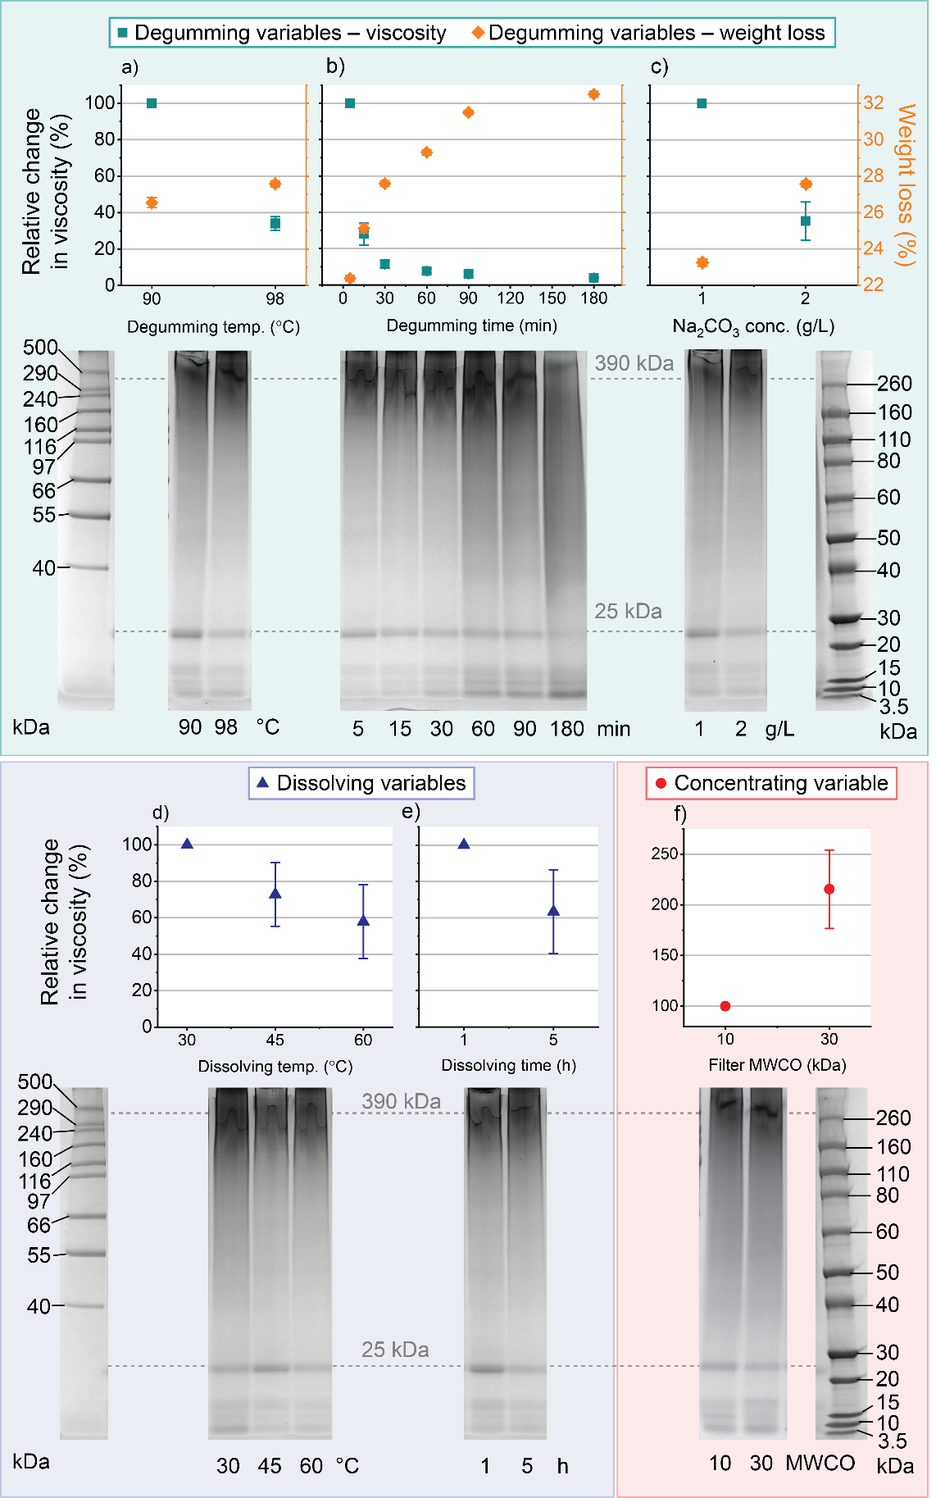
Figure 2. Changes in viscosity, weight loss and fibroin molecular weight as a function of degumming temperature (a), degumming time (b), degumming alkaline concentration (c), dissolving temperature (d), dissolving time (e) and concentration method (using 10 kDa or 30 kDa MWCO centrifuge filters; f). Each panel shows relative changes in dope viscosity (measured at 1737 s⁻¹) in the main graph and the corresponding molecular weight changes in the SDS - PAGE photo under each graph. Dotted lines across the gel images represent the expected sizes of the 390 kDa heavy chain and 25 kDa light chain of fibroin. For the top panels where degumming conditions were changed (a to c), the % weight loss is presented (orange diamonds, graphed on the right Y-axis). For each panel all variables (other than the one presented in the graph) were kept the same as follows: a) degumming temperature: 30 °C, Na₂CO₃: 2 g/L; dissolving temperature: 60 °C, dissolving time: 5 h; concentrating method: 14 kDa tubing); b) degumming time: 30 min, degumming temperature: 98 °C; dissolving temperature: 60 °C, dissolving time: 5 h; concentrating method: 14 kDa tubing; c) degumming time: 30 min, alkaline concentration: 2 g/L; dissolving temperature: 60 °C, dissolving time: 5 h; concentrating method: 14 kDa tubing; d) degumming time: 30 min, degumming temperature: 98 °C, alkaline concentration: 2 g/L; dissolving time: 5 h; concentrating method: 14 kDa tubing; e) degumming time: 30 min, degumming temperature: 30 °C, alkaline concentration: 2 g/L; dissolving temperature: 60 °C; concentrating method: 14 kDa tubing; f) degumming time: 30 min, degumming temperature: 98 °C, alkaline concentration: 2 g/L; dissolving time: 5 h, dissolving temperature: 60 °C). All viscosity measurements were taken from 8% w/v silk solutions.

Relationship between viscosity and spinnability
A series of spinning trials were conducted to determine the conditions that would produce continuous fibers. An applied shear rate of 1737 s⁻¹ was selected according to the dope solution viscosity needed for fiber formation. The viscosity of 0.097 Pa.s we mentioned here is the spinnable viscosity at shear rate 1737 s⁻¹, not the maximum viscosity determined by the classical experimental design approach. Silk dopes were made from silk degummed for 30, 60 and 180 min and the viscosity of each solution was tested at a range of concentrations (Figure 3). The highest achievable concentration for each degumming time (before the dope gelled) was determined through trial and error. It was found that regardless of the conditions, a viscosity of at least approximately 0.1 Pa.s was required for continuous wet spinning (Figure 3). This value is consistent with previous reports, in which 0.08 Pa.s was found to be a critical viscosity for continuous spinning of regenerated silk solution.⁴⁸ It is likely that below this critical limit, the fibroin MW is too low so that molecular chain entanglements is insufficient to allow fiber formation to occur. This suggests that tracking dope viscosity is an appropriate parameter to determine spinnability for subsequent Bayesian AEO modification of the dope preparation condition.
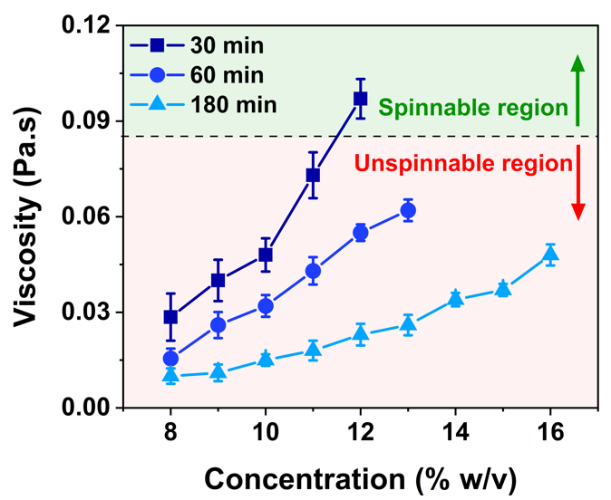
Figure 3. The relationship between the spinnability and viscosity of aqueous regenerated silk dope. Silk solution derived from 30, 60 and 180 min degummed fibers was concentrated by dialyzing against PEG. At different time points, the dialysis was stopped, the concentration of the dope was measured and wet spinning was attempted to determine spinnability. Other processing conditions were kept constant: degumming temperature: 98 °C, alkaline concentration: 2 g/L; dissolving time: 5 h, dissolving temperature: 60 °C, concentrating method: 14 kDa dialysis tubing.

Mechanical properties of RSF fibers prior to application of Bayesian optimization
Optimally degummed silk dope concentrated to 13% (w/v) had the highest viscosity and exhibited a good shelf-life with no gel formation at 25 ˚C for 12 h. To investigate the effect of drawing on the mechanical properties, a spin-draw of up to 10 times (10×) was applied during fiber coagulation process (Figure 4a). Spin-draw refers to drawing that occurs within the coagulation bath, expressed as the ratio or difference in the flow rate of the dope from the spinneret compared with the first roller. Spin-draw ratios higher than 10× could not be obtained without fiber breakage. Fibers at 1× drawing ratio possess a rough surface while the surface of the 10× drawn fibers showed fine striations (Figure 4b and 4c). Tensile tests were performed on fibers spun with different draw ratios (Table 1). The as spun and 2× drawn fibers were brittle, with poor mechanical properties compared with 4×, 6×, 8× and 10× drawn fibers. The RSF fibers exhibited considerably better mechanical properties with progressively increasing spin draw ratio of above 4×, presumably as a result of increased protein alignment upon fiber drawing.^{12, 49} Draw ratios of 4× and greater produced fibers that exhibited a sharp yield point with an initial drop in stress that was indicative of necking. Beyond the yield point these fibers exhibited a broad plastic deformation region before the final break. As the spin draw increased to 10× the yield point became less sharp and the plastic region became steeper (Figure 4a), which suggests a greater level of strain hardening. At a draw ratio of 6×, the RSF fibers displayed a breaking strain of 82.3 ± 15.5% and breaking stress of 103.1 ± 9.8 MPa (Table 1), which, although still lower than that of degummed B. mori silk (400 ± 20 MPa),²⁸ exhibited a higher breaking energy, calculated as the area under the stress strain curve (75.4 ± 17.3 MJ/m³ for 6× draw fibers vs 57.3 ± 4.7 MJ/m³ for B. mori silk).²⁸ At the highest draw ratio of 10×, the breaking stress further increased (155.0 ± 13.4 MPa) but at the expense of a relatively low breaking strain (38.2 ± 6.9%) and breaking energy (46.7 ± 3.9 MJ/m³) compared with moderately drawn fibers (Figure 4a, Table 1). These results are consistent with previous studies on the effect of molecular alignment resulting in increased mechanical properties.^{10, 50} However, the fibers were not strong enough compared with natural degummed B. mori silk fibers (400 ± 20 MPa)²⁸ and the strength of these fibers could be further increased by further optimizing the spinning dope.
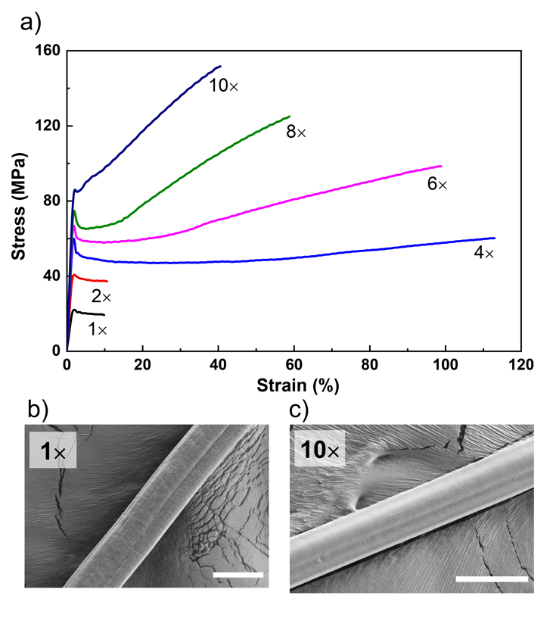
Figure 4. a) Representative strain-stress curves of wet spun fibers with different spinning ratios and b and c) SEM images of morphologies for 1x drawing ratio (b) and 10× drawing ratio (c). Curves are representative of 12 measurements at each draw ratio.

Table 1. A comparison of the mechanical properties of regenerated silk fibers. Values represent the mean ± standard deviation of 12 measurements at each draw ratio.
Draw ratio | Modulus  (GPa) | Breaking stress (MPa) | Breaking strain (%) | Breaking energy (MJ/m³)
1× | 1.8 ± 0.2 | 19.7 ± 1.6 | 8.5 ± 2.6 | 2.1 ± 1.1
2× | 3.5 ± 0.4 | 40.9 ± 5.1 | 13.4 ± 2.2 | 4.2 ± 2.0
4× | 3.9 ± 0.5 | 52.8 ± 8.4 | 97.5 ± 21.2 | 58.4 ± 15.6
6× | 4.5 ± 0.3 | 103.1 ± 9.8 | 82.3 ± 15.5 | 75.4 ± 17.3
8× | 4.9 ± 0.3 | 114.2 ± 12.9 | 51.3 ± 11.4 | 54.9 ± 15.1
10× | 5.3 ± 0.3 | 155.0 ± 13.4 | 38.2 ± 6.9 | 46.7 ± 3.9

Rapid Bayesian Optimization-driven parameter selection for silk solution preparation
A Bayesian AEO algorithm was developed to explore the matrix of parameters involved in the process of silk fibroin dope preparation for wet spinning. Table S2 shows the parameters used and their values. The algorithm was programmed to choose experimental conditions within appropriate ranges and with steps based on what is known of the effect of each variable (suitable ranges of time and temperature for degumming, thus excluding areas of the space known to not yield suitable dopes, Table S2). The results from the initial study described above were used as starting set for the algorithm. In order to optimize experimental resources and reduce analysis downtime, the algorithm was programmed to produce five different experimental conditions for each round of iteration. Within each round, the first suggested conditions were predicted to give the best results and following four conditions were used by the algorithm to explore the experimental space. Five iterations of the experiment were performed; after each set of experiments, the resulting dope viscosity values were fed back to the algorithm, which recalculated its model and produced five new experimental conditions to test. In some cases, the suggested conditions resulted in only partial dissolution of the silk or, if the silk did completely dissolve, in a dope that was so viscous it precipitated during the concentration step. These experimental conditions were reported back to the algorithm as a “fail” to guide the software to choose only the parameters that produced a stable spinning dope.
All tested experimental sets are displayed in Figure 5a; this is a parallel coordinate graph, the only graph which allows capturing all datasets and results from an n-dimensional experimental space. In this graph, the vertical axes represent each variable, with the name of the variable immediately above the axis, and along the vertical axis are represented all the permitted values of that variable (for example, degumming time, presented as t_{deg} min, shows a scale of 5 to 180 min). Each colored line running longitudinally connecting one point on each axis represents a single experiment; the point at which the colored line intersects each axis represents the value of that variable in that experiment. In addition, the color gradient used for the colored lines represents the quality of the output. In this case, since the output variable was viscosity, the line color represents dope viscosity – blue lines represent lower viscosity while red lines represent higher viscosity, as also displayed on the color scale on the right of the graph. Therefore, the line that is the brightest red represents the experimental conditions that produced the highest dope viscosity. In this way, all of the experimental conditions used in this work can be represented on a single graph. The viscosity values (Figure 5b) and molecular weight (Figure 5c) of the best conditions found in the classical approach and Bayesian were also displayed for comparison.
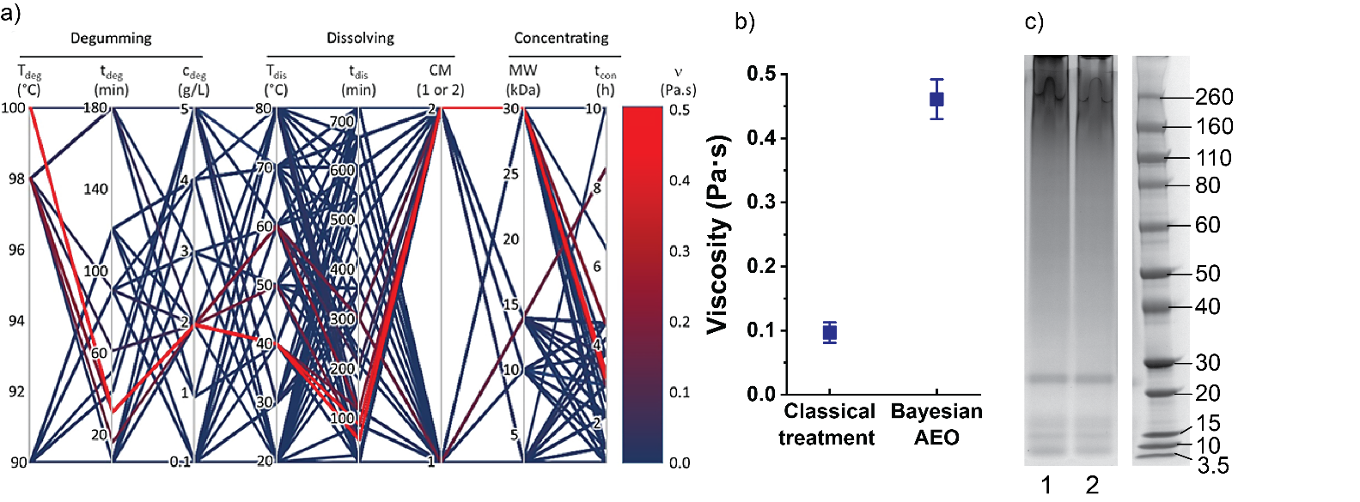
Figure 5 a) Suggested parameters for each experiment. (Where T is temperature; t is time; c is degumming concentration; CM is concentrating method; 1 for dialysis tubing and 2 for centrifuge filters; Mw is molecular weight of tubing or filters; ν is viscosity of concentrated silk solution), b) The maximum spinning dope viscosity of 13% (w/v) silk solution obtained with classical treatment and using Bayesian AEO, c) Molecular weight of the spinning dope obtained using classical treatment (lane 1) and using Bayesian AEO (lane 2).
The conditions that produced the highest dope viscosity using the classical approach vs. the Bayesian algorithm (reddest line in Figure 5a) are compared in Table 2.
Table 2: Comparison of the complete experimental conditions developed using the classical experimental design (classical treatment) vs. rapid Bayesian optimization (Bayesian AEO). NB: MWCO = molecular weight cut-off of the concentrating device used (dialysis tubing or centrifuge filters).
 | Degumming |  |  |  | Dissolving |  |  | Concentrating
 | Temp.  T_{deg} (°C) | Time  t_{deg} (min) | Na₂CO₃ concentration  c_{deg} (g/L) |  | Temp.  T_{dis} (°C) | Time  T_{dis} (min) |  | Concentrating method  CM (1 or 2) | MWCO  (kDa) | Time  t_{con} (h)
Classical treatment | 98 | 30 | 2 |  | 60 | 300 |  | 1 (dialysis tubing) | 14 | 10
Bayesian AEO | 100 | 30 | 2 |  | 40 | 60 |  | 2 (centrifuge filters) | 30 | 10

The classical treatment produced a dope viscosity (0.1 Pa.s) that is only slightly higher than what was defined as the spinnable region. Upon subsequent iterations of the Bayesian AEO, the dope viscosity increased to a maximum value of 0.46 Pa.s at the same concentration at 13% (w/v), which was attained on the third iteration. This dope viscosity represents a 4.75 - fold increase over that obtained using the classical experimental design approach. Since both silk solutions (classical approach and AEO optimized) exhibited shear thinning rheology, the viscosity of both solutions was higher at lower shear rates. For example, at the lowest shear rate recorded (0.11 s⁻¹), the viscosity of the classical approach and AEO optimized solutions was 0.859 and 7.144 respectively (Figure S5). This represents an even greater improvement for the AEO optimization of 8.3-fold. Such a high viscosity can be attributed to the lower dissolving temperature (40 ˚C) and dissolving time (60 min) compared with conditions found using traditional experimentation. Therefore, after five trials, the conditions that gave the highest viscosity were utilized for preparing the spinning dope.

Mechanical properties of RSF fibers using Bayesian AEO
In order to compare the mechanical properties of RSF fibers spun from dopes prepared with and without algorithmic assistance, the spinning parameters were kept constant to enable direct comparison between the two dopes. Room temperature wet pinning was carried using a dope concentration of 13% (w/v) and 30% (w/v) aqueous ammonium sulfate coagulation bath. The representative stress-strain curves for the RSF fibers using the classical dope preparation method and after using the algorithm at the same drawing ratio (10×) are presented in Figure 6. A more detailed figure containing the individual strain-stress curves results of RSF-6× and RSF-10× is included in Figure S4. The details of mechanical properties of between RSF-6× and RSF-10× were presented in Table S3. The stress-strain shape changed after using the algorithm. In addition, the surface and cross - section of RSF fibers with different drawing ratios were shown in Figure S3. Both RSF fibers showed distinct yield point followed with obvious strain hardening, with the yield point considerably higher for the fiber obtained using AEO-optimized conditions for dope preparation (Figure 6, Table 3). Not only did the viscosity of the dope increase using the algorithm, but the corresponding mechanical properties of RSF fibers were also improved, as presented in Table 3. By comparing our latest results with Zhao et al.⁵¹, we achieved a slightly higher strength (342.0 MPa vs 260 MPa), slightly lower strain (57.8% vs 78.9%) and slightly lower toughness (128.8 MJ/m³ vs 148.2 MJ/m³) than Zhou et al. This result is remarkable considering it involved no post drawing (only drawing during spinning) or steam annealing (both of which were used in Zhao et al. study). We believe this further highlights the great potential of the approach in study. Tensile tests show that the AEO-optimized dope produced fibers with greater modulus (11.4 GPa vs 5.3 GPa), a modest increase in breaking strength (155.0 vs 342.0 MPa) and a high plastic deformation region up to the fracture point at 57.8% elongation, suggesting a ductile mode of fracture. This large plastic deformation region and high elongation before break suggest that crystallinity and molecular alignment could be improved further in the fibers.⁵² As a result, the toughness of RSF fibers increased to 128.8 MJ/m³, which was higher than the native degummed B. mori silk (57.3 MJ/m³)²⁸.
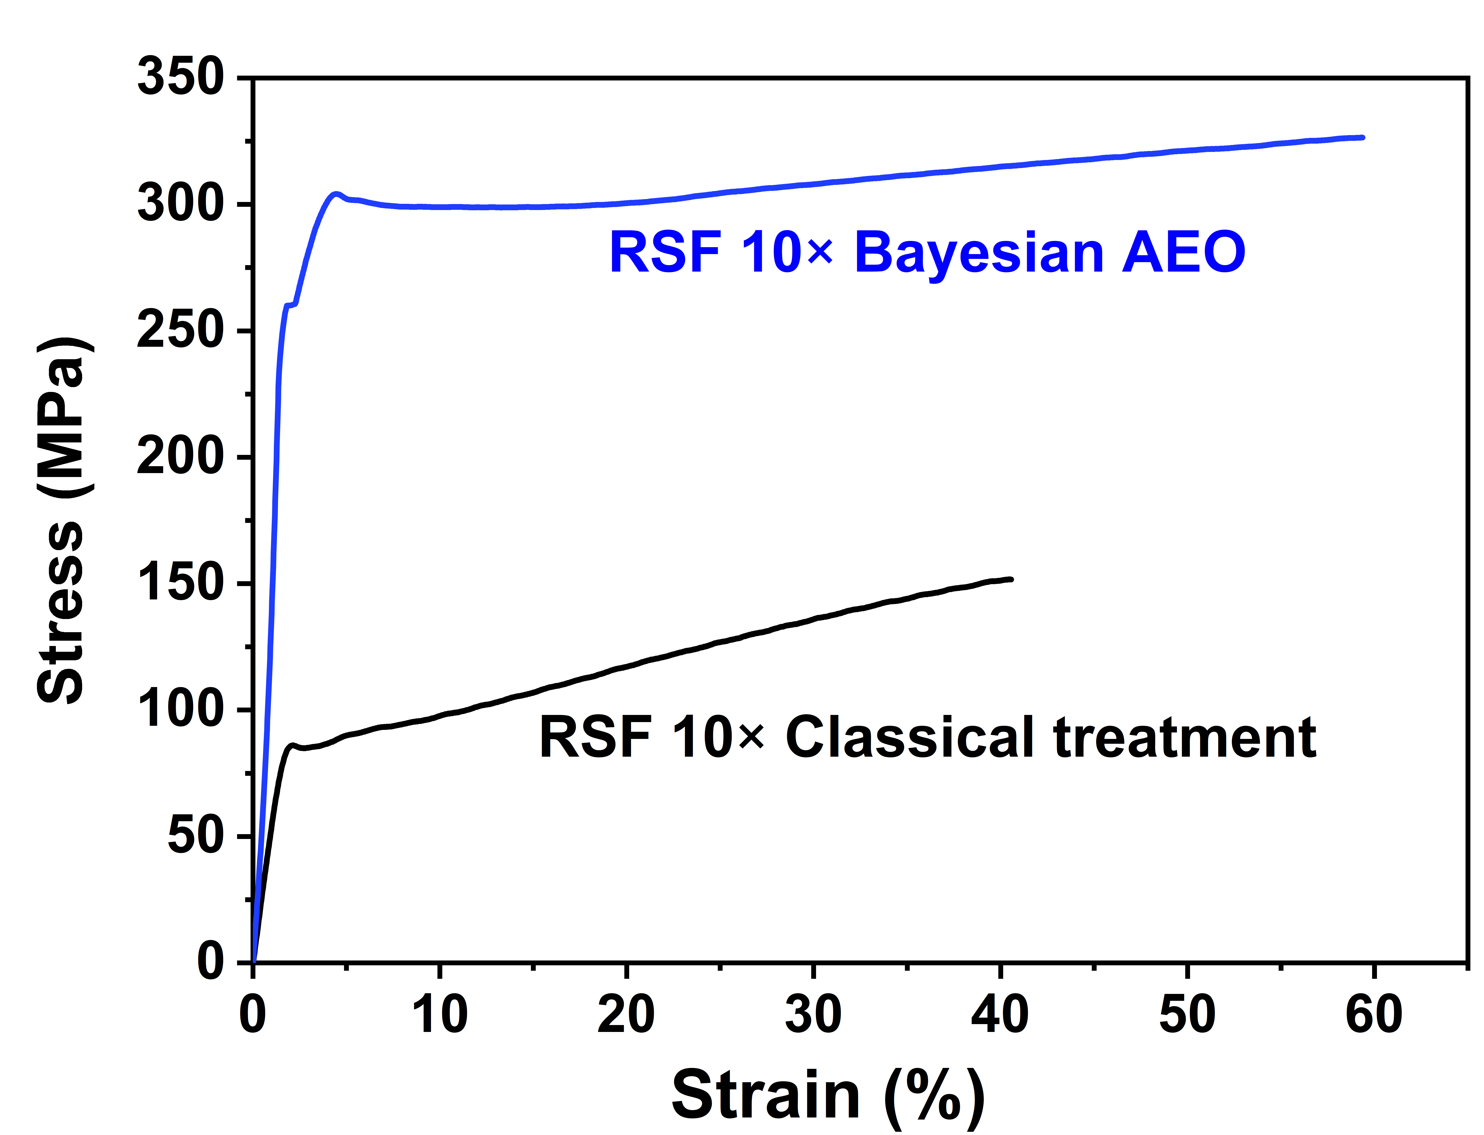
Figure 6. Representative strain-stress curves of wet spun fibers with classical treatment and using Bayesian AEO. Both fiber groups were spun at a 10× spinning ratio (RSF 10×)

Table 3. Comparison of tensile properties at the same spinning ratio (10×).
 | RSF 10×  Classical treatment | RSF 10×  Bayesian AEO | Fold change
Tensile strength  (MPa) | 155.0 ± 13.4 | 342.6 ± 23.9 | 2.2
Young's modulus  (GPa) | 5.3 ± 0.3 | 11.4 ± 1.0 | 2.2
Maximum elongation  (%) | 38.2 ± 6.9 | 57.8 ± 4.2 | 1.5
Toughness  (MJ/m³) | 46.7 ± 3.9 | 128.8 ± 14.4 | 2.8

Conclusions
Using a traditional approach in experimental design demonstrated that degumming, dissolving and concentrating conditions have a significant impact on the wet-spinning process of silk fibroin solutions, and established that the dope preparation itself, in addition to spinning conditions, exhibits considerable multivariate behavior. The use of an AEO driven experimental design produced significantly higher dope viscosities, which led to fibers that were tougher than natural B. mori fibers, in relatively few experimental iterations. Such improvements are not typically achievable using human-only endeavor or traditional statistical approaches. These results demonstrate that the use of the AEO method to develop silk processing parameters can deliver significant improvements to fiber mechanical properties. We believe this method could also be applied to other spinning process, including dry spinning and electrospinning. This method may provide the basis for further improvements if applied to the other stages of the spinning process (spinning flow rate, coagulation method, fiber drawing and post-treatment conditions).

Conflicts of interest
The authors declare no conﬂict of interest.

Acknowledgements
The authors acknowledge the Australian Research Council (FT130100380, FL170100006, IH140100018 and DP170102859) and the Institute for Frontier Materials (Research Excellence Grant Scheme) for funding. This work was performed in part using equipment and staff from the Victorian Node of the Australian National Fabrication Facility (ANFF) at Deakin University.

References:
1. Tao, H.; Kaplan, D. L.; Omenetto, F. G., Silk materials--a road to sustainable high technology. Adv. Mater. 2012, 24 (21), 2824-37.
2. Cai, Z. X.; Mo, X. M.; Zhang, K. H.; Fan, L. P.; Yin, A. L.; He, C. L.; Wang, H. S., Fabrication of chitosan/silk fibroin composite nanofibers for wound-dressing applications. Int. J. Mol. Sci. 2010, 11 (9), 3529-39.
3. Heim, M.; Romer, L.; Scheibel, T., Hierarchical structures made of proteins. The complex architecture of spider webs and their constituent silk proteins. Chem. Soc. Rev. 2010, 39 (1), 156-64.
4. Heim, M.; Keerl, D.; Scheibel, T., Spider silk: from soluble protein to extraordinary fiber. Angew. Chem. Int. Ed. Engl. 2009, 48 (20), 3584-96.
5. Liu, Y.; Qi, N.; Song, T.; Jia, M.; Xia, Z.; Yuan, Z.; Yuan, W.; Zhang, K. Q.; Sun, B., Highly flexible and lightweight organic solar cells on biocompatible silk fibroin. ACS Appl. Mater. Interfaces 2014, 6 (23), 20670-5.
6. Xu, W. P.; Zhang, W.; Asrican, R.; Kim, H. J.; Kaplan, D. L.; Yelick, P. C., Accurately shaped tooth bud cell-derived mineralized tissue formation on silk scaffolds. Tissue Eng., Part A 2008, 14 (4), 549-57.
7. Luo, Y.; Kirker, K. R.; Prestwich, G. D., Cross-linked hyaluronic acid hydrogel films: new biomaterials for drug delivery. J. Control. Release 2000, 69 (1), 169-84.
8. Gosline, J. M.; Demont, M. E.; Denny, M. W., The Structure and Properties of Spider Silk. Endeavour 1986, 10 (1), 37-43.
9. Pereira, R. F. P.; Silva, M. M.; Bermudez, V. D., Bombyx mori Silk Fibers: An Outstanding Family of Materials. Macromol. Mater. Eng. 2015, 300 (12), 1171-1198.
10. Plaza, G. R.; Corsini, P.; Marsano, E.; Perez-Rigueiro, J.; Elices, M.; Riekel, C.; Vendrely, C.; Guinea, G. V., Correlation between processing conditions, microstructure and mechanical behavior in regenerated silkworm silk fibers. J. Polym. Sci., Part B: Polym. Phys. 2012, 50 (7), 455-465.
11. Khan, M. M.; Morikawa, H.; Gotoh, Y.; Miura, M.; Ming, Z.; Sato, Y.; Iwasa, M., Structural characteristics and properties of Bombyx mori silk fiber obtained by different artificial forcibly silking speeds. Int. J. Biol. Macromol. 2008, 42 (3), 264-70.
12. Yazawa, K.; Malay, A. D.; Ifuku, N.; Ishii, T.; Masunaga, H.; Hikima, T.; Numata, K., Combination of Amorphous Silk Fiber Spinning and Postspinning Crystallization for Tough Regenerated Silk Fibers. Biomacromolecules 2018, 19 (6), 2227-2237.
13. Madurga, R.; Gañán-Calvo, A. M.; Plaza, G. R.; Atienza, J. M.; Guinea, G. V.; Elices, M.; López, P. A.; Daza, R.; González-Nieto, D.; Pérez-Rigueiro, J., Comparison of the effects of post-spinning drawing and wet stretching on regenerated silk fibers produced through straining flow spinning. Polymer 2018, 150, 311-317.
14. Ng, P. F.; Lee, K. I.; Meng, S.; Zhang, J.; Wang, Y.; Fei, B., Wet Spinning of Silk Fibroin-Based Core–Sheath Fibers. ACS Biomater. Sci. Eng. 2019, 5 (6), 3119-3130.
15. Madurga, R.; Gañán-Calvo, A. M.; Mariscal, T.; Plaza, G. R.; Guinea, G. V.; Elices, M.; Pérez-Rigueiro, J., Production of regenerated silkworm silk fibers from aqueous dopes through straining flow spinning. Text. Res. J. 2019, 89 (21-22), 4554-4567.
16. Magaz, A.; Roberts, A. D.; Faraji, S.; Nascimento, T. R. L.; Medeiros, E. S.; Zhang, W.; Greenhalgh, R. D.; Mautner, A.; Li, X.; Blaker, J. J., Porous, Aligned, and Biomimetic Fibers of Regenerated Silk Fibroin Produced by Solution Blow Spinning. Biomacromolecules 2018, 19 (12), 4542-4553.
17. Mollahosseini, H.; Fashandi, H.; Khoddami, A.; Zarrebini, M.; Nikukar, H., Recycling of waste silk fibers towards silk fibroin fibers with different structures through wet spinning technique. J Clean. Prod. 2019, 236, 117653.
18. Koeppel, A.; Holland, C., Progress and Trends in Artificial Review Silk Spinning: A Systematic Review. ACS Biomater. Sci. Eng. 2017, 3 (3), 226-237.
19. Xie, F.; Zhang, H.; Shao, H.; Hu, X., Effect of shearing on formation of silk fibers from regenerated Bombyx mori silk fibroin aqueous solution. Int. J. Biol. Macromol. 2006, 38 (3-5), 284-8.
20. Dou, H.; Zuo, B. Q., Effect of sodium carbonate concentrations on the degumming and regeneration process of silk fibroin. J. Text. Inst. 2015, 106 (3), 311-319.
21. Ki, C. S.; Kim, J. W.; Oh, H. J.; Lee, K. H.; Park, Y. H., The effect of residual silk sericin on the structure and mechanical property of regenerated silk filament. Int. J. Biol. Macromol. 2007, 41 (3), 346-53.
22. Li, C.; Rubin de Celis Leal, D.; Rana, S.; Gupta, S.; Sutti, A.; Greenhill, S.; Slezak, T.; Height, M.; Venkatesh, S., Rapid Bayesian optimisation for synthesis of short polymer fiber materials. Sci. Rep. 2017, 7 (1), 5683.
23. Ju, S. H.; Shiga, T.; Feng, L.; Hou, Z. F.; Tsuda, K.; Shiomi, J., Designing Nanostructures for Phonon Transport via Bayesian Optimization. Phys. Rev. X 2017, 7 (2), 021024.
24. Boulet-Audet, M.; Holland, C.; Gheysens, T.; Vollrath, F., Dry-Spun Silk Produces Native-Like Fibroin Solutions. Biomacromolecules 2016, 17 (10), 3198-3204.
25. Sun, M. J.; Zhang, Y. P.; Zhao, Y. M.; Shao, H. L.; Hu, X. C., The structure-property relationships of artificial silk fabricated by dry-spinning process. J. Mater. Chem. 2012, 22 (35), 18372-18379.
26. Allardyce, B. J.; Rajkhowa, R.; Dilley, R. J.; Atlas, M. D.; Kaur, J.; Wang, X. G., The impact of degumming conditions on the properties of silk films for biomedical applications. Text. Res. J. 2016, 86 (3), 275-287.
27. Laemmli, U. K., Cleavage of structural proteins during the assembly of the head of bacteriophage T4. Nature 1970, 227, 680-685.
28. Fang, G. Q.; Huang, Y. F.; Tang, Y. Z.; Qi, Z. M.; Yao, J.; Shao, Z. Z.; Chen, X., Insights into Silk Formation Process: Correlation of Mechanical Properties and Structural Evolution during Artificial Spinning of Silk Fibers. ACS Biomater. Sci. Eng. 2016, 2 (11), 1992-2000.
29. Srinivas, N.; Krause, A.; Kakade, S. M.; Seeger, M. W., Information-Theoretic Regret Bounds for Gaussian Process Optimization in the Bandit Setting. IEEE Trans. Inf Theory 2012, 58 (5), 3250-3265.
30. Zhang, F.; Lu, Q.; Ming, J. F.; Dou, H.; Liu, Z.; Zuo, B. Q.; Qin, M. D.; Li, F.; Kaplan, D. L.; Zhang, X. G., Silk dissolution and regeneration at the nanofibril scale. J. Mater. Chem. B 2014, 2 (24), 3879-3885.
31. Ko, J. S.; Yoon, K.; Ki, C. S.; Kim, H. J.; Bae, D. G.; Lee, K. H.; Park, Y. H.; Um, I. C., Effect of degumming condition on the solution properties and electrospinnablity of regenerated silk solution. Int. J. Biol. Macromol. 2013, 55, 161-8.
32. Kaur, J.; Rajkhowa, R.; Tsuzuki, T.; Millington, K.; Zhang, J.; Wang, X., Photoprotection by silk cocoons. Biomacromolecules 2013, 14 (10), 3660-7.
33. Gulrajani, M., Degumming of silk. In Silk dyeing, printing, and finishing, Gulrajani, M., Ed. Department of Textile Technology, Indian Institute of Technology: New Delhi, 1988; pp 63-95.
34. Pandit, M. W.; Sagar, A. J.; Rao, M. S., Studies on silk fibroin. I. Molecular weight, sedimentation coefficient, viscosity and optical rotation of silk fibroin from carbonate-extracted silk fiber. Arch. Biochem. Biophys. 1972, 149 (1), 259-68.
35. Rnjak-Kovacina, J.; DesRochers, T. M.; Burke, K. A.; Kaplan, D. L., The effect of sterilization on silk fibroin biomaterial properties. Macromol. Biosci. 2015, 15 (6), 861-74.
36. Wray, L. S.; Hu, X.; Gallego, J.; Georgakoudi, I.; Omenetto, F. G.; Schmidt, D.; Kaplan, D. L., Effect of processing on silk-based biomaterials: reproducibility and biocompatibility. J. Biomed. Mater. Res. B Appl. Biomater. 2011, 99 (1), 89-101.
37. Ki, C. S.; Kim, J. W.; Oh, H. J.; Lee, K. H.; Park, Y. H., The effect of residual silk sericin on the structure and mechanical property of regenerated silk filament. International journal of biological macromolecules 2007, 41 (3), 346-353.
38. Pellerin, C.; Rousseau, M. E.; Côté, M.; Pézolet, M. In Study of molecular orientation by vibrational spectroscopy: From polymers to silk, Macromolecular Symposia, Wiley Online Library: 2005; pp 85-98.
39. Hawthorn, A. C.; Opell, B. D., van der Waals and hygroscopic forces of adhesion generated by spider capture threads. J. Exp. Biol. 2003, 206 (Pt 22), 3905-11.
40. Zhang, L.; Chen, T.; Ban, H.; Liu, L., Hydrogen bonding-assisted thermal conduction in beta-sheet crystals of spider silk protein. Nanoscale 2014, 6 (14), 7786-91.
41. Ki, C. S.; Um, I. C.; Park, Y. H., Acceleration effect of sericin on shear-induced β-transition of silk fibroin. Polymer 2009, 50 (19), 4618-4625.
42. Chen, X.; Knight, D. P.; Shao, Z. Z.; Vollrath, F., Regenerated Bombyx silk solutions studied with rheometry and FTIR. Polymer 2001, 42 (25), 9969-9974.
43. Yoo, Y.-J.; Kim, U.-J.; Um, I.-C., The effect of coagulant and molecular weight on the wet spinnability of regenerated silk fibroin solution. International Journal of Industrial Entomology 2010, 21 (1), 145-150.
44. Cho, H.-J.; Um, I.-C., The effect of dissolution condition on the yield, molecular weight, and wet-and electro-spinnability of regenerated silk fibroins prepared by LiBr aqueous solution. International Journal of Industrial Entomology 2010, 20 (2), 99-105.
45. Tanaka, K.; Mori, K.; Mizuno, S., Immunological identification of the major disulfide-linked light component of silk fibroin. J. Biochem. 1993, 114 (1), 1-4.
46. Cho, H. J.; Ki, C. S.; Oh, H.; Lee, K. H.; Um, I. C., Molecular weight distribution and solution properties of silk fibroins with different dissolution conditions. Int. J. Biol. Macromol. 2012, 51 (3), 336-41.
47. Yang, M.; Shuai, Y.; Zhou, G.; Mandal, N.; Zhu, L.; Mao, C., Tuning molecular weights of Bombyx mori (B. mori) silk sericin to modify its assembly structures and materials formation. ACS Appl. Mater. Interfaces 2014, 6 (16), 13782-9.
48. Chung, D. E.; Um, I. C., Effect of Molecular Weight and Concentration on Crystallinity and Post Drawing of Wet Spun Silk Fibroin Fiber. Fibers Polym. 2014, 15 (1), 153-160.
49. Um, I. C.; Ki, C. S.; Kweon, H.; Lee, K. G.; Ihm, D. W.; Park, Y. H., Wet spinning of silk polymer. II. Effect of drawing on the structural characteristics and properties of filament. Int. J. Biol. Macromol. 2004, 34 (1-2), 107-19.
50. Liu, X. F.; Zhang, K. Q., Silk Fiber - Molecular Formation Mechanism, Structure-Property Relationship and Advanced Applications. Oligomerization Chem. Biol. Compd. 2014, 3, 69-102.
51. Zhou, G. Q.; Shao, Z. Z.; Knight, D. P.; Yan, J. P.; Chen, X., Silk Fibers Extruded Artificially from Aqueous Solutions of Regenerated Bombyx mori Silk Fibroin are Tougher than their Natural Counterparts. Adv. Mater. 2009, 21 (3), 366-370.
52. Mortimer, B.; Holland, C.; Vollrath, F., Forced reeling of Bombyx mori silk: separating behavior and processing conditions. Biomacromolecules 2013, 14 (10), 3653-9.

